
.

Secondary Schools Improvement Programme – SSIP

2023 Strategy

Contents

2.1 Introduction 4
2.2 SSIP Saturday Programme 4
2.3 Residential and Walk In Camps 6
2.4 Outreach 8
2.5 The Long-Distance Multimedia Support Centre (LDMSC) 9
2.6. Conclusion 9

SECONDARY SCHOOL INTERVENTION PROGRAM (SSIP)

Introduction

The Secondary School Improvement Programme (SSIP) is based on a centralised and standardised approach to how additional tuition is managed and delivered. It is an approach that seeks to establish what best practice exists in and out of the province and to ensure that this is replicated consistently across all the schools that are part of the programme.
This programme runs parallel to the normal school program. What is being taught during the week, according to the agreed upon GDE Work Schedule is consolidated during what is being considered as ‘the sixth school day’. The programme focuses on tackling examination questions and on how to achieve maximum results in key areas of the curriculum. There is also a strong focus on homework with the aim of supporting the curriculum that is being dealt with on a weekly basis in the classroom. Tutor and Learner Support Materials are developed, with every participating learner being afforded the same learning opportunities on the SSIP program every week
The Implementation of SSIP will continue for the 2023 academic year. This report presents a brief of the activities to be implement during the course of the year. The report focuses on the following:
- Saturday Programme
- Residential and Walk-in camps.
- Outreach
- Broadcasting

SSIP Saturday Programme

Districts will be provided with an equitable budget based on the number of learners in the districts for 2023. DITs prepared budgets, which they presented to the SSIP Committee. The committee approve the budgets ensuring that there is no over expenditure.

SSIP will be implemented on the following Saturdays in 2023.
Month | Dates
April | 15, 22
May | 6, 13, 20, 27
June | 3, 10
July | 22, 29
August | 5, 12, 19, 26
September | 2, 9, 16

SSIP will be implemented on 20 Saturdays.

The timetable for the Saturday SSIP will be confirmed after the release of the NSC results in the new year.
The timetable below is a sample of the Saturday timetable.
Week 1
Session 1 | Session 2 | Session 3
Maths/ Maths Lit/Tech Maths | Business Studies | Life Sc

Week 2
Session 1 | Session 2 | Session 3
Phy Sc / Tech Sc | Accounting / Geog | Econ

Residential and Walk In Camps

Residential and Walk In Camps will be implemented during the schools holidays. Districts will be provided with an equitable budget based on the number of learners in the districts for 2023. DITs prepared budgets, which they presented to the SSIP Camp Committee. The committee will approve the budgets ensuring that there is no over expenditure and the camps are conducted within the guidelines of the Camp Framework.

The districts will select the learners that attend the residential camps based on the needs to the individual district. All leaners will attend the walk-in camps.

The holiday programme will be implemented as indicated by the table below.
Month | Date
March/April camps | 24 March to 11 April
June/July camps | 23 June to 17 July
Sept/Oct camps | 29 Sept to 10 Oct

The timetable for the residential and walk in camps will be drafted according to the needs to the district as well as their allocated budgets.

The timetables below are a guideline for the districts.

Residential Camp timetable.
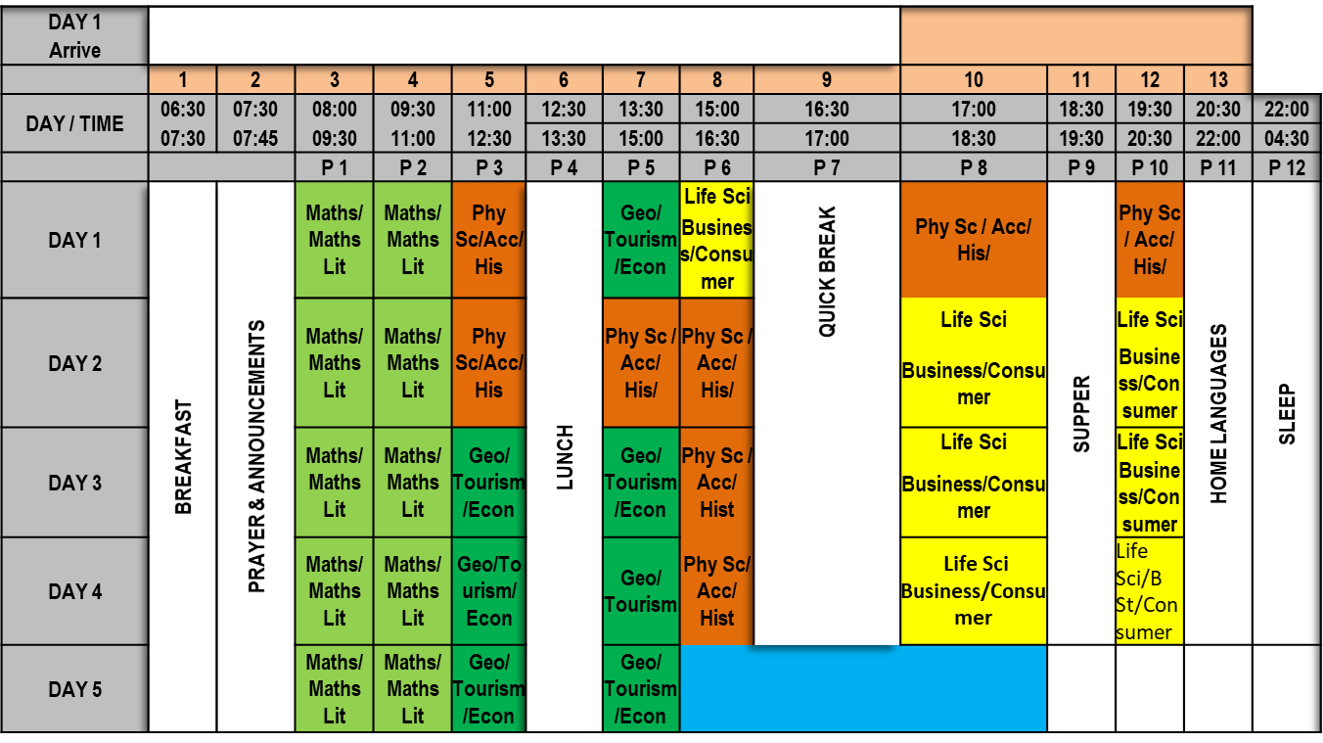

Walk In Camp timetable.
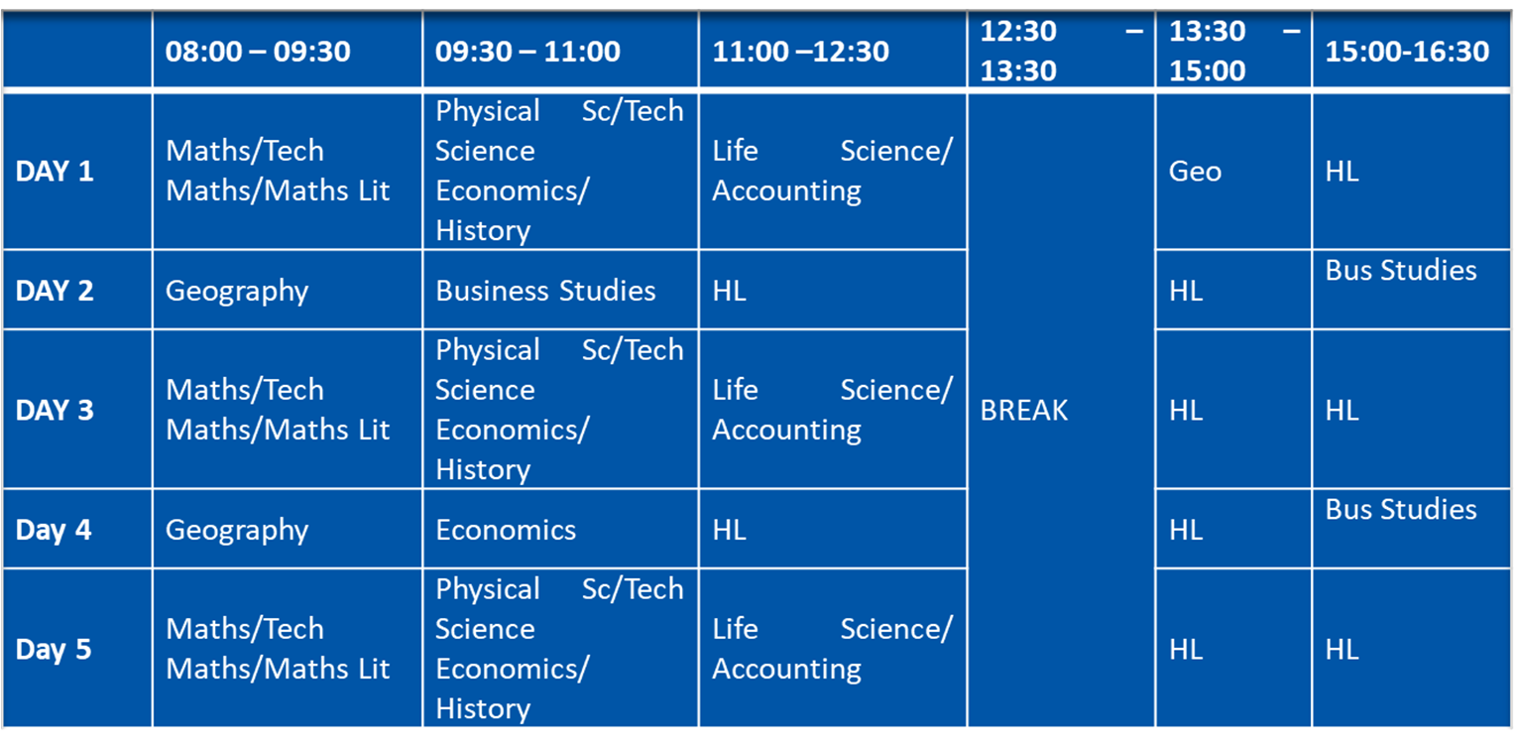

Outreach

The Outreach team, together with the Science Centre and the Career Centre Teams, will conduct a collaborative intervention in 12 Section 58 B Schools. The selection of the Section 58 B schools will be confirmed after the release of the NSC exam results in early 2023.
Objectives of the intervention
- To assist the selected 12 Section 58B schools with content coverage, teaching of difficult topics, PAT and SBA.
- To provide quality teaching and learning in mathematics, science and technology.
- Do coaching and mentoring amongst teachers to improve performance in mathematics, science and technology.
- To ensure the selected schools obtain at least 65% Grade 12 pass rate in their national senior certificate results at the end of the year.
- To provide motivation, career guidance and counselling to learners.

Activities to be conducted at the schools
Different departments within the Sci-Bono Discovery Centre will collaborate to provide the following services in Section 58B schools:
3.1. Science Centre: will assist the teachers and learners to conduct and complete the Practical assessment Tasks (PAT).
3.2. The Career Department: will provide motivation for both teachers and learners. They will also provide learners with career counseling and guidance.
3.3. Learner support unit: will assist the learners and teachers with topics that they find challenging. They will prepare and teach these topics.

2.5 The Long-Distance Multimedia Support Centre (LDMSC)

Conclusion

The SSIP Programme, with all its sub programmes, aims to contribute towards the goals of the GDE. This is to be achieved by providing learners with additional Saturday classes and holiday programmes. The inclusion of the Career Centre ensures the mental wellbeing of the learners.

