COMPLEX NUMBERS

Outcomes for this section:

By the end of this section, you should be able to:
- Define a complex number, $C$ , z = a + bi, where a and b are real numbers;
- Know the conjugate of z = a + bi;
- Know imaginary numbers i² = –1;
- Know how to add, subtract, divide and multiply complex numbers;
- Represent complex numbers in the Argand diagram;
- Know the argument of z;
- Know trigonometric (polar) forms of complex numbers;
- Solve equations with complex numbers with two variables.

Introduction
In Mathematics, we work with different types of numbers. The table below shows the different types of numbers we have encountered thus far in our study of Mathematics.
Number type | Symbol | Number type explained | Example
Natural numbers | $$N$$ | Are the basic counting numbers that start at 1. The numbers are spaced at regular intervals of one unit. | 1,2,3,4,…………..
Counting numbers or whole numbers | $$No$$ | Counting numbers are your natural numbers together with the number zero. These numbers start at 0. The numbers are spaced at regular intervals of one unit. | 0,1,2,3,………
Integers | $$Z$$ | Are positive or negative counting numbers. This includes all whole numbers from $-∞$ to $+∞$. | .,–3,–2,–1,0,1,2…
Rational numbers | $$Q$$ | Are numbers that can be expressed as a ratio of two numbers. NB: Any integer is a rational number because it can be expressed with a denominator of 1. | – $\frac{3}{4}$; $\frac{6}{7}$; 2
Irrational numbers | $$I$$ | Are those numbers that cannot be expressed as a ratio of two integers. NB: Irrational numbers when expressed as decimal numbers neither terminate nor repeat. | $\sqrt{7}$ = 2,645751…  $\sqrt[3]{4}$ = 1,587…..  $π$ = 3,14159…..
All the number types listed in the above table are collectively called REAL NUMBERS.
Recall from our work in grade 11, when dealing with the nature of roots of a quadratic equation, we said that if the discriminant ($∆ =b^{2} –4ac<0)$, the equation has no real roots.
Consider the following example:
Solve for x in the following quadratic equation, x² + 2x + 3 = 0, using the formula
x = $\frac{-b±\sqrt{b^{2}-4ac}}{2a}$
Solution: x² + 2x + 3 = 0 ; with a = 1 ; b = 2 and c = 3
x = $\frac{-b±\sqrt{b^{2}-4ac}}{2a}$
= $\frac{–2 ± \sqrt{2^{2} –4(1)(3)}}{2(1)}$
= $\frac{–2 ±\sqrt{4–12}}{2}$
= $\frac{–2 ± \sqrt{–8}}{2}$
= $\frac{–2 ± \sqrt{8}\sqrt{–1 }}{2}$
= $\frac{–2 ±2\sqrt{2 }\sqrt{–1 }}{2}$
x = – 1 $±\sqrt{2}$ $\sqrt{–1}$ …………….(1)
But there is no real number which is $\sqrt{–1}$ , as the square of any real number is always positive.
Therefore, we say that $\sqrt{–1}$ is an imaginary number and we denote it by the symbol i; i.e.:
i = $\sqrt{–1}$ OR i² = – 1.
So using this value of i, the solutions for the above equation can be expressed as:
x = – 1 $±$ $\sqrt{2}$ i or
x = –1 +$\sqrt{2}$ i and x = –1 – $\sqrt{2}$ i
NB: Some text use the letter j instead of the i to represent $\sqrt{–1}$

What is a complex number?
A complex number is any number that can be expressed in the form a + bi , where a and b are real numbers and i = $\sqrt{–1}$. In symbolic form, we can represent a complex number as:
z = a + bi , where a is the real part of z and b is the imaginary part of z.
Consider the following example:

z = 3 + 5 i
Imaginary part
Real part

Consider z = a + bi:
- If a = 0, then z = bi. We then say that the number is wholly imaginary.
- If b = 0, then z = a. We say that the number is real.
- If a = 0 and b = 0, then z = 0.

Activity 1
- For each of the following complex numbers, identify the real and imaginary parts.
 | Complex number | Real Part [$R(z)]$ | Imaginary Part [$Ι(z)]$
a) | z = 3 + 2i
b) | z = – 3 + 2i
c) | z = 5 – i
d) | z = – 5 –2i
e) | z = 3
f) | z = –7i
g) | z = 0
- Express each of the following numbers in the form: z = a + bi
a) | z = 3 + 2$\sqrt{–1}$ | b) | z = –3$\sqrt{–1}$ + 6
c) | z = – 4 + $\sqrt{–9}$ | d) | z = – 2 + $\sqrt{–8}$
e) | z = $\sqrt{–100}$ – $\sqrt{–64}$ | f) | z = $\sqrt{25}$ + $\sqrt{–64}$

The complex conjugate

If z = a + bi is a complex number, then $\overline{z}$ = a – bi is called the complex conjugate (or just the conjugate).
Consider the following example: z₁ = 5 + 8i and z₂ = 5 – 8i . In this case the real parts are the same but the imaginary parts have opposite signs, so z₂ is the conjugate of z₁.

Activity 2
- Complete the following table
 | Complex Number | Conjugate
a) | $z$= 4 + 5i
b) |  | $\overline{z}$ = 6 + 2i
c) | $z$ = 5 – 3i
d) |  | $\overline{z }$= – i
e) | $z$ = 5
f) |  | $\overline{z}$ = a + bi
g) | $z$= 3 + 4i
h) | $z$= 2 – 6i
i) |  | $\overline{z}$ = – 4 – 3i
j) | $z$= –8 + 5i

The powers of i
Recall from our introduction, we said that i = $\sqrt{–1}$ . Let us consider the powers of i
Starting with i = $\sqrt{–1}$
i² = i $×$ i = –1
i³ = i² $×$ i = –1 $×$ $\sqrt{–1}$ = – i
i⁴ = (i²)² = (–1)² = 1
i⁵ = (i⁴). i = 1(i) = i
i⁶ = i⁴ $×$ i² = 1(–1) = – 1
Can you see a pattern forming? ______________________________________________
Write down your observation: _________________________________________________

Activity 3
- Simplify each of the following
a) | i³ | b) | i⁴
c) | i⁶ | d) | i⁹
e) | i⁷ | f) | i⁴²
g) | i¹¹ | h) | i¹²

Calculating with complex numbers
Complex numbers have many applications in engineering. To use them effectively and efficiently, we must be able to carry out the usual arithmetic operations. We cannot add the real part and the imaginary part of a complex number. For instance, 2 + 3i $≠$ 5i.

5.1 Equality of complex numbers
For two complex numbers to be equal, their real part must be equal and their imaginary parts must be equal. This a necessary condition for the equality of two complex numbers, i.e.:
If z₁ = a +bi and z₂ = c + di
Then: z₁ = z₂ iff: a = c and b = d
Example 1: If a + bi = 8 + 9i then a = 8 and b = 9

Addition and Subtraction of complex numbers
- When adding, or subtracting two (or more) complex numbers, we add/subtract the real parts and separately add /subtract the imaginary parts. The following examples illustrate this:

Example 1: (3 + 7i) + (4 – 6i) = 3 + 7i + 4 – 6i……….[Remove brackets]
= (3 + 4) + (7i – 6i) ……..[Collect like terms]
= 7 + i…………………[Simplify]…

Example 2: (4 + 7i) – (2 – 5i) = 4 + 7i – 2 + 5i……….[Remove brackets]
= (4 – 2) + (7i + 5i)…….[Collect like terms]
= 2 + 12i …………….[Simplify]
Example 3: From 7 + 2i subtract 8 – 4i
Solution: Identify the subtrahend and the minuend first.
Then proceed as follows:
7 + 2i – (8 – 4i) = 7 + 2i – 8 + 4i……………….[Remove brackets]
= 7 – 8 + (2i + 4i)……………[Collect like terms]
= – 1 + 6i ……………………[Simplify]

Activity 4:
- Simplify each of the following expressions
a) | (8 + 4i) + (2 – 6i) | b) | (– 7 + 3i) +(8 –4i)
c) | 2–4i + 3(–1 + 2i) | d) | 4(–2 + 5i) + 5(7i + 2)
e) | 8 +3i – 7 – 2i | f) | (7 + 6i) – (4 – 2i)
g) | 2(9 – 3i) – 4(2 – 6i) | h) | 24 + 3i + 2(5i – 3)
- Determine the values of x and y in each of the following equations.
- x + yi = 4 – 2i
- x + yi + 3 – 2i = 4(–2 + 5i)
- 2x + 3yi = – x – 6i
- (x + y) + ( x – y)i = 7 + 2i

Multiplication of complex numbers
When multiplying complex numbers, we use the general algebraic method for multiplication.
Example 1: Consider the complex numbers z and w, where z = 3 + 2i and w = 5–4i.
Then zw = (3 + 2i)(5– 4i)
= 3(5 – 4i) + 2i(5 – 4i)………[Use distributive property]
= 15 – 12i + 10i – 8i² ……[Expand each bracket]
= 15 – 2i – 8(–1) ……..[Simplify. Note that i² = –1]
= 15 – 2i + 8………….[Simplify. (–8)(–1) = + 8]]
= 23 –2i …………..[Simplify]
Example 2: Simplify ( 5 – i)² and give your answer in the form a + bi, where a and b are real numbers.
Solution: (5 – i)² = (5 – i)(5 – i)
= 5 ( 5 – i) – i(5 – i)…….[Use the distributive property]
= 25 – 5i – 5i + i² ……..[Expand]
= 25 – 10i + (–1) ……..[Add like terms. Note the value of i² = –1]
= 25 – 1- 10i
= 24 - 10i …………..[Simplify]

Challenge to the reader.
Determine the product of: ( 3 + 4i)(2 – 5i)(1 – 2i)
Explain your method to your colleague.

Activity 5
- Simplify each of the following expressions. Write your answer in the form a + bi, where a and b are real numbers.
a) | (3 + i)(2 + 3i) | b) | (4 – 2i)(5 + 3i)
c) | (8 – i)(9 + 2i) | d) | (–3i + 9)(5 – i)
e) | i(2 – 3i)(i + 4) | f) | (3 – 2i)(7–5i)
- Simplify each of the following expressions, giving your answer in the form a + bi, where a and b are real numbers.
a) | (3 + 4i)(3 – 4i) | b) | (2 + i)(3 – 5i)
c) | (5 – i)² | d) | (2i +1)²
e) | (1 + i)³ | f) | (2 – i)⁴
g) | (–2 – i)(– 2 + i) | h) | ($\sqrt{2 }$ + i)²
i) | 3(2 – i) –i(1 – i) | j) | – 1 + i – (i + 1)²
k) | 2i – ($\overline{1+i)}$ | l) | (2 + i$\sqrt{3}$)²

Division of complex numbers
When dividing a complex number by a real number it is rather straight forward. For example: $\frac{5–4i}{3}$ = $\frac{5}{3}$ – $\frac{4i}{3}$. But how would we divide by a complex number?
We will demonstrate the technique by considering the following examples:
Example 1: $\frac{2+3i}{4+5i}$
In order to do the division we need to change the denominator to a real number. How do we do that? Recall in grade 11 when we dealt with division of surds of the type: $\frac{1}{1+\sqrt{5}}$, we could simplify this type of expression by multiplying the numerator and the denominator by the conjugate of the given denominator, i.e :1 – $\sqrt{5}$ .
$\frac{1}{1+\sqrt{5}}$ = $\frac{1}{1+ \sqrt{5}}$ $×$ $\frac{1–\sqrt{5}}{1–\sqrt{5}}$ [Multiply the numerator and denominator by conjugate of 1 +$\sqrt{5}$]
= $\frac{1–\sqrt{5}}{1 –5}$
= $\frac{1–\sqrt{5}}{–4}$
Coming back to our example : $\frac{2+3i}{4+5i}$, we are going to employ the same procedure as the one used above.
So, $\frac{2+3i}{4+5i}$ = $\frac{2+3i}{4+5i}$ $×$ $\frac{4 –5i}{4 –5i}$
= $\frac{8–10i+12i–15i^{2}}{16–25i^{2}}$…………..[Expand numerator and denominator]
= $\frac{8+2i–15(–1)}{16 –25(–1)}$ ……….[Simplify collect like terms. Note i² = –1]
= $\frac{23+2i}{41}$
= $\frac{23}{41}$ + $\left(\frac{2}{41}\right)$i

Using the method outlined above, let’s do the following examples.
Example 2: Simplify $\frac{3+i}{7 –3i}$and write your answer in the form a + bi, where a and b are real numbers.
Solution:
$\frac{3+i}{7 –3i}$ = $\frac{(3+i)}{(7 –3i)}$ $×$ $\frac{( 7+3i)}{(7+3i)}$..[Multiply numerator and denominator by conjugate]
= $\frac{21+9i+7i+3i^{2}}{49–9i^{2}}$ ………[Expand numerator and denominator]
= $\frac{21+3(–1)+16i}{49 –9(–1)}$……..[Simplify. Note i² = –1]
= $\frac{21–3+16i}{49+9}$………..[Simplify]
= $\frac{18+16i}{58}$
= $\frac{18}{58}$ +$\left(\frac{16}{58}\right)$i
= $\frac{9}{29}$ + $\left(\frac{8}{29}\right)$i

Example 3:
If $α$ = – 3 –5i, determine the value of $\frac{α–1}{α+1}$ in the form a + bi, where a and b are real numbers.
Solution:
Step 1: Determine the value of $α$ – 1:
$α$ – 1 = –3 –5i – 1
$α$ – 1 = – (4 + 5i)
Step 2: Determine the value of $α$ + 1:
$α$ + 1 = – 3 – 5i + 1
$α$ + 1 = – (2 + 5i)
Step 3: Now proceed to determine the value of: $\frac{α–1}{α+1}$ = $\frac{–(4+5i)}{–(2+5i)}$
= $\frac{(4+5i)}{(2+5i)}$ $×$ $\frac{(2–5i)}{(2–5i)}$….[Multiply by conjugate]
= $\frac{8–20i+10i–{25i}^{2}}{4–{25i}^{2}}$ ….[Expand]
= $\frac{8–25\left(–1\right)–10i}{4–25(–1)}$ …..[i² = –1]
= $\frac{8+25 –10i}{4+25}$
= $\frac{33–10i}{29}$
= $\frac{33}{29}$ – $\left(\frac{10}{29}\right)$i

Activity 6
- Express each of the following fractions in the form a + bi, where a and b are real numbers.
a) | $\frac{2+3i}{4–i}$ | b) | $\frac{4+3i}{5+i}$
c) | $\frac{8–i}{2+3i}$ | d) | $\frac{5i+2}{2i –3}$
e) | (3 – i)^{–2} | f) | $\frac{1}{2i+1}$
g) | $\frac{–2i}{1–i}$ | h) | $\frac{i(–i+2)}{3–2i}$
i) | $\frac{i}{3+2i}$ + $\frac{2}{3–2i}$ | j) | $\frac{3–i}{3+i}$ – $\frac{2i}{3–i}$
- If $z$ = $\frac{2+i}{1 –i}$ , express $z+ \frac{1}{z}$ in the form a + bi, where a and b are real numbers.

The Complex Plane
In some branches of mathematics, it is convenient to view complex numbers, x + yi , as ordered pairs (x ; y), of real numbers. In that case, the set $C$ of complex numbers is defined by:
$C$ ={z: z = ( x ; y), where x , y $∈$ $R$}

When the complex number x + yi is regarded as the ordered pair (x ; y) of real numbers, it can be represented by the point in the XY-Plane with coordinates (x ; y).

Imaginary axis
y
We call the x-axis the real axis and the y-axis is called the imaginary axis. The resultant plane is called the complex plane or Argand plane (named after the Swiss mathematician, Robert Argand, who in 1806 gave this geometric representation of the complex numbers and used it to prove that every polynomial equation has a solution

O
x
Real axis
Complex/Argand Plane

Consider the general complex number represented by: z = x + yi. This number can be represented by a vector from O to the point P(x ; y); i.e.: z = $\vec{OP}$.

From the diagram, alongside:
$\left|\vec{OP}\right|$ = $\sqrt{x^{2}+y^{2}}$ ….[Pythagoras]
= $\left|z\right|$ = r
We use $\left|z\right|$ to represent the length of the vector. We call $\left|z\right|$ the modulus of the complex number.
A diagram showing complex numbers is called an Argand diagram
I-axis
Real axis
x
y
P (x ;y)

O

Example: Represent the following complex numbers on an Argand diagram, and state the modulus for each of the numbers.
- z₁ = 3
- z₂ = 4 + 3i
- z₃ = 5i
- z₄ = –2 + 3i
- z₅ = –3 – i
- z₆ = – 2i
Solution:
(– 3 ; – 1)
(0 ; – 2)
(– 2 ; 3)
(0 ; 5)
(4 ; 3)
(3 ;0)
- $\left|z_{1}\right|$ = $\sqrt{3^{2}+0^{2}}$ = $\sqrt{9}$ = 3
- $\left|z_{2}\right|$ = $\sqrt{4^{2}+3^{2}}$ = $\sqrt{16+9}$ = $\sqrt{25}$ = 5
- $\left|z_{3}\right|$ = $\sqrt{0^{2}+5^{2}}$ = 5
- $\left|z_{4}\right|$ = $\sqrt{{(-2)}^{2}+3^{2}}$ = $\sqrt{13}$
- $\left|z_{5}\right|$ = $\sqrt{10}$
- $\left|z_{6}\right|$ = 2

Activity 7
- Represent the following complex numbers on an Argand diagram.

a) | 5 | b) | 5i | c) | –5
d) | –5i | e) | –5 + 5i | f) | –5 – 5i
g) | 5 – 5i | h) | – 1 + 2i | i) | 2–i
j) | –6 – 2i | k) | – 6i | l) | 0+ 0i

- Copy and complete the following table
 | Complex Number (z) | $$\left|z\right|$$ |  |  | Complex Number (z) | $$\left|z\right|$$
a) | 4 |  |  | b) | 3i
c) | – 3 |  |  | d) | – i
e) | 1 + i |  |  | f) | 2 – 2i
g) | 1 +$\sqrt{3}$ i |  |  | h) | –1 –$\sqrt{3}$ i
i) | $\sqrt{2}$ – $\sqrt{2}$ i |  |  | j) | 2 + i
k) | 1–3i |  |  | l) | – 1 + 3i
- If z = 3 + 5i, represent each of the following on an Argand diagram
- z
- zi
- zi²
- zi³
- zi⁴

- If z₁ = 5 + 2i and z₂ = 2 + 4i.
  - Determine z₁ + z₂ algebraically.
  - Hence, show z₁ + z₂ graphically.

- Given: z₁ = 8 –4i and z₂ = 4 – 6i.
  - Determine z₁ – z₂ algebraically.
  - Hence show z₁ – z₂ graphically.

The argument of z
Im
Re
$$θ$$
P( x ; y)
The position of a point P(x ; y) on the Argand diagram, can be given in terms of OP, the distance of P from the origin, and $θ,$ the angle measured anti-clockwise which OP makes with the positive real axis.
Recall, the length OP is the modulus of z and is denoted by $\left|z\right|$, and this length $\left|z\right|$ is always taken to be positive.
The angle $θ,$ (normally measured in radians) is the argument of z, denoted by arg z. The principal value of $θ$ is taken to be between – $π$ < $θ$< $π$; or any length of 2$π$; i.e: 0 < $θ$ < 2$π$
To find $θ$, we use: tan $θ$ = $\frac{y}{x}$, but we need to take care when either x or y is negative.

Examples
1. | Determine the argument of:  z = 3-3i | x = 3 ; y = – 3  Im  Re  $$θ$$  tan $θ$ = $\frac{–3}{3}$ = –1  $θ$ = arg z = $\frac{–π}{4}$

2. | Determine the argument of:  z = – 1 + 2i | x = – 1 ; y = 2  $$θ$$  Im  Re  tan $θ=$ $\frac{2}{–1}$ = – 2  $θ$ = 116,57º  $θ$ = arg z = 0,6476 $π$
3. | Determine the argument of :  z = – 1 – i | x = – 1 ; y = – 1  $\tan{θ}$ = $\frac{–1}{–1}$ = 1  $θ_{ref}$ = $\frac{π}{4}$ . But this angle lies in the third quadrant, so to calculate the arg z( i.e. the angle from the positive real axis or in a clockwise direction) is : arg z = $\frac{–π}{2}$ – $\frac{π}{4}$ = $\frac{–3π}{4}$  If the angle is measure anti-clockwise, then the angle will be:  $θ$ = $π+$ $\frac{π}{4}$ = $\frac{5π}{4}$
4. | Determine the argument of:  z = 2 + 2$\sqrt{3}$ i | x = 2 ; y = 2$\sqrt{3}$  $\tan{θ}$ = $\frac{2\sqrt{3}}{2}$ = $\sqrt{3}$  $θ$ = arg z = $\frac{π}{3}$

Activity 8
- Determine the argument of the following complex numbers
 | Complex Number (z) | arg z |  |  | Complex Number (z) | $$arg z$$
a) | 4 |  |  | b) | 3i
c) | – 3 |  |  | d) | – i
e) | 1 + i |  |  | f) | 2 – 2i
g) | 1 +$\sqrt{3}$ i |  |  | h) | –1 –$\sqrt{3}$ i
i) | $\sqrt{2}$ – $\sqrt{2}$ i |  |  | j) | 2 + i
k) | 1–3i |  |  | l) | – 1 + 3i
- Given: z = $\frac{1+i}{1 –2i}$
  - Write z in the form a + bi
  - Hence determine the modulus and argument of z

- The complex numbers z₁ and z₂ are given by: z₁ = 5 + i ; z₂ = 2 – 3i
  - Represent the points z₁ and z₂ on an Argand diagram
  - Determine z₁ – z₂ algebraically
  - Hence determine the modulus of z₁ – z₂
  - Determine a complex number $\frac{z_{1}}{z_{2}}$ in the form a + bi, where a and b are rational numbers.
  - Hence, determine the argument of $\frac{z_{1}}{z_{2}}$, giving your answer in radians correct to two decimal places.
  - Determine the values of the real constants p and q such that:
$\frac{p+qi+{3z}_{1}}{p–q+{3z}_{2}}$ = 2i

Trigonometric (polar) form of complex numbers
Im
$$θ$$
P(a ; b)

Sometimes it is convenient to express a complex number a + bi in a different form. On an Argand diagram, let OP be a vector a + bi. Let r = length of the vector and $θ$ the angle makes with the real axis.

Re

From the above diagram: OP² = r² = a² + b² …………….[Pythagoras]
In polar coordinates, the point P(r ; $θ$) is equivalent to the cartesian representation of P(x ;y)
r = $\sqrt{a^{2}+b^{2}}$
And, tan $θ$ = $\frac{b}{a}$ => $θ$ = tan^{–1} $\frac{b}{a}$
From our earlier work of Trigonometry, we know that: sin $θ$ = $\frac{b}{r}$ and cos $θ$ = $\frac{a}{r}$
Thus, b = r sin $θ$ and a = r cos $θ$
NB: For convenience, we introduce the notation : cis$θ$ = cos $θ$ + i sin$θ$ and r $∟θ$ = r[cos $θ$ + i(sin $θ$)]

Since z = a + bi
z = r cos $θ$ + r i(sin $θ$)
z = r[cos $θ$ + i(sin $θ$)]

Thus, if z has a modulus $\left|z\right|$ and an argument $θ$, the polar form of z is given by:
$z$ = r[cos $θ$ + i sin $θ$]
$z$ = $r$cis $θ$

Examples
1. | Express: z = –$\sqrt{2}$ – $\sqrt{2}$i in polar form.  P($–\sqrt{2}$ ; – $\sqrt{2}$) | z = –$\sqrt{2}$ –$\sqrt{2}$ i  where x = – $\sqrt{2}$ and y = – $\sqrt{2}$  $\left|z\right|$ = r = $\sqrt{x^{2}+y^{2}}$  = $\sqrt{(-{\sqrt{2})}^{2}+(-{\sqrt{2})}^{2}}$  = $\sqrt{2+2}$  = $\sqrt{4}$  $\left|z\right|$ = 2  tan $θ$ = $\frac{y}{x}$ = $\frac{-\sqrt{2}}{-\sqrt{2}}$ = 1  $θ= \frac{π}{4}$ , BUT note that the given point lies in the third quadrant, so to determine the arg z, we proceed as follows:  $θ$ = arg z = $\frac{–π}{2}$ - $\frac{π}{4}$ = $\frac{–3π}{4}$  $∴$ z = 2 cis($\frac{–3π}{4}$)
2. | Express: z = – 1 +i in polar form  P(–1 ; 1) | z = – 1 +i  Where: x = – 1 and y = 1  $\left|z\right|$ = r = $\sqrt{x^{2}+y^{2}}$ = $\sqrt{2}$  tan $θ$ = $\frac{1}{–1}$ = – 1  $θ$ = $\frac{3π}{4}$  z = $\sqrt{2}$ cis($\frac{3π}{4}$)
3. | Write $\sqrt{3}$ cis($\frac{5π}{6}$) in rectangular form. | $\sqrt{3}$ cis($\frac{5π}{6}$) = $\sqrt{3}$ [cos$(\frac{5π}{6}$) + isin($\frac{5π}{6}$)]  = $\sqrt{3}$ [$-\frac{\sqrt{3}}{2}$ ) + ($\frac{1}{2}$)i]  = $\frac{–3}{2}$ + $\frac{\sqrt{3}}{2}$i

Activity 9
- Convert the following complex numbers to polar form

a) | z = 4 | b) | z = 2i
c) | z = 1 + i | d) | z = 2 – 2i
e) | z = – 6 | f) | z = – 3i
g) | z = $\sqrt{3}$ – i | h) | z = $2\sqrt{3}$ + 2i
i) | z = 1 + 2i | j) | z = – 5 + 2i

- Convert z = k + ki to polar form.

- Convert the following numbers from polar form to rectangular form

a) | 2cis($\frac{π}{2}$) | b) | 8 cis ($\frac{π}{4}$)
c) | 3cis($\frac{π}{6}$) | d) | $\sqrt{2}$ cis($\frac{-π}{4}$)
e) | $\sqrt{3}$ cis ($\frac{2π}{3}$) | f) | $2\sqrt{2}$ cis($\frac{3π}{4}$)
g) | 5 cis 0 | h) | 4 cis($\frac{5π}{2}$)

Solving equations with complex numbers with two variables
In this section we will solve equations with complex numbers involving two variables.
Example 1: If (x + yi)(2 – i) = –i, determine the values of x and y if x, y $ϵ$ $R$.
Solution: Method 1:
(x + yi)(2 – i) = –i,
( x + yi) = $\frac{–i}{2–i}$………..[Divide both sides by (2 – i)]
(x + yi) = $\frac{–i}{2–i}$ $×$ $\frac{2+i}{2+i}$ ……..[Multiply RHS by conjugate of denominator]
(x + yi) = $\frac{–2i–i^{2}}{4–i^{2}}$
(x + yi) = $\frac{–2i–(–1)}{4 –(–1)}$ ……..[ i² = –1]
( x + yi) = $\frac{–2i+1}{5}$ ………...[Simplify numerator and denominator]
x + yi = $\frac{–2i}{5}$ + $\frac{1}{5}$
x + yi = $\frac{1}{5}$ – $\frac{2i}{5}$
Now, comparing real part and imaginary parts of the equation: x = $\frac{1}{5}$ and y = – $\frac{2}{5}$
Method 2:
(x + yi)(2 – i) = –i,
2x – xi + 2yi – yi² = – i ……[Expand LHS}
2x – y(–1) – xi + 2yi = – i ……[i² = –1]
2x + y – (x –2y)i = – i ……..[Group real terms and imaginary terms]
2x + y – (x – 2y)i = 0 – i…….[Write RHS in form a + bi]
Comparing real parts: 2 x + y = 0 ………..(1)
Comparing imaginary parts: x – 2y = 1……..(2)
Solving the above equations simultaneously as follows:
(2)$×$ 2: 2x –4y = 2 …….(3)
(3) – (1): –5y = 2
y = – $\frac{2}{5}$
Substitute y = $\frac{–2}{5}$ in (1): 2x – $\frac{2}{5}$ = 0
2x = $\frac{2}{5}$
x = $\frac{1}{5}$

Activity 10
- Solve for x and y in each of the following equations, if x, y $∈$ $R$

a) | 2x + 3yi = – x –6i | b) | (x + yi)(2 – i) = 8 + i
c) | (3 + 2i)(x + yi) = – i | d) | x² + xi = 4 – 2i
e) | 2(x + yi) = x – yi | f) | (x + yi)(2 + i) = 2x – (y + 1)i
g) | x + yi = 4 – 2i | h) | x + iy + 3 –2i = 4(–2 +5i)
i) | (2 + i)(3–2i) = x + yi | j) | (3–5i)(4 + i) = x + yi
k) | x + yi = $\frac{7+i}{2 –i}$ | l) | (2 –3i)² = x + yi

POLYNOMIALS

Outcomes for this section:
By the end of this section, you should be able to:
- Define a polynomial
- Revise methods of factorization studied in earlier grades
- Apply the remainder and factor theorems to cubic polynomials
- Use long division and synthetic division to factorise cubic polynomials
- Factorise cubic polynomials

Polynomials
You have studied polynomials in depth in earlier grades. Recall that a quadratic is a special form of a polynomial. Below are some examples of polynomials:
3x³–2x²+1 | 3 | 4–2x | x² | 1
2x⁴ | 1–2x+3x⁵ | $\sqrt{2}$ x² | $\frac{1}{2}$x¹⁷ | x
A (non-zero) polynomial, p(x), is an expression in x of the form:
ax^{n} + bx^{n–1} +……+ jx + k, where a, b,c,…..j,k are real numbers, a$≠$0, and n is a non-negative integer

- The number n is called the degree of the polynomial;
- The expressions ax^{n} ; bx^{n–1},…,k which make up the polynomial are called terms.
- The numbers a, b, c,…..k; are called coefficients; a is called the leading coefficient.
- The coefficient k is called the constant term.
Consider the quadratic polynomial: 4x² –3x + 1:
- The degree of the polynomial is 2;
- The expression is made up of 3 terms;
- The coefficient of x² is 4; the coefficient of x is – 3 and the constant term is 1
- The leading coefficient is 4
Polynomials have special names depending on their degree:
- A polynomial of degree 0 is called a constant polynomial or a constant, eg.: 2 ; k
- A polynomial of degree 1 is called a linear polynomial, eg: x + 1 ; 2x ; –7x + 99,9
- A polynomial of degree 2 is called a quadratic polynomial or a quadratic, eg: x² ; –$\frac{1}{2}$x²+ 7x– 99 ; 2x² + 8
- A polynomial of degree 3 is called a cubic polynomial or a cubic; eg: x³ ; –3x³ + 21; 1001x³–2x²+7x+1
When a polynomial is written in the form ax^{n} + bx^{n–1} + …….+jx +k , with the term of highest degree first and the other terms in descending degree order finishing with the constant term, the terms are said to be in descending order. If the terms are written in the reverse order, they are said to be in ascending order (or ascending powers of x). For example:
3x⁴ + x² – 7x + 5 is written in descending order (or powers of x); while 5 + 7x + x² + 3x⁴ is written in ascending order (or powers of x). The polynomial remains the same, regardless of the order in which it is written.
NB: The functions $\frac{1}{x}$ = x^{–1} and $\sqrt{x}$ = $x^{\frac{1}{2}}$ are not polynomials, because the powers of x are not positive integers or zero.

Division of polynomials
Before we consider the techniques of dividing polynomials, let’s recall the technique we used to divide numbers. Consider the following examples.
1. | Divide 19 by 5 | $\frac{19}{5}$ = 3 remainder 4  Remainder  19 = 5 $×$ 3 + 4  Quotient  Dividend  Divisor
2. | Perform the following operation: $\frac{23}{4}$ | Divisor  Quotient  5  4 23  Dividend  - 20  3  Remainder  $\frac{23}{4}$ = 5 + $\frac{3}{4}$
From the above we can deduce:
$\frac{Dividend}{Divisor}$ = Quotient + $\frac{Remainder}{Divisor}$
$∴$ Dividend = Divisor $×$ Quotient + Remainder

We will call this sentence a division statement.

Activity 1
- Perform the following operations. For each operation identify the dividend, the divisor, quotient and remainder.
- $\frac{17}{6}$ b) $\frac{19}{6}$ c) $\frac{20}{5}$
Using the method outline, lets extend our method outlined above to polynomials.
Examples
1. | Find the quotient and the remainder when the polynomial x² + 4x – 5 is divided by  x + 3 | We begin by writing x² + 4x – 5 in terms of a quotient and a remainder gives an expression in the form:  x² + 4x – 5 $≡$ (x +3).Q(x) + Remainder  We observe that the quotient must be of the form: ax + b. So,  x² + 4x – 5 $≡$ (x +3)(ax + b) + R  $≡$ ax² + bx + 3ax + 3b + R  $≡$ ax² + (b + 3a)x +(3b +R)  Comparing coefficients:  x² : a = 1………..(1)  x: b + 3a = 4…….(2)  b + 3(1) = 4  b = 1  x⁰ : 3b + R = –5  3(1) + R = – 5  R = – 8  Q(x) = (x + 1) ; R = – 8
2. | $\frac{2x^{3}+7x^{2}+10x+15}{x+2}$ | $2x^{3}+7x^{2}+10x+15$ $≡$(x +2).Q(x) + R  We observe that the quotient must be a quadratic,  i.e: Q(x) = ax² + bx + c  $2x^{3}+7x^{2}+10x+15$ $≡$(x +2)( ax² + bx + c) + R  $≡$ ax³ + (2a + b)x² + (2b + c)x + (2c + R)  Comparing coefficients:  x³: a = 2……..(1)  x²: 2a + b = 7  2(2) + b = 7…….from (1) a = 2  b = 3…………..(2)  x¹: 2b + c = 10  2(3) + c = 10 ………from (2) b = 3  c = 4 ……….(3)  x⁰: 2c + R = 15  2(4) + R = 15  R = 7  $\frac{2x^{3}+7x^{2}+10x+15}{x+2}$ = 2x² + 3x + 4 + $\frac{7}{x+2}$

Activity 2
Determine the quotient and the remainder in each of the following:
a) | $\frac{x–9}{x+3}$ | b) | $\frac{x^{2}–9}{x+3}$
c) | $\frac{3x^{2}+2x –5}{x+2}$ | d) | $\frac{2–3x+3x^{2}+ x^{3}}{x+1}$

3.The division process
The following examples will explain the process regarding the division of polynomials.
- Divide: x² + 7x + 9 by x + 1
x + 6  x + 1 x² + 7x + 9  x² + x  6x + 9  6x + 6  + 3  $∴$ $\frac{x^{2 }+7x+9}{x+1}$ = x + 6 + $\frac{3}{x+1}$ | - : The first term of the quotient is obtained by : $\frac{x^{2}}{x}$ = x  - x(x +1) = x² + x  - (x² + 7x +9) –(x² +x) = 6x + 9  - $\frac{6x}{x}$ = 6  - 6(x + 1) = 6x + 6  - 6x + 9 – (6x + 6) = 3
- Divide: x³ + 12x – 9 by x–2  x² + 2x + 16  x – 2 x³ +0x² + 12x – 9  x³ –2x²  + 2x² + 12x – 9  + 2x² – 4x  + 16x – 9  + 16x – 32  + 23  $∴$ $\frac{x^{3}+12x –9}{x–2}$ = x² + 2x + 16 + $\frac{23}{x–2}$ | 1) Write the given expression in descending powers of x, i.e:  x³ +0x² + 12x – 9 (NB: We introduced the term 0x²)  2) $\frac{x^{3}}{x}$ = x²  3) x²(x –2) = x³ –2x²  4) (x³ + 0x²+12x –9) – (x³ – 2x²) = + 2x² + 12x –9  5) $\frac{+ 2x^{2}}{x}$ = +2x  6) + 2x( x – 2) = 2x² – 4x  7) $\frac{16x}{x}$ = 16  8) 16(x – 2) = 16x –32  9) 16x – 9 – (16x – 32) = 23

In general: If P(x) denotes the dividend, Q(x) denotes the quotient, R denotes the remainder, and the divisor is (x – a), where a is a constant, then:
$\frac{P(x)}{(x–a)}$ = Q(x) + $\frac{R}{(x –a)}$
$∴$ P(x) = (x – a). Q(x) + R……………This is called a division statement
Division by ax+ b
If P(x) is divided by ax + b, then:
$\frac{P(x)}{ax+b}$ = Q(x) + $\frac{R}{ax+b}$
$∴$ P(x) = (ax + b).Q(x) + R
Note: The degree of the divisor must be $≤$ the degree of P(x)
The degree of R must be < the degree of the divisor for the process to stop

Activity 3
- Find the quotient and the remainder for each of the following, using long division
a) | (x² + 3x + 2) $÷$ ( x + 1) | b) | (x² –9x + 18) $÷$ ( x – 6)
c) | (x³ + 3x² + 3x + 1) $÷$ ( x + 1) | d) | (x³ + 8) $÷$ (x + 2)
e) | (x³ – 15x² + 75x – 125) $÷$ (x – 5) | f) | (x³ + 15x² + 75x + 125) $÷$ (x + 5)
g) | (x³ – 125) $÷$ (x – 5) | h) | (x³ + 64) $÷$ (x – 4)
i) | (2x³ + 5x² + 7x – 3) $÷$ (2x + 3) | j) | (6x³ – 5x² + 5x – 1) $÷$ (3x – 4)
k) | (6x³ + 7x² – 9x + 1) $÷$ (3x – 1) | l) | (4x³ – 2x² + 2x + 9) $÷$ (2x + 2)

4. Synthetic Division
Suppose that P(x) = 2x³ + 7x² + 10x + 15 is divided by x +2 . We will explain the method of synthetic division using this example.
 |  | x³ | x² | x¹ | x⁰
Divisor | –2 | 2 | 7 | 10 | 15 | Coefficients
 |  | 0 | –4 | - 6 | - 8 | Products
 |  | 2 | + 3 | +4 | + 7 | Answer
 |  | Quotient |  |  | Remainder
Method explained:
- Under the x³ column in the answer row, write down the 2
- Then multiply the 2 with the divisor –2 to give you a product of –4. Write your answer to this product under the x² column (3rd row)
- Then add the values of 7 + (–4) to give you + 3. Write your answer in the answer row.
- Then multiply your answer under the x² column with the divisor to give you a product of –6.
- Then add the product of –6 to the value of the coefficient of x¹ (10) to give you a sum of +4.
- Multiply the answer you obtained in 5 above (i.e. +4) with the divisor (–2) to obtain a product of +8 in the x⁰ column.
- Add your response to 6 above to the coefficient of the x⁰ variable to obtain a sum of +7- this is your remainder.

$∴$ $\frac{2x^{3}+7x^{2}+10x+15}{x+2}$ = 2x² +3x + 4 + $\frac{7}{x+2}$
Example 2: Use synthetic division to carry out the following divison process:
$\frac{x^{3}+3x^{2 }+3x+2}{x+1}$
Solution:
Divisor | x³ | x² | x¹ | x⁰ | Variables
–1 | +1 | +3 | +3 | +2 | Coefficients of variables
 |  | –1 | –2 | –1 | Products
 | +1 | +2 | +1 | +1 | Answer
 | Quotient |  |  | Remainder

$∴ \frac{x^{3}+3x^{2 }+3x+2}{x+1}$ = x² + 2x + 1 + $\frac{1}{x+1}$

Activity 4
Use the synthetic division process, to perform the following division sums.
a) | (x² + 3x + 2) $÷$ ( x + 1) | b) | (x² –9x + 18) $÷$ ( x – 6)
c) | (x³ + 3x² + 3x + 1) $÷$ ( x + 1) | d) | (x³ + 8) $÷$ (x + 2)
e) | (x³ – 15x² + 75x – 125) $÷$ (x – 5) | f) | (x³ + 15x² + 75x + 125) $÷$ (x + 5)
g) | (x³ – 125) $÷$ (x – 5) | h) | (x³ + 64) $÷$ (x – 4)
i) | (2x³ + 5x² + 7x – 3) $÷$ (3 + x) | j) | (6x³ – 5x² + 5x – 1) $÷$ (4–2x)
k) | (6x³ + 7x² – 9x + 1) $÷$ (3x – 1) | l) | (4x³ – 2x² + 2x + 9) $÷$ (2x + 1)

5.The Remainder Theorem
When a polynomial f(x) is divided by (ax–b), then the remainder is given by f($\frac{b}{a}$)
i.e.: f($\frac{b}{a}$) = R
NB: The proof of the Remainder Theorem is not required for examination purposes.

Worked examples:
- Given : f(x) = x³ + 5x² –17x –21. Without actual division, determine the remainder when f(x) is divided by:
- x + 1
- x – 4
- 2x + 1
a) | f(x) = x³ + 5x² –17x –21  f(–1) = (–1)³ + 5(–1)² –17(–1) –21  = – 1 + 5 +17 –21  f(–1) = 0  i.e. The remainder is 0 | Using the remainder theorem, the remainder when f(x) is divided by x + 1 is given by f(–1)
b) | f(x) = x³ + 5x² –17x –21  f(4) = (4)³ + 5(4)² –17(4) –21  = 64 +80 –68 –2  f(4) = 55  i.e.The remainder is 55 | Using the remainder theorem, the remainder when f(x) is divided by x –4 is given by f(4)
c) | f(x) = x³ + 5x² –17x –21  f($\frac{–1}{2}$) = ($\frac{–1}{2}$)³ + 5($\frac{–1}{2}$)² –17($\frac{–1}{2}$) –21  = – $\frac{1}{8}$ + $\frac{5}{4}$ + $\frac{17}{2}$ – 21  f(–$\frac{1}{2}$) = – $\frac{91}{8}$  i.e.The remainder is – $\frac{91}{8}$ | Using the remainder theorem, the remainder when f(x) is divided by 2x +1 is given by f($\frac{–1}{2}$)
- Without actual division, determine the remainder when the polynomial:
x³ –3x² + 3x + 4 is divided by 3x + 2
 | Let f(x) = x³ –3x² + 3x + 4  Then :  f(– $\frac{2}{3}$) = (${\frac{–2}{3})}^{3}$ – 3(${\frac{–2}{3})}^{2}$ + 3($\frac{–2}{3}$) + 4  = $\frac{–8}{27}$ – $\frac{12}{9}$ – 2 + 4  = $\frac{–8 –36–54+108}{27}$  f(– $\frac{2}{3}$) = $\frac{–10}{27}$  i.e the remainder is $\frac{–10}{27}$ | Let the divisor: 3x + 2 = 0  Then x = – $\frac{2}{3}$  Using the remainder theorem, the remainder when f(x) is divided by 3x + 2 is given by: f(– $\frac{2}{3}$)
- When the polynomial x³ + 3x² + 3x + c is divided by x – 2, the remainder is 30. Determine the numerical value of c using the remainder theorem.
 | Let: f(x) = x³ + 3x² + 3x + c  Then:  f(2) = (2)³ + 3(2)² + 3(2) + c  = 8 + 12 + 6 + c  = 26 + c  But: f(2) = 30 ….Given  26 + c = 30  c = 4 | Let the divisor: x – 2 = 0  Then x = 2  Using the remainder theorem, the remainder when f(x) is divided by x – 2 is given by: f(2)
- When the polynomial x³ + 3x² + bx + c is divided by x–1, the remainder is 8; and when it is divided by x + 1, the remainder is 0. Use the remainder theorem to determine the numerical values of b and c
 | Let: f(x) = x³ + 3x² + bx + c  Then:  f(1) = (1)³ + 3(1)² + b(1) + c  = 1 + 3 + b + c  = 4 + b + c  But: f(1) = 8 …….Given  4 + b + c = 8  b + c = 4 ……..(1)  f(–1) = (–1)³ + 3(–1)² + b(–1) + c  = – 1 + 3 – b + c  = 2 – b + c  But: f(–1) = 0…….Given  2 – b + c = 0  b – c = 2 ………..(2)  - + (2): 2b = 6  b = 3  Substitute b = 3 in (1):  3 + c = 4  c = 1 | Let the divisor: x – 1 = 0  Then x = 1  Using the remainder theorem, the remainder when f(x) is divided by x – 1is given by: f(1) = 8 ;  Let the divisor: x + 1 = 0  Then x = –1  Using the remainder theorem, the remainder when f(x) is divided by x + 1 is given by: f(–1) = 0

Activity 5
- Use the remainder theorem to find the remainder when:
a) | 6x² + 5x – 1 is divided by x–1 | b) | 3x² + 6x – 8 is divided by x + 3
c) | 3x³ + 2x –4 is divided by x–2 | d) | 2x³+4x²–6x +5 is divided by x–1
e) | 6x³–2x² +5x –4 is divided by x | f) | 8x³ + 4x + 3 is divided by 2x–1
g) | 4x² + x³ –7x + 8 is divided by  x + 3 | h) | 2x³ + 3x² + 4x + 5 is divided by  x + 2
- The expression 2x³ –3x² + ax – 5 gives a remainder of 7, when divided by x–2. Find the value of the constant a.
- The cubic 3x³ +bx² –7x + 5 gives a remainder of 17 when divided by x + 3. Determine the value of b.
- The cubic expression cx³ + dx² + 3x + 8 leaves a remainder of – 6 when divided by x–2, and a remainder of –34 when divided by x + 2. Determine the numerical values of c and d.
- ** The remainder when the expression x³ –2x² + ax + b is divided by x–2 is five times the remainder when the same expression is divided by x–1; and 12 less than the remainder when the same expression is divided by x – 3. Determine the values of the constants a and b.

The factor theorem
If a given number is expressed as the product of two numbers, then these numbers are called factors of the given number.
Example: 10 = 2 $×$ 5
The factors of 10 are 2 and 5
And: $10 ÷5=2$
$10 ÷2=5$
We notice that: If a number is divided by one of its factors, then the remainder is zero.
Similarly, if an algebraic expression is divided by one of its factors then the remainder is zero.
Stated more formally:
If ax–b is a factor of the polynomial f(x), then f($\frac{b}{a}$) = 0.
NB: The proof need not be known for examination purposes.

Worked examples:
1. | Given: f(x) = x³ + 3x² –13x –15. Factorise f(x) completely.
 | f(x) = x³ + 3x² – 13x –15  =(x + 1)(ax² + bx + c)  x³ + 3x² –13x –15 = ax³ +(a +b)x² +(b+c)x +c  Comparing coefficients:  x³ : 1 = a  x²: 3 = a + b  = (1) + b  2 = b  x¹: –13 = b + c  –13 = 2 + c  - 15 =c  $∴$ x³ + 3x² –13x –15 = (x +1)(x² + 2x –15)  = (x + 1)(x + 5)(x – 3) | We know that if f(x) has a linear factor  ax + b, then the constant b will be a factor of 15. In other words, one of : $± 1 ; ±3 ; ±5 or ±15$  We start bey evaluating: f(1) = +24 $≠$ 0  f(–1) = 0, Hence (x + 1) is a factor of f(x).
2. | Given: f(x) = 2x³ – 5x² – 19x + 42.  - Factorise f(x) completely  - Hence, solve for x
a) | f(x) = 2x³ – 5x² – 19x + 42  2x³ – 5x² – 19x + 42 = (x–2)(ax² + bx +c)  =ax³ +(b–2a)x² +(c–2b)x –2c  Comparing coefficients:  x³: 2 = a  x²: – 5 = b –2a  = b – 2(2)  –5+4 = b  –1 = b  x⁰: 42 = – 2c  –21 = c  f(x) = (x – 2)(2x² –x –21)  f(x) = (x – 2)(2x – 7)(x + 3) | We know that if f(x) has a linear factor  ax + b, then the constant b will be a factor of 42. In other words, one of : $± 1 ; ±2 ; ±3;±6 ±7; ±14 ±21 or ±42$  We start bey evaluating: f(1) = +20 $≠$ 0  f(–1) = 54 $≠0$,  Next we try f(–2) = 44 $≠0$  Next we try f(2) = 0  Hence (x – 2) is a factor of f(x).
b) | To solve for x, we equate f(x) = 0  i.e: (x – 2)(2x – 7)(x + 3) = 0  So: (x – 2) = 0 OR (2x – 7) = 0 OR (x +3) =0  x = 2 OR x = $\frac{7}{2}$ OR x = –3
3. | Given the polynomial g(x) = 3x³ + 4x² + 5x –6. Determine all factors if x $∈$ $C$
 | g(x) = 3x³ + 4x² + 5x –6  =(3x –2)(ax² + bx + c)  = 3ax³ +(3b–2a)x² +(3c–2b)x –2c  Comparing coefficients:  x³: 3 = 3a  a = 1  x²: 4 = 3b –2a  = 3b –2(1)  6 = 3b  b = 2  x¹: 5 = 3c –2b  5 = 3c –2(2)  9 = 3c  3 = c  g(x) = (3x –2)(x² + 2x + 3)  To determine the factors of g(x), let g(x) = 0  i.e: 3x – 2 = 0 OR x² + 2x + 3 = 0  x = $\frac{2}{3}$  OR:  x² + 2x + 3 = 0  This expression cannot be resolved into linear factors, so we will make use of the quadratic formula: x = $\frac{-b±\sqrt{b^{2}-4ac}}{2a}$ a = 1; b = 2 ; c = 3  x = $\frac{–2 ±\sqrt{–8}}{2}$  = $\frac{–2 ±2\sqrt{2} i}{2}$  x = $–1 ±\sqrt{2} i$ | Look for the factors of 3 and –6;  for 3 we will try: $±$ 1 ; $± 3$ and for –6 we will try:$±$ 1$;±2$ ; $± 3$ ; $± 6$  Lets try: x = 1  g(1) = 18 $≠$ 0 ;  g(–1) = 2 $≠$ 0  Through trial and error, we arrived at:  g($\frac{2}{3}$) = 0  Hence (3x –2) is a factor of g(x).

Activity 6
- Use the factor theorem to factorise each of the following cubic polynomials, p(x). In each case write down all the roots of the equation p(x) = 0 if; x is a complex number.
a) | p(x) = x³ + 2x² –5x –6 | b) | p(x) = x³ – 3x² – x + 3
c) | p(x) = x³ – 3x² –13x + 15 | d) | p(x) = x³ – 3x² – 9x – 5
e) | p(x) = x³ + 3x² –4x –12 | f) | p(x) = 2x³ +7x² – 5x – 4
g) | p(x) = 3x³ –x² – 12x + 4 | h) | p(x) = 6x³ +7x² –x – 2
i) | p(x) = x³ + 2x² –4x + 1 | j) | p(x) = 4x³ +8x² + x – 3
- Express the function (x –1)(x² –2x –11)–16 as the product of linear factors. Hence, solve the equation (x–1)(x² –2x –11) = 16.
- Given p(x) = x(x² –13) + 12.
  - Express p(x) as a product of linear factors.
  - Hence, solve the equation p(x) = 0
- The cubic polynomial x³ + ax –12 is exactly divisible by x + 3.
  - Determine the value of the constant a
  - Hence, solve the equation x³ + ax –12 = 0
- A function is defined by: f(x) = x³ – 3x² + x + 1.
  - Find f(1) and f(–2) and hence state a factor of f(x).
  - Express f(x) in the form (x +p)(x² + qx +r), where p, q and r are numbers to be determined.
  - Hence solve the equation f(x) = 0
- ** Show that (x –2) is a factor of x³ – 9x² + 26x – 24. Find the set of values for which
x³ – 9x² + 26x – 24 < 0.
- Given that k(x) = 6x³ + ax² + bx + 4.
You are also told that k(–1) = –15 and k(3) = 49.
- Show that a = –13 and b = 0
- Write, k(x) as the product of linear factors.
- Hence solve for x, if k(x) = 0
- Given p(x) = x³ + ax² + bx – 6 is exactly divisible by x² + x –6. Determine the values of a and b.

DIFFERENTIAL CALCULUS

Outcomes for this session:
By the end of this session, you should be able to:
- Develop an intuitive understanding of the limit concept, in the context of approximating the rate of change or gradient of a function at a point.
- Determine the average gradient of a curve between two points, i.e.: m = $\frac{f\left(x+h\right)-f(x)}{h}$
- Determine the gradient of a tangent to a graph, which is also the gradient of the graph at that point. Introduce the limit principle by shifting the secant until it becomes a tangent.
- Use first principles for $f^{' }$(x) = $\lim_{h→0}{\frac{f\left(x+h\right)-f(x)}{h}}$ for f(x) = k ; f(x) = ax and
f(x) = ax + b.
- Use the rule $\frac{d}{dx} \left(ax^{n}\right)= {anx}^{n-1}$ for n $∈ R.$
- Find equations of tangents to graphs of functions.
- Sketch graphs of cubic polynomial functions using differentiation to determine the co-ordinate of stationary points. Also, determine the x-intercepts of the graph using the factor theorem and other techniques.
- Solve practical problems concerning optimization and rates of change, including calculus of motion.

Introduction

Calculus is a branch of mathematics involving or leading to calculations dealing with continuously varying functions. To a Roman in the days of the empire a “calculus” was a pebble used in counting and gambling. Centuries later “calculare” came to mean “to compute”, “to reckon”, “to figure out”. To the mathematician, physical scientist, and social scientist of today, calculus is elementary mathematics (algebra, geometry, trigonometry) enhanced by the limit process.
Calculus takes ideas from elementary mathematics and extends them to a more general situation. The table below contains some examples. On the left-hand side, you will find an idea from elementary mathematics; on the right, this same idea as extended by calculus.
Elementary Mathematics | Calculus
Slope of a line y = mx + c | Slope of a curve y = f(x)
Tangent line to a circle | Tangent line to a more general curve
Average velocity, Average acceleration | Instantaneous velocity, Instantaneous acceleration
Distance moved under a constant velocity. | Distance moved under varying velocity.
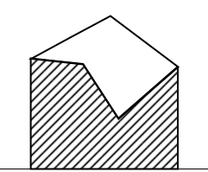  Area of a region bounded by line segments. | 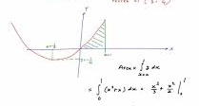  Area of a region bounded by curves
Length of a line segment | Length of a curve

Differentiation is used in calculations involving velocity and acceleration, rates of change and maximum and minimum values of curves.
Before, we proceed; let us first revise some concepts which we encountered in earlier grades.

Functional Notation
In an equation such as y = 3x² + 2x – 5, it is said to be a function of x and it may be written as y = f(x).
An equation written in the form f(x) = 3x² + 2x – 5 is termed functional notation. The value of f(x) when x = 0 is denoted by f(0) and the value of f(x) when x = 2 is denoted by f(2), and so on. Thus, when f(x) = 3x² + 2x –5, then
f(0) = 3(0)² + 2(0) – 5 = –5 and f(2) = 3(2)² + 2(2) – 5 = 12 + 4 – 5 = 11.

Activity 1
- If f(x) = 4x² –3x + 2, determine the value of:
- f (0) | - f (3) | - f (–1)
- f (3) – f (–1)
- Given that f(x) = 5x² + x –7, determine the value of:
- f (2) $÷$ f(1) | - f (3 + a) | - f ( 3 + a) – f(3)
- $\frac{f\left(3+a\right)–f(3)}{a}$
- If f(x) = 6x² -2x + 1, determine the value of:
- f (0) | - f (1) | - f (2)
- f (–1) | - f (–3)
- If f(p) = 2p² + 5p – 7, determine the value of:
- f (1) | - f (2) | - f (–1)
- f (2) – f (– 1)
- Given: f(x) = 3x³ + 2x² – 3x +2, determine the value of:
- f (1) | - f (2)
- Use your results to a) and b) above, to show that f (1) = $\frac{1}{7}$ f (2)
- If f(x) = –x² + 3x + 6 , determine the value of:
- f (2) | - f (a) | - f (2 + a)
- f (2 + a) – f (2) | - $\frac{f\left( 2+a\right)–f(2)}{a}$

Average gradient
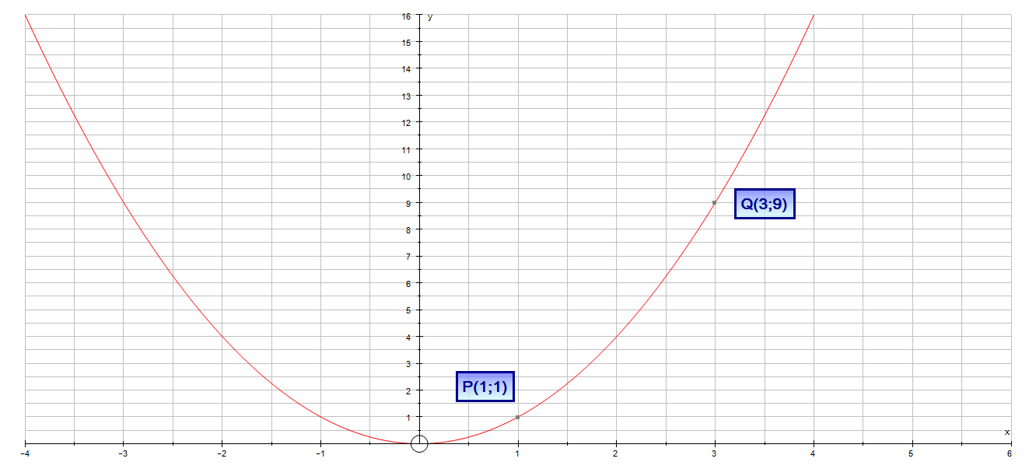
If we are asked to calculate the gradient of the line passing through P(1;1) and Q(3;9) on the curve y = x², we proceed as follows.
M_{PQ} = $\frac{y_{Q}-y_{P}}{x_{Q}-x_{P}}$ = $\frac{9-1}{3-1}$ = $\frac{8}{2}$ =4
We say that “4 is the average gradient of y = x² between P(1;1) and Q(3;9)”
y = x²
We define the average gradient (or average rate of change) of a given function, say f, between two points (a ; f(a)) and (b; f(b)) as the gradient of the line joining the points on the curve. We say that the average gradient of the function, f over the interval [a; b] is the gradient of the line joining the two points.

y
x
a
b
Suppose that A(a ; f(a)) and B(b; f(b)) are two arbitrary points on the curve y = f(x). The average gradient of y = f(x) between A and B is given by:
M_{AB} = $\frac{f\left(b\right)-f(a)}{b-a}$ = $\frac{Δy}{Δx}$
Now, if b – a = h (i.e: b = a +h) , then the average gradient is defined by:
$$\frac{f\left(a+h\right)-f(a)}{h}$$

B

C
A

Worked Examples
1. | Consider the function f(x) = 1 – x² | Solution
1.1 | Determine the value of: $\frac{f\left(2+h\right)–f(2)}{h}$ | Step 1: Find the value of f(2 + h), i.e:  f (2 + h) = 1 – (2 + h)²  = 1 – ( 4 + 4h + h²)  f (2 + h) = –3 –4h –h²  Step 2: Find the value of f(2), i.e:  f(2) = 1 – (2)²  f(2) = –3  Step 3: Now using your results from Steps 1 and 2 above, evaluate the given expression, i.e.:  $\frac{f\left(2+h\right)–f(2)}{h}$ = $\frac{–3–4h-h^{2} –(–3)}{h}$  = $\frac{–3–4h–h^{2}+3}{h}$  = $\frac{–4h–h^{2}}{h}$  = $\frac{h(–4 –h)}{h}$ ; h $≠$ 0  $\frac{f\left(2+h\right)–f(2)}{h}$ = –4 –h
1.2 | Interpret your answer | This answer represents the average gradient of f(x) = 1 –x² between x = 2 and x = 2 + h
2. | Given: f(x) = x² + 1.
2.1 | Find the average gradient between the points R (a ; f(a)) and  S(a + h ; f(a +h)) | Step1 : Find the value of f(a) , i.e:  f(a) = a² + 1  Step 2: Find the value of f(a + h) , i.e.:  f(a+h) = (a + h)² + 1 = a² + 2ah + h² + 1  Step 3: Now determine the average gradient,i.e:  $\frac{f\left(a+h\right)–f(a)}{h}$ = $\frac{a^{2}+2ah+h^{2}+1 –(a^{2}+1)}{h}$  = $\frac{2ah+ h^{2}}{h}$  = $\frac{h(2a+h)}{h}$ ; h $≠$ 0  $\frac{f\left(a+h\right)–f(a)}{h}$ = 2a + h
2.2 | Hence, find the average gradient between the points x = – 2 and  x = 0. | f(–2) = (–2)2 + 1 = 5  f(0) = (0)2 + 1 = 1  h = b – a  h = 0 – (–2)  h = 2  Average gradient = 2(–2) + 2 ……substitution  = –2
2.3 | What happens to the average gradient as S moves closer to R? | From 2.1: The average gradient = 2a + h  As S comes closer to R , the value of h approaches zero, thus making the average gradient = 2a.

Activity 2
- Find the average gradient of the given curve in each of the following cases.
- y = 2x , between x = 3 and x = 7 |  | - y = 3x + 4 between x = 2 and x = 5
- y = x² , between x = 0 and x = 2 |  | - y = 2x² –1 between x = –4 and x = 6
- y = x³ between x = 3 and x = 4
- Consider the function f : x $→$ x² + x. Determine the average gradient
- between x = 1 and x = 3 |  | - over the interval [– 3 ; – 2]
- between the points (–1 ; f(–1)) and (4 ; f(4))
- If g(x) = 8 –2x – x², determine the average rate of change of g on the interval
[2 ; 3]
- Consider the function, defined by f(x) = – x²
- Determine $\frac{f\left(1+h\right)–f(1)}{h}$ |  | - Interpret your answer graphically.
- Hence, find the average gradient of f on the interval [1 ;4]
- The average rate of change of a function f between ( 3 ; 4) and (5 ; a) is 0,5. Determine the numerical value of a

The gradient of a curve
We already know that the gradient of a straight line which passes through the points
A (x₁ ; y₁) and B (x₂ ; y₂) is given by : M_{AB} = $\frac{y_{2} – y_{1}}{x_{2}–x_{1}}$ , provided $x_{2}–x_{1}$ $≠$ 0.
We have also seen that the gradient of a straight line is the same (constant) at all points on the line.
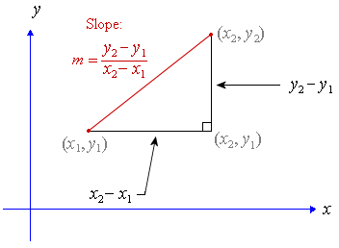
However, the gradient is not the same at all points on a curve.
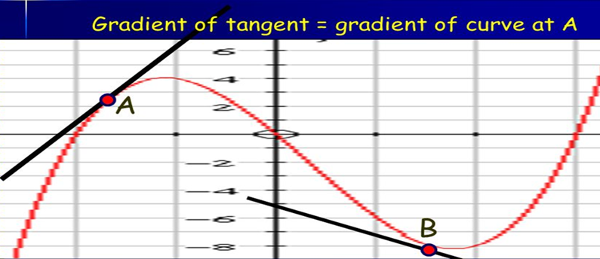
Notice that at point A the gradient is positive and at at point B the gradient is negative.
In general terms, we define the gardient of a curve at a given point, say P(x ; y), to be the gradient of the tangent line to the curve at the point P.
Consider the following example. Suppose we are asked to find the gradient of the curve,
y = x² at the point P(3; 9), we need the gardient of the tangent line to the curve at point P.
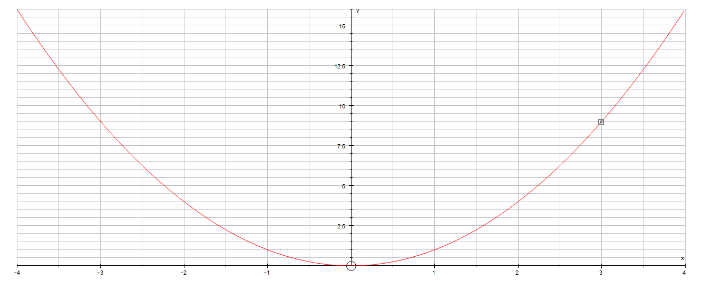
P ( 3 ; 9)
It is obvious that drawing a tangent line by eye is not a very accurate method for finding the gradient of a curve. We therefore need an algebraic method for finding the gradient of any curve.

A
B
C
$$δy$$
$$δx$$
For the curve shown alongside, let the points A and B have
co-ordinates (x₁ ; y₁) and (x₂ ; y₂) respectively. In functional
notation, y₁ = f(x₁) and y₂ = f(x₂), i.e. A (x₁ ; y₁)
B (x₂ ; y₂) and C( x₂ ; y₁)
The gradient of chord AB = $\frac{BC}{AC}$ = $\frac{f\left(x_{2} \right)-f(x_{1 })}{(x_{2} – x_{1})}$ = $\frac{δy}{δx}$
As, $δx$ tends to zero (i.e. $δx →0)$, $\frac{ δy}{δx}$approaches the value of the
gradient of the tangent line at A. This value is called the limiting value of $\frac{δy}{δx}$ and is written as $\lim_{δx→0}{\frac{δy}{δx}}$. The figure below illustrates this phenomenon.
As the points, B,B₁,B₂,…B_{n} approaches point A, $δx$ tends to zero, until B_{n} coincides with point A. The limiting value of $\frac{δy}{δx}$ is called the differential coefficient or the first derivative of y with respect to x and is denoted by $\frac{dy}{dx}$. This process of finding this limiting value is called differentiation. NB: It is important to understand that $\frac{dy}{dx}$ does not mean dy divided by dx. It means the derivative of y wrt x. The $\frac{d}{dx}$ is an operator, operating on the function y. To see this more clearly, we can write $\frac{dy}{dx}$ as $\frac{d(y)}{dx}$.
A
B₁1
B₃
Tangent to the curve at A
B

B₂

Consider the function f(x) = x²
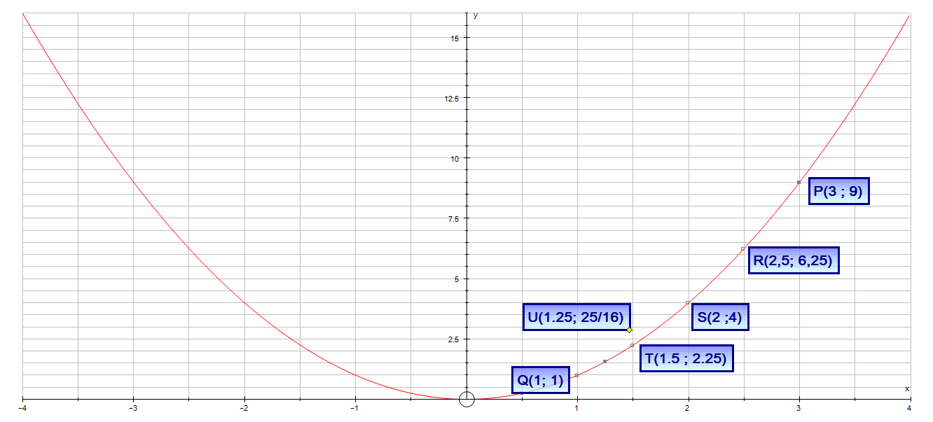
In the above figure, the gradient of chord PQ = $\frac{9-1}{3-1}$ = $\frac{8}{4}$ = 2
The gradient of chord RQ = $\frac{6,25-1}{2,5-1}$ = 3,5
The gradient of SQ = $\frac{4-1}{2-1}$ = $\frac{3}{1}$ = 3
The gradient of TQ = $\frac{2,25-1}{1,5-1}$ = 2,5
The gradient of UQ = $\frac{\frac{25}{16 }-1}{\frac{5}{4}-1}$ = 2.25
From the above we notice that as the chord PQ comes closer and closer to the point Q(1;1), the value of its gradient comes closer to 2. We call, 2 the limiting value of the gradient of the chord PQ and when P coincides with Q, the chord becomes the tangent to the curve.

Activity 3
- Plot and sketch the curve f(x) = 4x² –1 for values of x from [–1; 4].
- Label the co-ordinates (3; f(3)) and (1; f(1)) as M and N respectively.
- Join the points M and N to form the chord MN.
- Determine the gradient of chord MN.
- Move point M closer and closer to N to determine the gradient of the tangent of the curve at N. Use the following x -values to assist you
  - T(2,5 ; f(2,5))
  - R(2 ; f(2))
  - S(1,5 ; f(1,5))
  - J (1,25 ; f(1,25))
  - K (1, 01 ; f(1,01))

Intuitive definition of a limit
- Let f be a function which is defined for all of x “near” x = a. If, as x tends to a from both the left and from the right, f(x) tends to a number, say b, then we say that the limit of f(x), as x tends to a is b.
- We write: $\lim_{x→a}{f(x)}$ = b OR f(x) $→$ b as x $→$ a
- We say nothing about f(a). Perhaps f(a) exists and perhaps it doesn’t. And if it does, perhaps $\lim_{x→a}{f(x)}$ = f(a) and perhaps not!
- When dealing with limits we only care about where we are going, not whether we get there!

Worked Examples:
1. | Find: $\lim_{x→3}{(x+1)(3x–2)}$ | $\lim_{x→3}{(x+1)(3x–2)}$  = $\lim_{x→3}\left({3x}^{2}+x –2\right)$ ….Simplify  = 26
2. | Find: $\lim_{x→3}{\frac{x^{2}–4}{x –2}}$ | $\lim_{x→3}{\frac{x^{2}–4}{x –2}}$  = $\lim_{x→3}{\frac{(x-2)(x+2)}{(x-2)}}$ ----------Factorise numerator  = $\lim_{x→3}{(x+2)}$  = 5
3. | Find: $\lim_{x→–1}{\frac{x^{3}+1}{x^{2}-1}}$ | $\lim_{x→–1}{\frac{x^{3}+1}{x^{2}-1}}$  = $\lim_{x→–1}{\frac{(x+1)(x^{2}-x + 1)}{(x –1)(x+1)}}$  = $\lim_{x→–1}{\frac{x^{2 }–x+1}{x –1 }}$  = $\frac{({-1)}^{2}–\left(–1\right)+1}{\left(–1\right)–1}$  = $\frac{-3}{2}$

Activity 4
In each of the following, determine the limits, if it exists.
- $\lim_{x→4}{12}$ |  | - $\lim_{x→5}{0}$ | - $\lim_{x→7}{k}$ , where k is a constant
- $\lim_{x→2}{(2x+3)}$ |  | - $\lim_{x→1}{(x^{2}–2x)}$ | - $\lim_{x→2}{\frac{( x+3)}{( x –4)}}$
- $\lim_{x→–1}{\frac{(x+1)}{(x –1)}}$ |  | - $\lim_{x→0}{\frac{(x^{2}+x –2)}{(x^{3}+8)}}$ | - $\lim_{x→0}{\frac{x^{3}}{ x^{2}}}$
- $\lim_{h→0}{\frac{(\sqrt{x+h} - \sqrt{x })}{h}}$ ; where x > 0

Differentiation from first principles
In the diagram alongside, A and B are two points arbitrary points a curve defined by y = f(x) ; $δx \left(delta x\right) and δy (delta y)$ represent small increments in the x and y directions respectively.
Gradient of chord AB = $\frac{δy}{δx}$
But $δy$ = f(x + $h$) – f(x)
Hence, $\frac{δy}{δx}$ = $\frac{f\left(x+h\right)–f(x)}{h}$
As $δ$x $→0$, $\frac{δy}{δx}$ approaches a limiting value and the gradient of the chord approaches the gradient of the tangent at A.When determining the gradient of a tangent to a curve there two notations used. The gradient of the curve at a in the diagram alongside can be written as: $\lim_{δx→0}{\frac{δy}{δx}}$ OR $\lim_{h→0}{\frac{f\left(x+h\right)-f(x)}{h}}$
In Leibnitz notation: $\frac{dy}{dx}$ = $\lim_{δx→0}{\frac{δy}{δx}}$
In functional notation:
$f^{'}\left(x\right)$ = $\lim_{h→0}{\frac{f\left(x+h\right)-f(x)}{h}}$

NB : $δx$ = h = x_{B} – x_{A}
$δy$ = y_{B} – y_{C} = y_{B} – y_{A}
y
x
B(x + $δx$ ; y +$δy$)
$$δx$$
C (x_{B} ; y_{A})
$$δy$$
A (x; y)

$\frac{dy}{dx}$ is the same as $f^{'}\left(x\right)$ and is called the differential coefficient or the derivative. The process of finding the differential coefficient is called differentiation.
To summarise: The differential coefficient
$\frac{dy}{dx}$ = $f^{'}\left(x\right)$ = $\lim_{δx→0}{\frac{δy}{δx}}$
= $\lim_{h→0}{\frac{f\left(x+h\right)-f(x)}{h}}$

Worked examples:
1. | Determine the derivative of f(x) = 2x , from first principles  Solution:  Begin by determining the value of: f(x + h) = 2(x + h) = 2x + 2h  $f^{'}\left(x\right)$ = $\lim_{h→0}{\frac{f\left(x+h\right)-f(x)}{h}}$  = $\lim_{h→0}{\frac{\left(2x+2h\right)–2x}{h}}$  = $\lim_{h→0}{\frac{2x+2h –2x}{h}}$  = $\lim_{h→0}{\frac{2h}{h}}$  $∴$ $f^{'}$ (x) = 2
2. | Differentiate, y = 3x + 6, from first principles.  Solution:  Let f(x) = 3x + 6  Then; f(x + h) = 3(x + h) + 6  = 3x + 3h + 6  $f^{'}\left(x\right)$ = $\lim_{h→0}{\frac{f\left(x+h\right)-f(x)}{h}}$  = $\lim_{h→0}{\frac{\left(3x+3h+6\right)–(3x+6)}{h}}$  = $\lim_{h→0}{\frac{3x+3h+6 –3x–6}{h}}$  = $\lim_{h→0}{\frac{3h}{h}}$  $∴$ $f^{'}$ (x) = 3
3. | Use first principles, to determine the derivative of the function defined by  g(x) = –5.  Solution:  g(x) = –5 is a horizontal line with gradient 0;  i.e. g(x) = –5x⁰  Then: g(x + h) = –5(x +h)⁰ = – 5  $f^{'}\left(x\right)$ = $\lim_{h→0}{\frac{f\left(x+h\right)-f(x)}{h}}$  = $\lim_{h→0}{\frac{\left(–5\right)–(–5)}{h}}$  = $\lim_{h→0}{\frac{–5+5}{h}}$  = $\lim_{h→0}{\frac{0}{h}}$  $∴$ $f^{'}$ (x) = 0

Activity 5
Differentiate the following functions from first principles.
a) | f(x) = x | b) | f(x) = 3x
c) | f(x) = x + 2 | d) | f(x) = 4
e) | f(x) = 3 – 6x | f) | f(x) = a + 2px
g)** | f(x) = 3x² | h)** | f(x) = x² + 4

Differentiation rules
To calculate the derivative of, say f(x) = x^{google}, from first principles this may be a daunting task to the ordinary human being. To assist in accomplishing this and other similar tasks, rules for differentiation have been developed and accepted.
Suppose that y = x^{n} , where n is a real number
Then: $\frac{dy}{dx}$ = nx^{n–1}

8.1 Notation
The following are the commonly used symbols depicting differentiation of a function.
- Symbols instructing differentiation are : $\frac{d}{d}$ or D;
- Symbols indicating differentiation to the variable x are: $\frac{d}{dx}$ or D_{x} ;
- Differentiation with respect to the variable y are indicated by: $\frac{d}{dy}$ or D_{y} ;
- Differentiation of f(x) with respect to x are indicated by:
  - $\frac{d}{dx}$f(x) or $\frac{df(x)}{dx}$ or D_{x}[f(x)] or $f^{'}$(x)
- Differentiation of y with respect to x are indicated by:
  - $\frac{d}{dx}$y or $\frac{dy}{dx}$ or D_{x}[y] or $y^{'}$

8.2 Rules for differentiation
The following are the commonly used rules for differentiation.
1. | If y = x^{n} ; where n is a real number; then :  $\frac{dy}{dx}$ = nx^{n–1}
2. | $\frac{d}{dx}$[f(x) $±$ g(x)] = $\frac{d}{dx}$ f(x) $±$ $\frac{d}{dx}$ g(x)
3. | $\frac{d}{dx}k.f(x)$ = $k.\frac{d}{dx}f(x)$ ; where k is a constant.
4. | $\frac{d}{dx}k$ = 0 ; where k is a constant.

Worked examples
1. | Use the rules of differentiation to calculate the derivatives of the following functions with respect to x.
a) | y = x³  Use rule 1: n = 3 ; n–1 = 2  $\frac{dy}{dx}$ = 3x³⁻¹ = 3x² | b) | f(x) = x ^{½}  Use rule 1: n = ½ ; n –1 = –1/2  $\frac{dy}{dx}$ = $\frac{1}{2}x^{\frac{-1}{2}}$
c) | y = 3x² – 6  $\frac{dy}{dx}$ = 6x | d) | y = 3 – 2x – $\frac{4}{x^{2}}$  y = 3 – 2x – 4x⁻²  $\frac{dy}{dx}$ = 0 –2 – 4(–2x^{–3})  = 0 – 2 + 8x^{–3}  $\frac{dy}{dx}$ = – 2 + $\frac{8}{x^{3}}$
2. | Use the rules of differentiation to differentiate the following function with respect to m; i.e: y = mx³ + m²x – m³x + $\sqrt{x}$  Solution: D_{m} = x³ + 2mx – 3m²x
3. | Calculate $f^{'}$(t), using the rules of differentiation, if f(t) = $\frac{3}{\sqrt{t}}$  Solution: f(t) = $\frac{3}{\sqrt{t}}$  = 3$t^{\frac{-1}{2}}$  $f^{'}$(t) = 3($\frac{–1}{2}$. $t^{\frac{-3}{2}}$ )  $∴$ $f^{'}$(t) = $\frac{-3}{2t^{\frac{3}{2}}}$

Activity 6
1. | Calculate$\frac{dy}{dx}$, in the following using the rules of differentiation.
a) | y = x⁶ | b) | y = 99
c) | y = 4x³ + 2x² – 4x + 3 | d) | y = $\frac{x}{\sqrt{x}}$
2. | Differentiate, the following with respect to x, using the rules of differentiation.
a) | 3x –6 | b) | x(x–2)
c) | $\frac{x^{3}}{2}$ | d) | $\frac{πx^{2}}{4}$
3. | Calculate the derivative (differential coefficient) of the following, using the rules of differentiation.
a) | $\frac{x^{3}}{3}$ + $\frac{x^{2}}{2}$ – x + 4 | b) | $\frac{3}{x^{3}}$ + $\frac{2}{x^{2}}$ – $\frac{1}{x}$ + 0,25
4. | Calculate, $f^{'}$ (x) in the following, using the rules of differentiation.
a) | f(x) = 2 – 4x + 6x² | b) | f(x) = $\frac{x^{6}–x}{x}$
5. | Calculate, $f^{'}$(t) in the following, using the rules of differentiation.
a) | f(t) = 6t⁴ – 4t + 2 | b) | f(t) = 2tx – 3t²x² + 4t³x
6. | Calculate $\frac{d}{dx}(y)$ of the following using, the rules of differentiation.
a) | y = sin 30º + $π$ – $πx$ | b) | y = (x – 2)²
c) | y = ax² + bx + c | d) | y = x(x² – 4)
e) | y = $\sqrt{x}$(x² – x) | f) | y = $\frac{x^{2}-4}{x-2}$
7. | Calculate, using the rules of differentiation, D_{x}(y) of the following:
a) | y = $\frac{4πx^{3}}{3}$ | b) | y = $4πx^{2}$
c) | y = $πx^{2}$ + 2$πx$ | d) | y = cos k – sin2$π$ + kx – $2πx^{3}$

8.3 Equations of tangents to graphs of functions
The derivative also results in the gradient of a tangent to a function. For example, if we differentiate the equation of a curve, we will get the formula for the gradient of the curve at a point, and thus the gradient of a tangent to the curve at that point. We can then proceed to calculate the equation of a tangent to the curve at that point.

Worked examples
1. | Given: y = x² + 1.
a) | Determine the value of y when x = 1 | At x = 1:  y = (1)² + 1 = 2  The point is (1; 2)
b) | Determine $\frac{dy}{dx}$ using the rules of differentiation. | y = x² + 1  $\frac{dy}{dx}$ = 2x ……using rules
c) | Calculate the gradient of y = x² + 1 at x = 1 | The value of the gradient at x = 1 is given by:  m = 2(1) = 2
d) | Hence, determine the equation of the tangent to the curve at x = 1 | The required equation is given by:  y – y₁ = m(x – x₁)  y – 2 = 2(x – 1)  y – 2 = 2x – 2  y = 2x
2. | Determine the equation of the tangent to y = 3x² – 4x– 6 at (1 ; – 7)  Solution:  Step 1: Determine $\frac{dy}{dx}$ ; i.e: $\frac{dy}{dx}$ = 6x – 4  Step 2: Determine the value of the derivative at x = 1; i.e:  m = 6(1) – 4  m = 2  Step 3: Determine the equation of the tangent, using the gradient at the specified point and the given point.  y – y₁ = m(x – x₁)  y – (–7) = 2(x – 1)  y + 7 = 2x – 2  y = 2x – 9
3. | Calculate the point on y = 3x² – 4x – 6 where the gradient is 2.  Solution:  Step 1: Determine $\frac{dy}{dx}$ ; i.e: $\frac{dy}{dx}$ = 6x – 4  Step 2: You are given the value of m = 2  i.e. 6x – 4 = 2  6x = 6  x = 1  Step 3: Use the x –value obtained in Step 2 above to obtain the corresponding y-value;  i.e: y = 3(1)² – 4(1) – 6  y = – 7  Step 4: Write down the coordinates ; i.e (1; – 7)

Activity 7
1. | Determine, the gradient of the curve at the given value of x
 | Function |  | Value of x
a) | f(x) = x² – 2x |  | x = 3
b) | g(x) = x³ – 2x² + x – 1 |  | x = 2
c) | xy = 3 |  | x = 1
d) | y = (3x –1)² |  | x = 0
e) | y = $\frac{x^{3}–1}{x –1}$ |  | x = 2
f) | y = $\frac{x^{2}+3x+2}{x+1}$ |  | x = 1
2. | Determine the equation of the tangents to the curve at the given value of x
a) | y = x³ – 2x² + 4 , at x = 2 | b) | xy = 4 at x = – 2
c) | y = x² – 2x – 8, at x = 1 | d) | y = x³ at x = 1
e) | y = – 3x² + 2x + 1 , at x = – 1 | f)** | y = $\frac{4+x}{x}$ at x = 2
3. | Determine the coordinates of the point P at which the gradient of the curve y = x² is 6.
4. | Determine the equation of the tangent to the curve y = 3x – x² which is parallel to the line y – x – 4 = 0.
5** | Q(x ; y) is any point on the curve defined by y = x² – 5x.
a) | Determine the equation of the tangent at Q which is parallel to the straight- line  y = 2x + 1
b) | Draw a sketch to illustrate the given information
c) | Calculate the co-ordinates of the point Q.
d) | Hence, determine the equation of the straight-line PQR
Summary (How to find the equation of a tangent touching a curve at a point where x = k)
- Determine $f^{' }(x)$. This gives you the gradient function.
- Next calculate $f^{' }(k)$. This gives you the actual gradient at that point, x = k.
- Find f(k), the y-coordinate of the “touching point”.
- Let the equation of the tangent be y = mx +c. Substitute m (the gradient); k (the x-value) and f(k) (for the y-value) to calculate c.
- Write down the equation of the tangent.

8.4 Sketching of cubic polynomial functions
A
The point A is a local maximum

y

x

The point B is a local minimum
B

We cannot really say the cubic function has a certain maximum or minimum value, since the function values increase from $-∞ to+∞$, or decrease from $+∞ to–∞$. We can only talk about local maximum or minimum points, which are obtained at the stationary points.
Note the importance of calculating $f^{'}$(x) when sketching third degree functions. At the turning point(s) (stationary point), the gradient function $[f^{'}$(x)] is equal to zero. We can therefore determine the x-value(s) of the turning point(s) (if any) of a cubic function, by solving $f^{'}$(x) = 0.
In cubic functions, $f^{'}$(x) will always be a quadratic function. We can use our theory of quadratics (i.e. nature of roots) to tell us more about the turning points. The discriminant (or delta) of the derivative of the cubic function will determine whether the function has:
- Two stationary points ($∆ of f^{'}\left(x\right) will be >0)$
- One point of inflection ($∆ of f^{'}\left(x\right) will be=0)$
- No stationary points ($∆ of f^{'}\left(x\right) will be<0)$
Suppose we are asked to sketch the graph defined by: y = ax³ + bx² + cx + d. We will proceed as follows:
Step 1: Determine the shape – if the coefficient of a > 0
– if the coefficient of a < 0
Step 2: Determine the intercepts
Y-intercepts: Let x = 0, calculate f(0), so y-intercept is (0 ; d)
X -intercepts: let f(x) = 0. Factorise f(x) by: grouping of terms OR using the factor theorem OR synthetic division
Step 3: Stationary points
- Determine $f^{'}$(x).
- Let $f^{'}$(x). = 0 and solve for x. The solutions are the x-coordinates of the stationary points, say x = p or x = t
- Now find f(p) and f(t). These give you the y-coordinates of the stationary point.
Step 4: Sketch the graph by:
- Plotting the intercepts (x and y-intercepts)
- Stationary points
- Join them to form the graph

Worked example:
Use the method outlined above, to sketch the graph of y = f(x) = –x³ + 3x + 2.
Solution:
- Shape - a < 0
- Intercepts:
  - Y-intercept. Let x = 0, y = 2 ; (0; 2)
  - X-intercepts: Let y= 0 : Then 0 = –x³ + 3x + 2.
f(–1) = –1(–1)³ + 3(–1) + 2 = 0.
Thus, (x + 1) is a factor of –x³ + 3x + 2.
Find the other factors by inspection or division.
f(x) = –x³ + 3x + 2
      - = (x +1)(–x² + x + 2)
0 = –(x + 1)(x² – x – 2)
0 = –(x +1)(x –2)(x + 1)
So, x-intercepts are given by: (–1 ; 0) ; (–1 ; 0) and (2 ; 0)
3.Stationary points:
f(x) = –x³ + 3x + 2.
Find corresponding y -values.
f(–1) = 0 ; (–1 ; 0)
f(1) = –(1)³ + 3(1) + 2 = 4
(1 ; 4)
$f^{'}$(x) = –3x² + 3
$Let$ $f^{'}$(x) = 0
–3x² + 3 = 0
–3(x² –1) = 0
(x – 1)(x + 1) = 0
x = 1 OR x = – 1

- Sketch
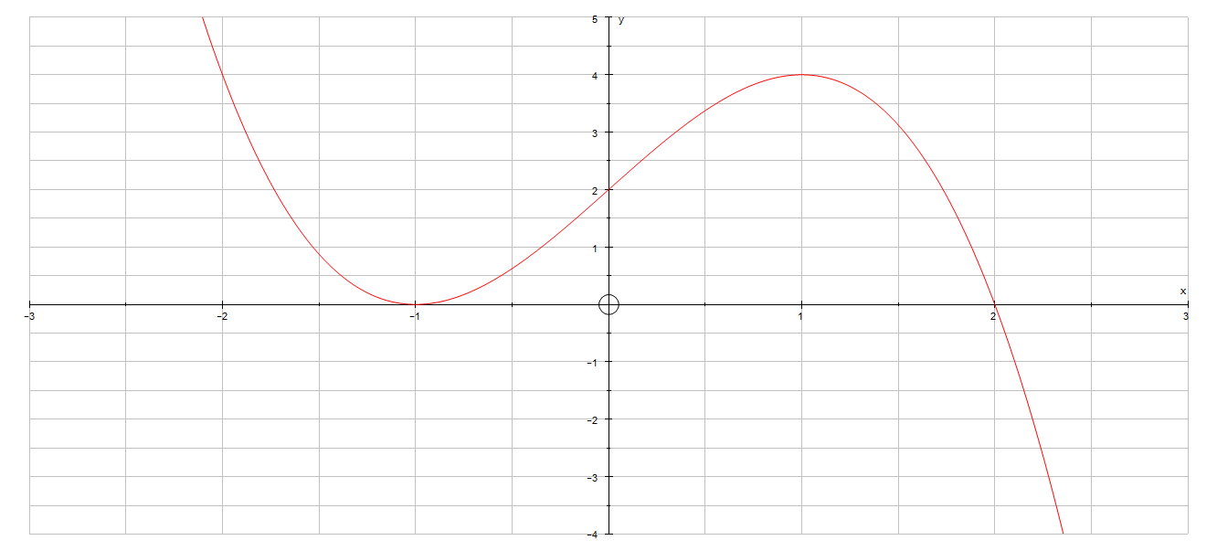
y = –x³ +3x + 2

Activity 8
1. | Use the method outlined above to sketch the graphs of the following cubic functions. Show all critical values clearly on your sketch.
a) | y = x³ + 3x² – 9x –27 | b) | y = (x–1)(6 – x)(x + 2)
c) | y = x³ | d) | y = (x – 1)³ + 8
e) | y = (x + 1)³ – 8 | f) | y = x³ – 8
g) | y = –4x³ + 13x² + 5x –14 | h) | y = 4x³ + 5x² – 12x + 3
i) | f(x) = x³ + x² – 6x | j) | v = 6a –a² – a³
k) | m(x) = 3x² – 5x –12 | l) | g(x) = x³ + 2x² – 8x
2. | Use the given information to sketch a possible graph of one function
a) | - Zeros at 4 and 6  - Stationary point at x = 5  - Increasing on the interval (– $∞$ ; 5)  - Decreasing on the interval (5 ; $∞$)  - f(0) = – 4
b) | - Zeros at –5  - Stationary points at x = – 4 and x = 0.  - f(-4) = 8 and f(0) = 1  - Increasing on the interval (–5 ; –4) and (1 ; $∞$)  - Decreasing on the interval (–4 ; 0)
c)** | - $f^{'}$(x) > 0 for x < – 2  - $f^{'}$(x) = 0 at x = – 2  - $f^{'}$(x) < 0 for –2 < x < 2  - $f^{'}$(x) = 0 at x = 2  - $f^{'}$(x) > 0 for x > 2  - Zeros exist at –4 ; 0 and 4  - f(– 2) = 3 and f(2) = –1

8.5 Application of theory of maxima and minima
The following formulae will assist you when dealing with optimisation problems involving mensuration
$θ$

Shape | Perimeter | Area
a  c  b  Triangle | P = a + b + c  S= $\frac{a+b+c}{2}$ | Area = $\frac{1}{2}$ $×$ base $×$ Perp. Height  Area = $\frac{1}{2}$acsin $θ$  Area = $\sqrt{s(s-a)(s-b)(s–c)}$
Square | P = 4s | Area = s²
Rectangle | P = 2l + 2b | Area = lb
Parallelogram | P = 2l + 2b | Area = base $×$ perp. Height
Trapezium | P = sum of four sides | Area = $\frac{1}{2}×$(sum of // sides)$×$ h
Circle | C = $2π$r = $π$D | Area = ${πr}^{2}$

Object | Volume | Surface area
Rectangular solid | V = lbh | TSA = 2lb + 2lh + 2bh ( for a closed box)
Cube | V = s³ | TSA = 6s²
Sphere | V = $\frac{4}{3}$ $πr^{3}$ | Surface Area = ${4πr}^{2}$
Right circular cylinder | V = ${πr}^{2}$h | Area of curved surface = $2πrh$  TSA = ${2πr}^{2}+2πrh$

Worked example:
Find the dimension of a 700 kl cylindrical oil storage tank, that can be made with the least cost of sheet metal, assuming there is no wasted sheet metal.
Solution:
This questions wants us to minimise the surface area of a right circular cylindrical tank with volume = 700 kl.
TSA = ${2πr}^{2}+2πrh$ and V = 700 kl = 700 m³
V = ${πr}^{2}$h = 700
Make h the subject of the formula above: h = $\frac{700}{{πr}^{2}}$ ----------------(1)
Substitute (1) in TSA = ${2πr}^{2}+2πrh$
i.e: A = ${2πr}^{2}+2πr(\frac{700}{{πr}^{2}}$ )
A = ${2πr}^{2}$ + $1400r^{–1}$
$\frac{dA}{dr}$ = ${4πr}^{1}$ – $1400r^{–2}$
Let $\frac{dA}{dr}$ = 0: ${4πr}^{1}$ – $1400r^{–2}$ = 0
$\frac{4πr^{3 }–1400}{r^{2}}$ = 0
${4πr}^{3}$ = 1400
$r^{3}$ = $\frac{1400}{4π}$
r = $\sqrt[3]{\frac{1400}{4π}}$ = 4,81m
Then, h = $\frac{700}{π{(4,81)}^{2}}$ = 9,62m

Activity 9
1. | A rectangular piece of land is enclosed by 1600m of fencing. Determine the maximum possible area of the piece of land.
2. | A prism has dimensions (3–x) ; ( x + 3) and ( x + 3).
a) | Set up an expression for the volume of the prism.
b) | Determine the dimensions of the prism so that it will have a maximum volume.
c) | Hence, calculate this maximum volume.
3. | A rectangle has the following dimensions: Length = 2x and breadth = 100 – x.
a) | Determine the dimensions of the rectangle so that it has a maximum area.
b) | Calculate this maximum area.
4. | A rectangular box has the following dimensions:  Height = x units; Length = (12 – x) units ; and Breadth = 2x units
a) | Set up an expression to calculate the volume of the box.
b) | Calculate the dimensions of the box so that it will have a maximum volume.
c) | Hence, calculate this maximum volume.
5. | A right circular cylinder has the following dimensions:  Height = (120 – x) units  Radius = 2x units.
a) | Set up an expression to calculate the volume of this cylinder.
b) | Calculate the radius of this cylinder which will yield a maximum volume.
c) | Hence, calculate this volume (leave $π$ in your answer)
6. | The volume of a cylindrical container is 64 m³. Determine the radius r and height h in terms of $π$, if the external area has a minimum value when:
a) | the cylinder has no lid ; and
b) | the cylinder has a lid.
7. | A rectangular piece of cardboard has dimensions 80 mm by 30 mm. Equal squares of x mm in length are cut out at each corner. The cardboard is then folded to form an open box.
a) | Show that the volume of the box is given by: V = x(80 – 2x)(30 – 2x)mm³
b) | Hence, calculate the maximum volume of the box.
8. | A closed rectangular box, with a rectangular base has the following dimensions.  Length = 2x cm; and width of x cm. The total surface area is 243 cm².
a) | Determine the height in terms of x
b) | If height = ( $\frac{81}{2x}$ – $\frac{2x}{3}$) cm; determine:  - the volume in terms of x;  - the dimensions of the box if the volume is to be a maximum;  - the maximum volume of the box
9. | A hollow cylinder with radius r cm, is closed at one end, must have a total exterior surface area of 462 cm².
a) | Show that the height of the cylinder is given by: height = $\frac{462-πr^{2}}{2πr}$ cm
b) | Determine the volume in terms of $π$ and r.
c) | Hence, calculate the value of r which will yield a maximum volume. (Use $π$ = $\frac{22}{7}$)
10. | The dimensions of a right circular cylinder are limited in such a way that the sum of the circumference of its base ($2πr$) and its height is equal to 15 metres. If r is the radius of its base and ${πr}^{2}h$ is its volume, calculate:
a) | the volume in terms of r and $π$
b) | r in terms of $π$ if the volume is a maximum
c) | the maximum volume if $π$ = 3,142

8.6 Calculus of motion
We usually deal with the rate of change with respect to time.
Distance: s = f(t); where s is the distance covered and t represents the time taken (t > 0)
[Distance is a function of time]
Speed (velocity) : v = $\frac{ds}{dt}$ which represents $\frac{change in distance}{change in time}$ OR $f^{'}$(t)
Acceleration : a = $\frac{dv}{dt}$ [ a = $\frac{d^{2}s}{{dt}^{2}}$ OR $f^{''}$(t) ]
NB: a is obtained from the second derivative of f(t)

Worked example
A body moves along a straight line according to the law: s(t) = 0,5t³ – 2t, where s is measured in metres and t -time is measured in seconds.
Calculate:
- the speed after two seconds | v = $\frac{ds}{dt}$ = 1,5t² – t  s’(t) =1,5t² – t  s’(2) = 1,5 (2)² – 2  = 4ms⁻¹
- the acceleration after two seconds | a = $\frac{dv}{dt}$  = 2(1,5)t  = 3t  After two seconds, a = 3(2) = 6 ms⁻²

Activity 10
1. | The following equations of motion of objects are given. Determine the distance travelled (s) of the object; the velocity (v) and the acceleration (a) at the indicated time.
a) | s(t) = 4t² – 6t , if t = 2seconds | b) | s(t) = 32t – 8t² if t = 2 seconds
c) | s(t) = 100 – 4t – 8t² if t = 3 seconds | d) | s(t) = 6t² – 2t³ if t = 1 second
2. | A rocket is fired vertically into the sky. After t seconds, the rocket reaches a height of f(t) metres, where f(t) = 100t – 5t²
a) | After how many seconds will the rocket reach a height of 320 metres?
b) | Determine the speed of the rocket after 2 seconds.
ci | After how many seconds will the rocket reach its maximum height?
cii | What is the maximum height?
d) | Determine the acceleration of the rocket.
e) | After how many seconds will the rocket reach the ground?
3. | A ball is dropped from a building. In t seconds, it falls f(t) metres, where f(t) = 3t².
a) | What is the speed after 2 seconds?
b) | If the ball is on the ground for 5 seconds, how high is the building?
c) | What is the speed of the ball when it reaches the ground?
4. | A stone is thrown vertically upwards off the roof of a building. Its displacement after t seconds is given by s(t) = 5t – 5t².
a) | Find the: i) velocity and ii) acceleration at any time (t)
b) | What was the stone’s initial velocity?
c) | What is the maximum height above the building reached by the stone?
d) | i) How long does the stone take to return to the top of the building; and
 | ii) How fast is the stone falling?
5. | A man drives a car for 10 minutes. The car travels according to the law:  s(t) = 250t² –1,25t⁴, where t is time in minutes and s distance travelled in metres.
a) | How far did the man travel in the car?
b) | What is its maximum speed?
6.** | The volume of a metal cube with each side x cm is given by V = x³
a) | Find the instantaneous rate of change of V
b) | Find the rate of change of the volume if the length of one side is 5 cm.
c) | Find the total surface area (A) of the metal cube.
d) | Find the instantaneous rate of change of the surface area
e) | Find the rate of change of the surface area if the length of one side is 5 cm

INTEGRATION
Outcomes for this section:
By the end of this section, you should be able to:
- Understand the concept of integration as a summation function (definite integral) and as converse of differentiation (indefinite integral).
- Apply standard forms of integrals as a converse of differentiation.
- Integrate the following functions:
  - kx^{n}, with n $∈$ $R$; with $n ≠ –1$
  - $\frac{k}{x}$ and ka^{nx} with a > 0 ; k , a $∈$ $R$
- Integrate polynomials consisting of terms of the above forms.
- Apply integration to determine the magnitude of an area included by a curve and the x-axis or by a curve, the x-axis and the ordinates x = a and x = b where a , b $∈$ $Z$.

Introduction
The process of integration reverses the process of differentiation. In differentiation, if f(x) = 2x², then $f^{'}$(x) = 4x. Thus the integral of 4x is 2x². We can represent this process pictorially as follows:

The situation gets a bit more complicated, because there are an infinite number of functions we can differentiate to give 4x. Here are some of those functions:
f(x) = 2x² + 7 ; g(x) = 2x² – 8 ; h(x) = 2x² + $\frac{1}{2}$.

Activity 1
Write down at least five other functions whose derivative is 4x.

You would have noticed that all the functions have the same derivative of 4x, because when we differentiate the constant term we obtain zero. Hence, when we reverse the process, we have no idea what the original constant term might have been. So we include in our response an unknown constant, c, called the arbitrary constant of integration. The integral of 4x then is 2x² + c.
In differentiation, the differential coefficient $\frac{dy}{dx}$ indicates that a function of x is being differentiated with respect to x, the dx indicating that it is “with respect to x”. In integration, the variable of integration is shown by adding d(the variable) after the function to be integrated. When we want to integrate a function, we use a special notation: $\int{f\left(x\right)dx}$. Thus, to integrate 4x, we will write it as follows:

There must always be a term of the form dx

$\int{ 4x dx}$ = 2x² + c , c $∈$ $R$.
Integral sign
Constant of integration
This term is called the integrand

Note that along with the integral sign, there is a term of the form dx, which must always be written, and which indicates the variable involved, in our example x. We say that 4x is integrated with respect x. The function being integrated is called the integrand. Technically, integrals of this type are called indefinite integrals, to distinguish them from definite integrals, which we will deal with later. When you are required to evaluate an indefinite integral, your answer must always include a constant of integration.
Formally, we define the anti-derivative as: If f(x) is a continuous function and F(x) is the function whose derivative is f(x), i.e.: $F^{'}$(x) = f(x) , then:
$\int{f\left(x\right)dx}$ = F(x) + c; where c is any arbitrary constant.

Activity 2
- In each of the following determine the function f(x), if the derivative $F^{'}$(x) is given:
No. | $F^{'}$(x) | f(x)
1. | 4x
2. | x⁴
3. | 2x²
4. | 0
5. | $$x^{\frac{3}{2}}$$
6. | -2x³
7. | $$\frac{1}{5}x^{10}$$
- Explain how the derivative $F^{'}$(x) and the function f(x)are related to each other

- Complete the following diagram:

The general solution of integrals of the form kx^{n}

From Activity 2 above, the general solution of integrals of the form $\int{kx^{n}}$dx , where k and n are constants is given by:

$\int{kx^{n}}$dx = $\frac{kx^{n+1}}{n+1}$ + c ; where $n≠ -1$ and c $∈$ $R$
The following table provides you with a ready list of integrals to use.
Function, f (x) | Indefinite integral $\int{f(x)dx}$
f (x)= k , where k is a constant | $\int{kdx}$ = kx + c ; where c $∈$ $R$
f (x)= x | $\int{xdx}$ = $\frac{1}{2}$ $x^{2}$ + c; where c $∈$ $R$
f (x) = x² | $\int{x^{2}dx}$ = $\frac{1}{3}x^{3}$+ c; where c $∈$ $R$
f(x) = ax^{n} | $\int{{ax}^{n}dx}$ = $\frac{{ax}^{n+1}}{n+1}$ + c; where c $∈$ $R$
f (x) = $x^{-1}$ = $\frac{1}{x}$ | $\int{\frac{1}{x}}$dx = ln$\left|x\right|$ + c; where c $∈$ $R$
f (x) = ka^{nx} | $\int{{ka}^{nx}}$dx = $\frac{{ka}^{nx}}{n.lna}$ + c ; where c $∈$ $R$ ; a > 0 and a $≠$ 1

Worked Examples
1. | Use the above table to determine the following indefinite integrals
a) | $\int{x^{7}}$ dx  = $\frac{x^{7+1}}{7+1}$ + c ; where c$∈$ $R$  = $\frac{x^{8}}{8}$ ; where c$∈$ $R$ | Compare $\int{x^{7}}$ dx with $\int{ax^{n}dx}$ = $\frac{{ax}^{n+1}}{n+1}$ + c,  Then: a = 1; n = 7 ; n + 1 = 8
b) | $\int{3t^{4}}$ dt  = 3$\left(\frac{t^{4+1}}{4+1}\right)$+ c; where c$∈$ $R$  = $\frac{{3t}^{5}}{5}$ + c ; where c$∈$ $R$ | Note: In this example, we are integrating with respect to t.  Compare $\int{3t^{4}}$dt with : $\int{at^{n}dt}$ = $\frac{{at}^{n+1}}{n+1}$ + c  Then: a = 3 ; n = 4 ; n + 1 = 5
c) | $\int{\frac{2}{u^{2}}}$du  = $\int{2u^{-2}}$du  = 2 $\int{u^{-2}}$du  = 2 ($\frac{u^{-2+1}}{-2+1}$) + c ; where c$∈$ $R$  = $\frac{-2}{u}$ + c ; where c$∈$ $R$ | Note: in this example, we are integrating with respect to u.  Explain the method used
d) | $\int{\sqrt{x}}$ dx  = $\int{x^{\frac{1}{2}}}$ dx  =  = $\frac{2}{3}$ | Complete
e) | Evaluate the following indefinite integral:  $\int{a^{2x}}$dx | Let I = $\int{a^{2x}}$dx  Let 2x = u  2dx = du  = $\frac{1}{2}$ $\int{a^{2x} (2dx)}$  = $\frac{1}{2}\frac{a^{2x}}{\ln{a}}$ + c ; c $∈ R$

Activity 3
- Use the method outlined above to find a general expression for the function f(x) in each of the following cases.
 |  | $F^{'}$ (x) |  |  | f(x)
a) |  | 4x³
b) |  | 6x⁵
c) |  | 2x
d) |  | 3x² + 5x⁴
e) |  | 10x⁹ – 8x⁷ – 1
f) |  | –7x⁶ + 3x² + 1
g) |  | 1 – 3x⁻²
h) |  | (x – 2)² – $\frac{3}{x^{2}}$
i) |  | $\frac{-2}{{5x}^{-1}}$ + $\frac{3}{\sqrt[5]{x}}$
- Determine the indefinite integrals in the following cases
a) | $\int{(9x^{2}} –4x-5)dx$ |  | b) |  | $\int{(12x^{2}}+6x+4)dx$
c) | $\int{-5}dx$ |  | d) |  | $\int{(16x^{3}}-{6x}^{2}+10x-3)dx$
e) | $\int{(2x^{3}}+5x)dx$ |  | f) |  | $\int{(x+{2x}^{2}})dx$
g) | $\int{({2x}^{2}}$– 3x – 4)dx |  | h) |  | $\int{(1-2x-{3x}^{2}})dx$
- Determine the following indefinite integrals
a) | $\int{\frac{1}{x^{3}}}$dx |  | b) |  | $\int{(x^{2}} – \frac{1}{x^{2}}$)dx
c) | $\int{\sqrt{x}} dx$ |  | d) |  | $\int{6x^{\frac{2}{3}}} dx$
e) | $\int{\frac{6x^{4}+5}{x^{2}}}$dx |  | f) |  | $\int{\frac{1}{\sqrt{x}}}$dx

Revision of area of irregular shapes
Recall in grade 11 you used the mid-ordinate rule to determine the area of irregular figures.
Consider the following example: Plot the graph of y = 3x –x², by completing a table of values of y from x = 0 to x = 3. Determine the area enclosed by the curve, the x-axis and ordinate x = 0 and x = 3 using the mid-ordinate rule.
x | 0 | 0,5 | 1,0 | 1,5 | 2,0 | 2,5 | 3,0
y = 3x – x² | 0 | 1,25 | 2 | 2,25 | 2 | 1,25 | 0

Using the mid-ordinate rule with six intervals, where the mid-ordinates are located at
Mid -ordinate | 0,25 | 0,75 | 1,25 | 1,75 | 2,25 | 2,75
Corresponding y-values | 0,6875 | 1,6875 | 2,1875 | 2,1875 | 1,6875 | 0,6875

Area $≈$ (0,5)[0,6875 + 1,6875 + 2,1875 + 2,1875 + 1,6875 + 0,6875]
= (0,5)(9,125)
= 4,563 square units
Let’s consider the next example. Determine the area bounded by the function, f(x) = –x² + 4 on the interval [–1 ; 2]

y
x
f (0) = 4

f (2) = 0
f (1) = 3
0
2

–1

To assist us in answering the question posed, lets partition the interval [– 1 ; 2] into three (3) rectangles. Each rectangle is 1 unit wide. We will use the right-hand y-value of each rectangle as the height of the rectangle.
Area = sum of the areas of the three rectangles
= Area of rectangle 1 + Area of rectangle 2 + Area of rectangle 3
What did you observe/ notice about this activity?
Because we used the right-hand y-value, there was no contribution to the area from the third rectangle- because the y-value is zero.
As you can observe from the diagram, the area calculation is an underestimation of the true area and our choice of a partition of only three rectangles is not a good one.
What next?
= [1 $×$ f(0)] + [1 $×$ f(1)] + [1 $×$ f(2)]
= (1 $×$ 4) + (1 $×$ 3) + ( 1 $×$ 0)
= 4 + 3 + 0
= 7 square units.

To obtain a better estimate of the area under the curve for the given interval, let’s increase the number of partitions.
In the diagram alongside, we have portioned the interval into 12 rectangles, each a quarter ($\frac{1}{4}$) unit wide. We will once again use the right-hand y-value as the height of each rectangle.
NB: Rectangle width is the total interval width (3 units) divided by the number of rectangles (12).
The height is the y-value at the right of each rectangle.
–1
2
–2

Area = sum of areas of 12 rectangles
= Area rectangle 1 + Area rectangle 2 + ……….+ Area rectangle 12
= [$\frac{1}{4}$ $×$f($\frac{-3}{4}$)] + [$\frac{1}{4}$ $×$ $f\left(\frac{-1}{2}\right)$] + [$\frac{1}{4}$ $×$ $f\left(\frac{-1}{4}\right)$] + [$\frac{1}{4}$ $×$ $f\left(0\right)$] +……+ [$\frac{1}{4}$ $×$ $f\left(\frac{7}{4}\right)$] + [$\frac{1}{4}$ $×$ $f\left(2\right)$]
= $\frac{1}{4}$[ $\frac{55}{16}$ + $\frac{15}{4}$ + $\frac{63}{16}$ + 4 +$\frac{63}{16}$ + $\frac{15}{4}$ + $\frac{55}{16}$ + 3 + $\frac{39}{16}$ + $\frac{7}{4}$ + $\frac{15}{16}$ + 0]
= $\frac{275}{32}$ square units OR 8,59 square units
How does an increase in the number of partitions affect the area needed?
The more partitions the interval is divided up, the more rectangles emerge and the closer we get to the actual area bounded by the curve on the given interval. Our aim is to make the number of rectangles in the interval tend to infinity.
Also, it is very logical to use a partition that makes each sub-interval (rectangle) the same width. This makes the calculation easier. Note the partition width $\frac{1}{4}$ is a common factor in the calculation.

Activity 4
1. | Using rectangles, calculate the areas described in each of the following cases. Use a partition with a sensible number of rectangles. Make sure each rectangle has the same width. Make a rough sketch for each case.
a) | f(x) = 2x + 7 between the x-axis, and x = – 2 and x = 3.
b) | k(x) = x² bounded by the x –axis and x = – 4 and x = – 1.
c) | j(x) = $\frac{1}{x}$ , with x > 0, bounded by the x-axis and x = 1 and x = 4.
d) | m(x) = x² + 2, between the x-axis and x = – 5 and x = 3. Is this area an under- or overestimate of the true area?
e) | p(x) = $\sqrt{25–x^{2}}$ between the x-axis and the two x-intercepts. Can you work out the exact area under this curve? How accurate was your partitioning method?
f) | h(x) = 2 sinx, between the x-axis and x = $\frac{π}{4}$ and x = $π$.
2. | Create an Excel spreadsheet to approximate the area bounded by the curve  t(x) = –x² + 4 on the interval [–1 ; 2] for 3 different rectangle widths.
3. | Determine the area under the function g(x) = $\frac{–12}{x}$ , for x $∈$ [– 1 ; 6], by dividing the given interval into five trapeziums. Let the height of each trapezium be 1 unit. Use the following formula to assist you to calculate the area of each trapezium:  Area = $\frac{1}{2}$ $×$ (sum of parallel sides) $×$ height
3.1 | How does this method compare with method of dividing the given interval into rectangles?

What about areas that fall below the x-axis?
Consider the following example: h(x) = x(x – 2)(x + 2)
y

x
2
–2
0

The function defined by h(x) = x(x – 2)(x + 2), has x-intercepts at x = –2 ; 0 and 2. The area below the curve, bounded by the x-axis on the left from x = –2 to x = 0 is the same as the area above the curve on the right from x = 0 to x = 2. There is symmetry to the curve- if you rotated the left half of the curve where x < 0 about the origin through 180⁰ you would obtain the right half of the curve where x > 0.
Whether you use the rectangle or trapezium method to calculate the area bounded by the curve, the x-axis, between x = –2 and x = 2, you would use all the y-values as positive lengths in your calculations. Alternatively, the total area is double the area under the curve from
x = – 2 to x = 0.
Using the trapezium rule, with partitions of $\frac{1}{2}$ unit wide, the area of the left-hand half under the curve, between x = –2 and x = 0 is:
Area = sum of areas of the trapeziums
= {[$\frac{1}{2}$ $×[$ f(–2) $+$f(-1,5)]$×$ $\frac{1}{2}$ } + {[$\frac{1}{2}$ $×[$ f(–1,5) $+$f(-1)]$×$ $\frac{1}{2}$ } +…+{[$\frac{1}{2}$ $×[$ f(–1) $+$f(0)]$×$ $\frac{1}{2}$ }
= $\frac{1}{4}$[0 +2,625 + 2,625+ 3 + 3+ 1,875 + 1,875 + 0]
= $\frac{15}{4}$ square units OR (3,75 square units)
So, total area = 2 ($\frac{15}{4}$ ) = $\frac{15}{2}$ square units OR (7,5 square units)
The scope of this course does not warrant extensive exploration of Riemann sums to determine the area of a curve bounded by the x-axis, and the ordinates x = a and x = b.

The definite integral

In the previous section we developed a method (a long method!) of finding the area between the curve and the x-axis. The general notation for the area under the curve is $\int_{a}^{b}{f\left(x\right)dx}$. This is known as the definite integral of f(x).
We define the definite integral of a function f(x) as :
$\int_{a}^{b}{f\left(x\right)dx}$ = F(b) – F(a);
where $F^{'}$(x) = f(x). We call this a definite integral because the result of integrating and evaluating is a number. (The indefinite integral has an arbitrary constant in the result). The numbers a and b are called the lower limit and upper limit, respectively. We can see that the value of a definite integral is found by evaluating the function (found by integration) at the upper limit and subtracting the value of this function at the lower limit.
The definite integral can be interpreted as the area under the curve of y = f(x) from x = a to x = b, and in general as a summation.

NB: If we asked to evaluate the definite integral, without mention of calculating area, one
would proceed as follows:
Evaluate: $\int_{-2}^{2}{x^{3}}dx$ = $\frac{1}{4}{[2}^{4} –{(–2)}^{4}$] = 0

The fundamental theorem of Calculus

If f(x) is continuous on the interval $a ≤x ≤b$ and if F(x) is any indefinite integral of f(x), then: $\int_{a}^{b}{f\left(x\right)dx}$ = ${[F\left(x\right)]}_{a}^{b}$
= F(b) – F(a)
This theorem is showing us how to evaluate an integral once the integration process has taken place.
NB: When evaluating the definite integral there is no need to consider the arbitrary constant.

Worked Examples
 | Evaluate the following definite integrals
1 | $\int_{2}^{5}{8xdx}$ | Let I = $\int_{2}^{5}{8xdx}$  = $\left[\frac{8}{2}\right]{[x^{2 }]}_{2}^{5}$ using definition  = 4[$5^{2}$ – $2^{2}$] using fundamental theorem of calculus  = 4[ 25 - 4]  = 4[21]  $∴$I = 84
2. | $\int_{0}^{2}{\left(6x+7\right)dx}$ | Let I = $\int_{0}^{2}{\left(6x+7\right)dx}$  = ${[3x^{2}+7x]}_{0}^{2}$  = [3 (2)² + 7(2)] – [3(0)² + 7(0)]  = 12 + 14 – 0  $∴$I = 26
3. | $\int_{0}^{1}{2dx}$ | Let I = $\int_{0}^{1}{2dx}$  = ${[2x]}_{0}^{1}$  = [2(1) – 2(0)]  $∴$I = 2
4. | $\int_{2}^{4}{\frac{12}{x}}$ dx | $Let I= \int_{2}^{4}{\frac{12}{x}}$ dx  = 12 $\int_{2}^{4}{\frac{1}{x}}$ dx  = 12 $\left[{\ln\left|x\right|]}_{2}^{4}\right]$  $∴$I = 12(ln 4 – ln 2) = 12ln 2

Activity 5
1. | Evaluate the following definite integrals, using the method outlined above.
a) | $\int_{-1}^{1}{\left(x-1\right)\left(x+2\right)dx}$ | b) | $\int_{0}^{1}{\left(2x-3\right)dx}$
c) | $\int_{0}^{1}{\left(3x+2\right)dx}$ | d) | $\int_{–1}^{0}{{5x}^{4}}$ dx
e) | $\int_{1}^{2}{\frac{dx}{x^{2}}}$ | f) | $\int_{1}^{2 }{\frac{x^{4}+1}{x^{2}}}$dx
g) | $\int_{2}^{3}{{10}^{nx}}$dx | h) | $\int_{-2}^{3}{(x^{2}}+5)dx$

Some properties of integrals.
Here are some simple properties of the integral that are often used in computations. Throughout take f and g as continuous functions.
1. | $\int_{a}^{b}{f\left(x\right)dx}$ = –$\int_{b}^{a}{f\left(x\right)dx}$
2. | $\int_{a}^{b}{f\left(x\right)dx}$ + $\int_{b}^{c}{f\left(x\right)dx}$ = $\int_{a}^{c}{f\left(x\right)dx}$
3 | Constants may be factored through the integral sign:  $\int_{a}^{b}{k.f\left(x\right)dx}$ = k.$\int_{a}^{b}{f\left(x\right)dx}$
4. | The integral of a sum (and /or difference) is the sum (and /or difference) of the integrals:  $\int_{a}^{b}{[f\left(x\right) ±g\left(x\right)]dx}$ = $\int_{a}^{b}{f\left(x\right)dx}$ $±$ $\int_{a}^{b}{g\left(x\right)dx}$
5. | The integral of a linear combination is the linear combination of the integrals:  $\int_{a}^{b}{[k.f\left(x\right)+m.g\left(x\right)]dx}$ = k.$\int_{a}^{b}{f\left(x\right)dx}$ + m.$\int_{a}^{b}{g\left(x\right)dx}$
Properties 1 and 2 will be explained with a worked-out example. The reader can investigate the other properties by themselves.

Property 1: $\int_{a}^{b}{f\left(x\right)dx}$ = –$\int_{b}^{a}{f\left(x\right)dx}$
Consider, finding the area bounded by f(x) = –x² + 9 on the interval [–3 ; 3]
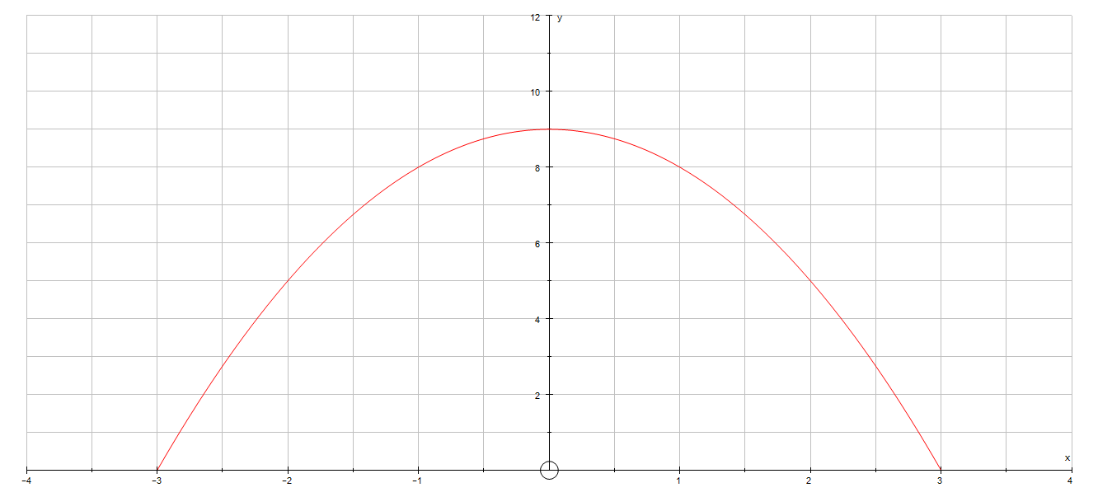
We will first evaluate: I₁ = $\int_{-3}^{3}{{(–x}^{2}}+9 )dx$
I₁ = $\int_{-3}^{3}{{(–x}^{2}}+9 )dx$
= $[{\frac{-x^{3}}{3}+9x]}_{-3}^{3}$
= $\frac{-1}{3}$ [3³ – 27(3)] –[$\frac{-1}{3}($(–3)³ – 27(–3))]
= $\frac{-1}{3}$ [27–81] – [$\frac{-1}{3}$(–27 +81)]
= 18 +18
I₁ = 36 square units.
Next, we will evaluate I₂ = $–\int_{3}^{–3}{{(–x}^{2}}+9 )dx$
I₂ = $–\int_{3}^{–3}{{(–x}^{2}}+9 )dx$
= –$[{\frac{-x^{3}}{3}+9x]}_{-3}^{3}$
= –[–$\frac{1}{3}$ ((–3)³ –27(–3))] – [–$\frac{1}{3}$((3)³ –27(3))]
= –[–$\frac{1}{3}$(–27 +81)]– [–$\frac{1}{3}$(27 –81)]
= –[–18] –[–18]
I₂ = 36 square units.
So, I₁ = I₂ . Can you explain why this worked?
You will need this property of integrals to understand the following example.

Areas above and below the x-axis.
Find the area enclosed between the curve defined by g(x) = 4x(x–1)(x–2) and the x-axis.
The graph of g(x) is sketched below ad the required area is indicated with
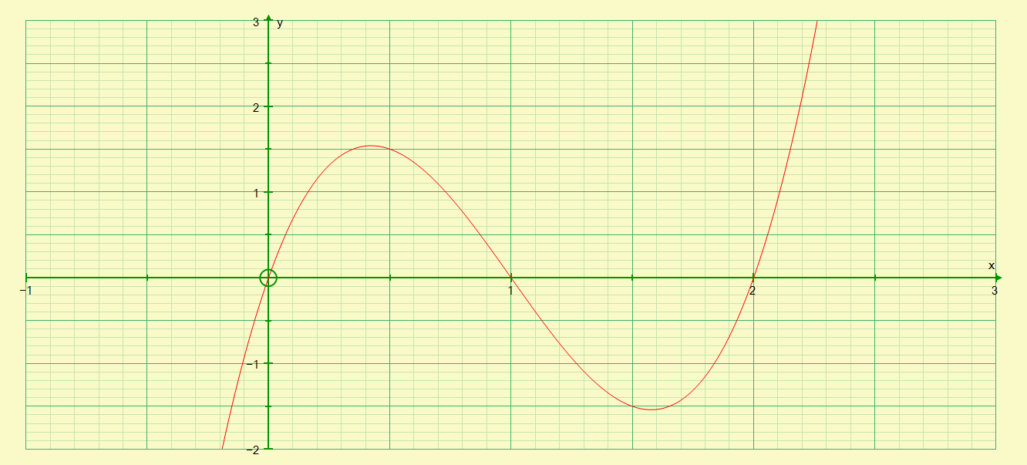
B
Q
A
P
We can first calculate the area over the interval [0 ;2] and observe what results we get.
$\int_{0}^{2}{\left[4x\left(x-1\right)\left(x-2\right)\right]dx}$ = $\int_{0}^{2}{\left({4x}^{3}-12x^{2}+8x\right)dx}$
= ${[x^{4}-{4x}^{3}+{4x}^{2}]}_{0}^{2}$
= [2⁴ –4(2)³ + 4(2)²] –[0]
= 16 –32 + 16 – 0
= 0 square units.
Is this possible? We will respond to this later.
Our first attempt failed to provide us with a reasonable/acceptable answer. Next we are going to break up the interval [0 ; 2] into the intervals, namely [0 ;1] and [1 ;2] and see what results we yield.
Consider the interval [0 ; 1] - NB: In this interval the graph lies above the x-axis
I₁ = $\int_{0}^{1}{\left[4x\left(x-1\right)\left(x-2\right)\right]dx}$ = $\int_{0}^{1}{\left({4x}^{3}-12x^{2}+8x\right)dx}$
= ${[x^{4}-{4x}^{3}+{4x}^{2}]}_{0}^{1}$
= [1⁴ –4(1)³ + 4(1)²] –[0]
= 1 –4 + 4 – 0
I₁ = 1 square unit.
Next, consider the interval [1 ;2] – NB: In this interval, the graph lies below the x-axis
I₂ = $\int_{1}^{2}{\left[4x\left(x-1\right)\left(x-2\right)\right]dx}$ = $\int_{1}^{2}{\left({4x}^{3}-12x^{2}+8x\right)dx}$
= ${[x^{4}-{4x}^{3}+{4x}^{2}]}_{1}^{2}$
= [2⁴ –4(2)³ + 4(2)²] –[1⁴ –4(1)³ + 4(1)²]
= 16–32 + 16 – [1 – 4 + 4]
= 0 –1
= –1……..(**)
I₂ = 1 square unit.
The negative sign in (**) tells us that that part of the graph is below the x-axis hence the – sign in front of the one. Remember area cannot be a negative value. So, the area of the graph over the interval [1 ;2] is 1 square unit. Thus, the total area of the graph over the interval
[0 ;2] is 2 square units.
With a colleague determine the value of I₂ if the upper and lower limits were switched around, i.e: I₂ = $\int_{2}^{1}{\left[4x\left(x-1\right)\left(x-2\right)\right]dx}$.
How does your response compare to the original value of I₂ above?
What have we observed from this example?
From this example, we conclude, that when finding the total area enclosed by a curve and the x-axis, we must first find the areas above and below the axis separately. The sum of these, disregarding the signs, will be the actual area required. This also emphasizes the need for a rough sketch to understand what the function looks like and where it is above or below the axis.

Property 2: $\int_{a}^{b}{f\left(x\right)dx}$ + $\int_{b}^{c}{f\left(x\right)dx}$ = $\int_{a}^{c}{f\left(x\right)dx}$
Consider, finding the area bounded by f(x) = x⁴ + 2x³ + 3 on the interval [–2 ;1]
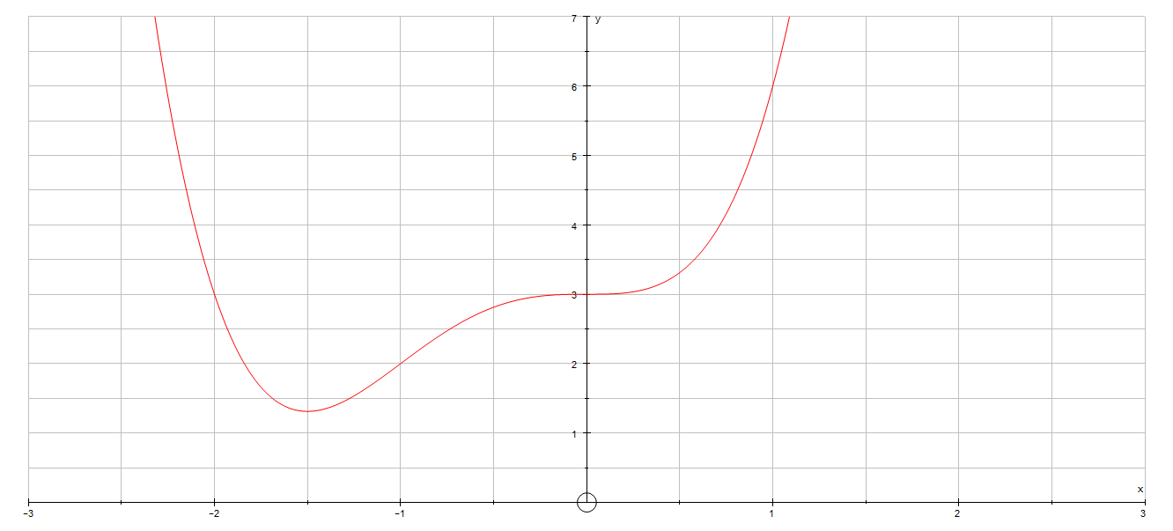
We will first split the interval [–2 ; 1] into two parts, viz: [–2 ; –1] and [–1 ;1]
A₁ = $\int_{-2}^{-1}{(x^{4}+2x^{3}}+3)dx$ + $\int_{-1}^{1}{(x^{4}+2x^{3}}+3)dx$
= ${[{\frac{x}{5}}^{5}+\frac{x^{4}}{2}+3x]}_{-2}^{-1}$ + [$\frac{x^{5}}{5}+\frac{x^{4}}{2}$ $+3x]_{-1}^{1}$
A₁ = $\frac{81}{10}$ square units.
Next, we will determine the area under the curve using the interval as one part, ie : [–2 ; 1]
A₂ = $\int_{-2}^{1}{(x^{4}+2x^{3}}+3)dx$ = [$\frac{x^{5}}{5}+\frac{x^{4}}{2}$ $+3x]_{-2}^{1}$
A₂ = $\frac{81}{10}$ square units.
Surprisingly, (or not so surprisingly), the two answers are the same!

Activity 6

Property 3: $\int_{a}^{b}{k.f\left(x\right)dx}$ = $k.\int_{a}^{b}{f\left(x\right)dx}$
With your partner, explore the validity of property 3 using the following functions:
- f(x) = x² and k = 2
- f(x) = 2x and k = –0,5
- f(x) = $\frac{1}{x^{2}}$ and k = –1,5
Comment on your findings.

Activity 7
Investigate the validity of the following property:
$\int_{a}^{b}{\left(f\left(x\right)+g\left(x\right)\right)dx}$ = $\int_{a}^{b}{f(x)dx}$ + $\int_{a}^{b}{g(x)dx}$, if f(x) = –3x and g(x) = x² + 6 for the interval [–4 ;–1].
- You will need to draw graphs of the two functions on the same set of axis.
- You will need to show all working details.
- Comment on your findings.

Activity 8
1. | Show that: $\int_{1}^{3}{\left(4x+1\right)dx}$ = – $\int_{3}^{1}{\left(4x+1\right)dx}$
2. | Show that: $\int_{0}^{2}{(3x^{3}}-6x-9)dx$ = $3\int_{0}^{2}{(x^{3}}-2x-3)dx$
3. | Show that: $\int_{1}^{4}{2x^{-2}dx}$ = $\int_{1}^{2}{2x^{-2}dx}$ + $\int_{2}^{4}{2x^{-2}dx}$
4. | Show that: $\int_{-3}^{4}{(-x^{2}}+5x-6)dx$ = $\int_{-3}^{4}{-x^{2}}dx$ + $\int_{-3}^{4}{(}5x-6)dx$

Area under a curve
Use the properties of definite integrals developed in the previous section to calculate the area under a curve. NB: If asked to evaluate a definite integral without explicitly asked to calculate the area, then proceed to evaluate the definite integral without concern about the answer-i.e the answer can be 0 or a negative value!!

Worked examples:
- Find the area under the curve y = x² , between x = 1 and x = 3.
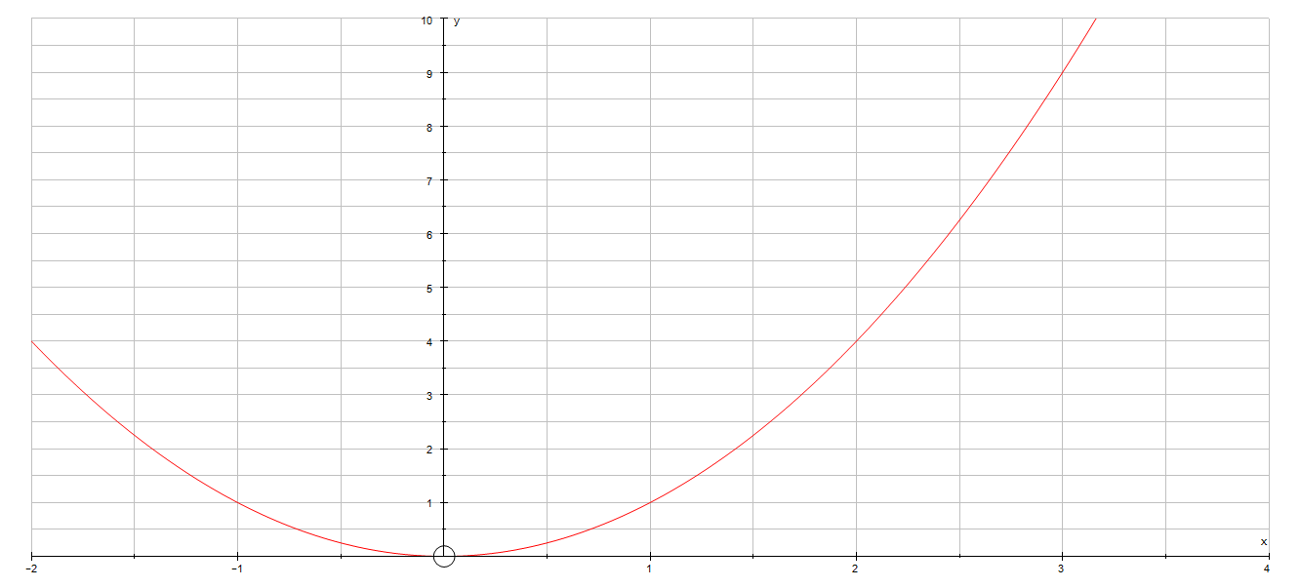
Let the required area be A , then: A = $\int_{1}^{3}{x^{2}dx}$
= $[{\frac{x^{3}}{3}]}_{1}^{3}$
= $\frac{3^{3}}{3}$ – $\frac{1^{3}}{3}$
A = $\frac{26}{3}$ square units
- Find the area between the curve y = x² + 4x and the x-axis from:
- x = – 2 to x = 0
- x = – 2 to x = 2
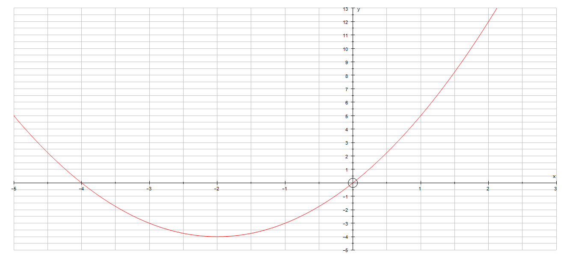
A₂
A₁
Solution:
- Let A₁ = $\int_{-2}^{0}{\left(x^{2}+4x\right)dx}$

= $[ \frac{x^{3}}{3}{+ 2x^{2}]}_{-2}^{0}$
= 0 –[$\frac{{-2}^{3}}{3}+2({-2)}^{2}]$
= 0 – [ $\frac{16}{3}$]
= – $\frac{16}{3}$ …..the minus sign tells us the area is below the x-axis
Thus, A₁ = $\frac{16}{3}$
- For the interval [– 2 ; 2], we observe that the required area comprises of two parts – one part below the x-axis and the other part above the x-axis.

Calculate A₂ , as follows:
A₂ = $\int_{0}^{2}{\left(x^{2}+4x\right)dx}$ = $\frac{32}{3}$ (The reader should verify the accuracy)

So, the area over the interval [–2 ; 2] is obtained by adding A₁ and A₂, i.e:
A = A₁ + A₂
= $\frac{16}{3}$ + $\frac{32}{3}$ = 16 square units.

- With your partner, attempt the following. The given sketch is a graphical representation of the function defined by: f(x) = x³ – 4x² + 3x. Determine the area between the curve and the x-axis from x = 0 to x = 3.

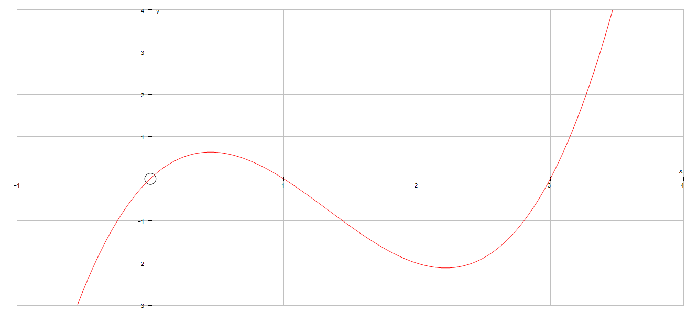

- (A challenge) Find the area enclosed between the curve y = x² – 2x –3 and the straight-line y = x + 1.

Activity 9
1. | Use the properties of definite integrals which you have studied thus far, to evaluate the following definite integrals.
a) | $\int_{-2}^{2}{\left(6t^{2}+1\right)dt}$ |  | b) | $\int_{0}^{1}{\left(2x+1\right)\left(x+3\right)dx}$
c) | $\int_{2}^{4}{\left(5x-4\right)dx}$ |  | d) | $\int_{-3}^{3}{\left({6x}^{3}+2x\right)dx}$
2. | Calculate the areas of the following:
a) | $\int_{-2}^{2}{\left(6t^{2}+1\right)dt}$ |  | b) | $\int_{0}^{1}{\left(2x+1\right)\left(x+3\right)dx}$
c) | $\int_{2}^{4}{\left(5x-4\right)dx}$ |  | d) | $\int_{-3}^{3}{\left({6x}^{3}+2x\right)dx}$
3. | Find the area under the curve y = x² from x = 0 to x = 6.
4. | Find the area under the curve y = 3x² + 2x from x = 0 to x = 4.
5. | Find the area under the curve y = 3x² -2x from x = – 4 to x = 0.
6. | Find the area enclosed by the x-axis and the following curves and straight lines.
a) | y = x² + 3x ; x = 2 ; x =5 |  | b) | y = $\frac{1}{8}$x³ + 2x ; x = 2 ; x =4
c) | y = (3x–4)² ; x = 1 , x =3 |  | d) | y = 2 – x³ ; x = –3 ; x = – 2
7.a) | Sketch the curve y = x(x +1)(x –3), showing where it cuts the x-axis.
b) | Calculate area of the region, above the x-axis, bounded by the x-axis and the curve.
c) | Calculate area of the region, below the x-axis, bounded by the x-axis and the curve.
8. | The diagram shows the region under  y = 4x +1 between x =1 and x = 3. Find the area below the graph between x = 1 and x= 3, using: |  |  | y = 4x +1  y  3  1  x
a) | The formula for the area of a trapezium |  |  | y = 4x +1  y  3  1  x
b) | integration |  |  | y = 4x +1  y  3  1  x
c) | How do the results in a) and b) compare with each other? Explain. |  |  | y = 4x +1  y  3  1  x
9. | The diagram alongside shows the region bounded by y = $\frac{1}{2}x –3$, by x =14 and the x-axis. A(r ; 0) is the x-intercept of the straight line graph. |  |  | x  y = $\frac{1}{2}x –3$  14  A (r ;0)
a) | Determine the numerical value of r. |  |  | x  y = $\frac{1}{2}x –3$  14  A (r ;0)
b) | Determine area of the shaded region using: |  |  | x  y = $\frac{1}{2}x –3$  14  A (r ;0)
i) | the formula for the area of a triangle. |  |  | x  y = $\frac{1}{2}x –3$  14  A (r ;0)
ii) | integration |  |  | x  y = $\frac{1}{2}x –3$  14  A (r ;0)
10. | Calculate the areas of the following:
a) | y = 1 + x² for 0 < x < 2 |  | b) | y = 5x – x² ; for x $∈$ [0 ; 5]
11. | Evaluate $\int_{0}^{2}{x\left(x–1\right)\left(x–2\right)dx}$ and explain your answer with reference to the graph of  y = x(x–1)(x–2).
12. | Given that: $\int_{-a}^{a}{15x^{2}}$dx = 3430. Determine the numerical value of a
13. | Given that: $\int_{1}^{p}{(8x^{3}}+6x)dx$= 39. Determine two possible values of p. Use a graph to explain why there are two values.
14 a) | Determine: $\int{x(x^{2}}–2)dx$
b) | The diagram alongside, shows the graph of y = x(x² –2), for x > 0. The value of a is such that the two shaded regions have equal areas. Find the value of a. |  |  | $$\sqrt{2}$$  0  a
15. | Show that the area enclosed between the curves y = 9 –x² and y = x² – 7 is $\frac{128\sqrt{2}}{3}$

ANALYTICAL GEOMETRY

Outcomes for this section:
By the end of this section, you should be able to:
- Identify the equation x² + y² = r², as the equation defining a circle with radius r and centre (0; 0).
- Find the equation of the circle when the radius is given or a point on the circle is given. Only circles with the origin as centre.
- Determination of the equation of a tangent to a given circle. (Gradient or point of contact is given).
- Find the points of intersection of the circle and a given straight line.
- Plotting the graph of an ellipse defined by: $\frac{x^{2}}{a^{2}}$ + $\frac{y^{2}}{b^{2}}$ = 1.

Introduction
A circle is a set of points which are equidistant from a fixed point, the centre of the circle. The distance from the centre to any point on the circle is the length of the radius, while the distance around the whole circle is the circumference or the perimeter of the circle.
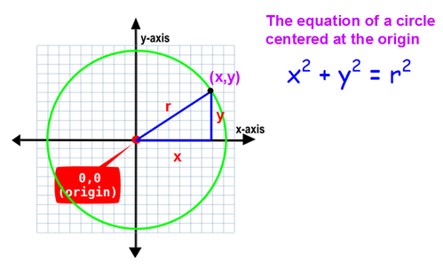

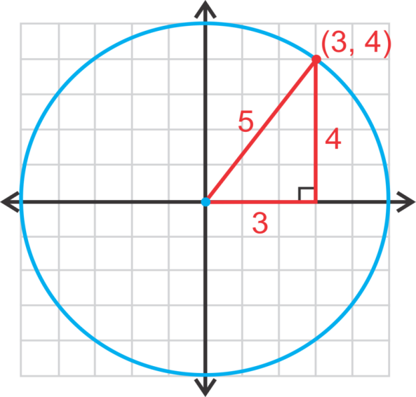

Circle with centre (0 ; 0) and radius of r units.

Worked examples
1. | Determine the equation of a circle with centre at the origin and radius 5 units. | Start with equation: x² + y² = r²  Substitute value of radius in above equation;  i.e: x² + y² = 5²  $∴$ x² + y² = 25 is the required equation.
2. | Determine the equation of the circle with centre (0;0) and passing through the point (–4 ; 2). | Start with equation: x² + y² = r²  Substitute (–4 ;2) in above equation:  i.e: (–4)² + (2)² = r²  16 + 4 = r²  r² = 20  x² + y² = 20 is the required equation of the circle.
d) | Find one other point with integer coordinates that lie on the circle. | Discuss in your groups.

Activity 1
- Determine the equation of the circle centred at (0 ;0) and with the given radius or given point on the circle
 | Radius or Given Point on circle | Equation
a) | Radius = 3 units
b) | Radius = 7 units
c) | Radius = $\sqrt{7}$ units
d) | Passing through (cos 60⁰ ; sin 60⁰)
e) | Passing through (3 tan 45⁰ ; 2 cot 135⁰)
f) | Passing through ($\log_{\frac{1}{2}}{2}$ ; $\log_{9}{3}$)
2. | In each of the following, write down the radius of the given circles.
a) | x² + y² = 9 | b) x² + y² = 25
c) | x² + y² = 10 | d) 2x² + 3y² = 10
3. | The point T(12 ;–5) lies on the circle with centre at O(0 ;0).
a) | Determine the equation defining the circle.
b) | Determine the co-ordinates of R, if RT is a diameter of the circle.
c) | Show that K(0 ; –13) lies on the circle.
d) | Show that $T\hat{K}$R = 90º
4. | P(–2 ;3) ; Q (2 ; 3) and R(3 ;–2) are three points in the Cartesian plane.
a) | Plot the given points on the Cartesian plane.
b) | Determine the equation of the circle with centre (0 ;0) and passing through the points P,Q and R.
c) | Write down the radius of the circle passing through the points P, Q and R.
d) | If RD is a diameter of the circle passing through P,Q and R, determine the equation of RD in the form ax + by + c = 0.
e)** | Find the equation of the tangent to the circle at D.
5. | The points G(–5 ; 12) and H(5 : –12) are the endpoints of diameter GH.
a) | Determine the equation of the circle with diameter GH.
b)** | If B(0 ;13) and D(–1 ; $–2\sqrt{3}$) are points in the Cartesian plane, show that GBHD is a cyclic quadrilateral.
6. | The points M(3 ; –2) and N(2 ; –3) are points on a circle with centre at O(0 ; 0).
a) | Determine the equation of the circle.
b) | Show, using analytical methods (i.e. Analytical Geometry methods) that the line drawn from the centre to the midpoint of the chord MN is perpendicular to the chord.

3.The equation of a tangent to the circle

Recall in grade 11, we defined a secant as a straight line which cuts a circle in two distinct points. A tangent, on the other hand, is a straight line that touches a circle in one and only one point.
You will recall from your studies of Euclidean Geometry in grade 11, that the tangent to a circle is perpendicular to the radius or diameter drawn to the point of contact of the tangent.
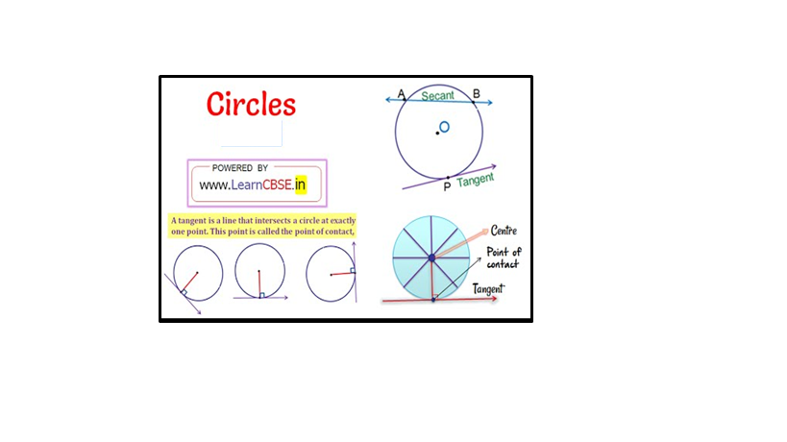

3.1 Condition for y = mx +c to be a tangent to x² + y² = r²
Figure 1  B  B  M  r  P  A  O  O is the centre of the circle, with OM $⊥$ AB. OP is the radius of the circle. | Figure 2  M  A  B  P  O  r  O is the centre of the circle, with OM $⊥$ AB. OP is the radius of the circle. | Figure 3  P  A  M  O  r  O is the centre of the circle, with OM $⊥$ AB. OP is the radius of the circle.
In the above figure AB is a secant to the circle. | In the above above AB does not intersect the circle. | In the above figure AB is a tangent to the circle.

Note that AB:
Intersects the circle in two places (see Figure 1) if OM < r
- Does not intersect the circle (see Figure 2) if OM > r
- Intersects the circle in one and only one place (see Figure 3) if OM = r

Worked examples
1. | Show that 2x + y + 5 = 0 is a tangent to the circle defined by: x² + y² = 5
Proving that there are two equal roots
Write the given straight-line equation in the form y = mx + c,

i.e: y = – 2x – 5

Substitute y = –2x – 5 in x² + y² = 5

i.e: x² + (–2x –5)² = 5
x² + 4x² + 20x + 25 – 5 = 0
5x² + 20x + 20 = 0
5(x² + 4x + 4) = 0
(x + 2)² = 0
x = – 2 is a repeated root, which implies that the straight line: 2x + y + 5 = 0 is a tangent to the given circle.
 | Can you solve the given problem differently? Discuss with your partner.

3.2 The equation of the tangent through a given point (x₁ ; y₁) on the circle x² + y² = r²
In the diagram alongside, A (x₁ ; y₁) is an arbitrary point on the circle defined by: x² + y² = r².
P(x ; y) is any point on the tangent through A.
M_{OA} = $\frac{y_{1}}{x_{1}}$ ; Hence M_{AP} = – $\frac{x_{1}}{y_{1}}$ (Why?)
The equation of the tangent AP is given by:
y – y₁ = m(x – x₁)
= – $\frac{x_{1}}{y_{1}}$ (x – x₁)
yy₁ – y₁y₁ = – xx₁ + x₁x₁
yy₁ + xx₁ = $x_{1}^{2}$ + $y_{1}^{2}$
= r²
The equation of the tangent through
(x₁ ; y₁) on x² + y² = r² is given by:
xx₁ + yy₁ = r²

r
P(x ;y)

O
A(x₁ ; y₁)
x
y

Worked examples
1. | The point P(3; – 2) is a point on the circle defined by: x² + y² = r²
a) | Determine the equation of the circle. | The equation of the circle is of the form:  x² + y² = r².  Hence; (3)² + (–2)² = r²  r² = 13  Required equation is: x² + y² = 13
b) | Determine the equation of the tangent to the circle at the point P(3 ; – 2) | The equation of the tangent through  P(3 ;–2) is of the type: xx₁ + yy₁ = r²  x(3) + y(–2) = 13  Required equation is: 3x –2y =13
2. | Determine the equation of the tangent to the circle x² + y² = 10 at the point  K(–3 ; 1)
 | Method 1: (Using the formula developed above)  The equation of the tangent through K is of the type: xx₁ + yy₁ = r²  i.e: x(–3) + y(1) = 10  –3x + y = 10  y = 3x + 10 is the required equation. | Method 2:  First determine the gradient of the radius, OK;  M_{OK} = $\frac{–1}{3}$  M_{tangent} = 3 (Do you recall, why?)  Equation of tangent is:  y -y₁ = m(x – x₁)  y – (1) = 3(x –(–3))  y – 1 = 3x + 9  y = 3x + 10 is the required equation.

Activity 2
1. | Determine the equation of the tangent to the circle at the given point.
 | Equation of circle | Given point
a) | x² + y² = 25 | P(3 ; –4)
b) | x² + y² = 5 | M(1 ; – 2)
c) | 4x² + 4y² = 65 | R($\frac{-1}{2}$ ; 4)
2. | In the diagram alongside, a crank mechanism is shown. BT is a tangent to the circle at T. OT is the radius of the circle, with centre O. OT = 10 units and OB = 40 units, with B a point on the x-axis. | T  x  B  O
a) | Determine the equation of the circle in the form x² + y² = r²
b) | Determine the length of BT.
c) | Determine the co-ordinates of T if T $\hat{O}$B = 30⁰
d) | Determine the equation of the tangent BT at the point T.
3.** | The point K(5 ;0) is a point outside the circle x² + y² = 5. P and Q are two distinct points on the given circle. Determine the equations of the tangents KP and KQ to the circle.
a) | Prove that x + 2y – 5 = 0 is a tangent to the circle x² + y² = 5.
b) | Calculate the coordinates of the point of contact.
c) | If a second tangent to the circle is drawn parallel to the line x + 2y – 5 = 0; calculate:
ci) | The gradient of the second tangent.
cii) | The coordinates of the point of contact.
ciii) | Hence, write the equation of the second tangent in the form ax + by + c = 0.

3.3 The points of intersection of the circle x² + y² = r² and a given straight line

Worked example
1. | The straight-line y = x + 2 cuts the circle x² + y² = 20 at two points, A and B.  A  B  x  y  O
a) | Determine the co-ordinates of A and B. | At A and B:  x² + (x+2)² = 20  x² + x² +4x + 4 – 20 = 0  2x² + 4x –16 = 0  x² + 2x – 8 = 0  (x + 4)(x – 2) = 0  x = – 4 OR x = 2  y = – 2 OR y = 4  A(–4 ; –2) B(2 ; 4)
b) | Determine the length of chord AB. | AB² = (x_{B} – x_{A})² + (y_{B} – yA)²  = (2 – (–4))² +(4 – (–2))²  AB² = 36 + 36  = 2(36)  AB = $6\sqrt{2}$
c) | Determine the gradient of OB. | M_{OB} = $\frac{y_{B}–y_{O}}{x_{B}–x_{o}}$ = $\frac{4–0}{2 –0}$ = 2
d) | Hence determine the equation of the tangent to the circle at B, in the form ax + by + c = 0 | M_{OB}$×$ M_{tangent} = – 1  M_{tangent} = $\frac{–1}{2}$  Equation of tangent at B is:  y– y₁ = m(x – x₁)  y – 4 = $\frac{–1}{2}$ ( x – 2)  2y – 8 = –x + 2  2y + x – 10 = 0

Activity 3
1. | The straight line defined by x – y = 1 cuts the circle x² + y² = 13 at A and B.
a) | Determine the co-ordinates of A and B.
b) | Determine the length of the chord AB.
c) | Determine the co-ordinates of M the midpoint of chord AB.
d) | Show, using analytical methods that OM $⊥$ AB
e) | Does the point T(– 3 ;2) :  - Lie on the circle; or  - Lie inside the circle; or  - Lie outside the circle?  Justify your response, using appropriate calculations
f) | Determine the gradient of OT
g) | Hence, determine the equation of the tangent to the circle at T(–3 ; 2), in the form  y = mx + c
2. | The straight-line 2y – x = 5 intersects the circle x² + y² = 10. Determine the coordinates of the points of intersection.
3. | Determine the coordinates of the points of intersection of x = 5y –13 and the circle  x² + y² = 13
4. | The straight-line y + x + 1 = 0 is a secant of the circle x²+ y² = 25. Determine the points of intersection of the circle and the secant.
5. | The straight-line defined by 2x + y + 7 = 0 intersects the circle through (–4 ; –1) with centre (0 ; 0) in two points.
a) | Determine the equation of the circle in the form x² + y² = r²
b) | Determine the co-ordinates of the points of intersection of the line and the circle.
6. | The straight-line x + y = 5 intersects the circle x² + y² = 17 at A and B. C is the midpoint of chord AB. Determine:
a) | the coordinates of the points A and B.
b) | the coordinates of C, the midpoint of chord AB.
c) | the equation of the circle with centre (0 ; 0) and passing through C.
7. | The point A(–1 ; 2) is a point on a circle with centre (0 ; 0). The line PAQ is a tangent to the circle. RS is a chord of the circle with gradient $\frac{1}{3}$ and intersecting the y-axis at J(0 ; – $1\frac{2}{3}$). Determine:
a) | the equation of PQ | b) | the equation of RS
c) | the equation of the circle. | d) | the coordinates of R and S.
8. | Determine the equation of the tangent to the circle in the following cases:
a) | Tangent through A(5 ;3) on the circle x² + y² = 34
b) | Tangent parallel to the x-axis, to the circle x² + y² = 9
c) | Tangent, perpendicular to the x-axis to the circle x² + y² = 8
d) | Tangent through P(–1 ; 2) on the circle x² + y² = r². Will Q(3 ; 4) lie on the tangent?
9a) | Determine the equation of the circle with centre at (0 ; 0) and passing through  P(7 ; –4).
b) | Determine the equation of the tangent to the circle at P (7 ; – 4).
c) | Determine the size of the angle which the tangent makes with x -axis.
10. | The straight-line y = 4x + c touches the circle x² + y² = 17. Determine the value of c.
11. | The origin (0 ; 0) is the centre of two concentric circles.  A(– 3 ; k) is a point in the third quadrant on the larger circle.  B(3 ; – 2) is a point on the smaller circle.  AC is a tangent to the smaller circle at C The length of AC is $\sqrt{21}$ units.  AB produced cuts the x-axis at D.
a) | Represent the given information on the Cartesian Plane.
b) | Determine the equation of the smaller circle.
c) | Determine the equation of the larger circle.
d) | Hence, determine the numerical value of k
e) | Show that the equation of AB is given by: 2y – x + 7 = 0
f) | Hence, determine the co-ordinates of D.

4.The conic sections
When a double right circular cone is cut by a plane, the resulting intersection is called a conic section or more briefly, a conic. The figure below depicts the four important cases.

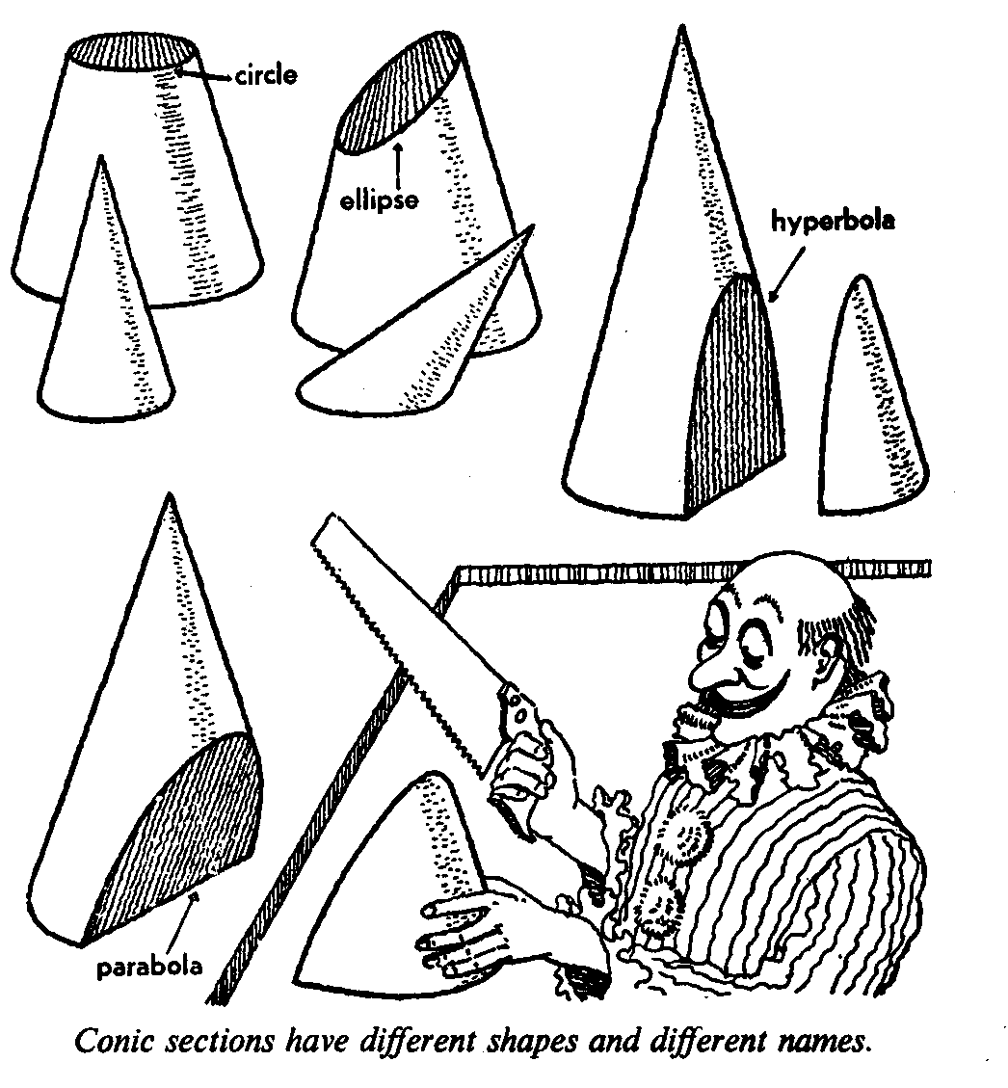
In this section, we will focus on the ellipse.

4.1 The ellipse
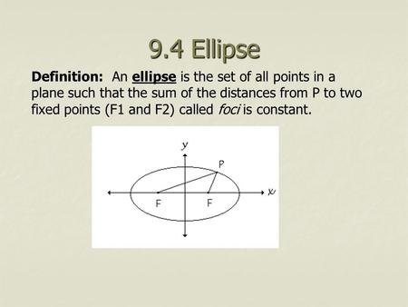
Symbolically, d(P , F₁) + d(P, F₂) = k.
A simple way to illustrate the ellipse is to picture a piece of string with each end fastened to fixed points called focus points or foci (see figure below). The string length is arbitrarily set to 2a. If a pencil is used to pull the string tight and is then moved around the foci, the resulting shape will be an ellipse. The length of string remains constant at 2a, but the distance (S₁ and S₂) from the pencil to each focus will change at each point. The foci are located at F₁ and F₂, and A and B are two arbitrary points on the ellipse. All the points on the closed curve defined by the ellipse are represented by the set of x and y points, P(x,y). 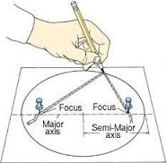
P (x ; y)
F₂
F₁
S₂
S₁

4.2 Terminology associated with ellipses
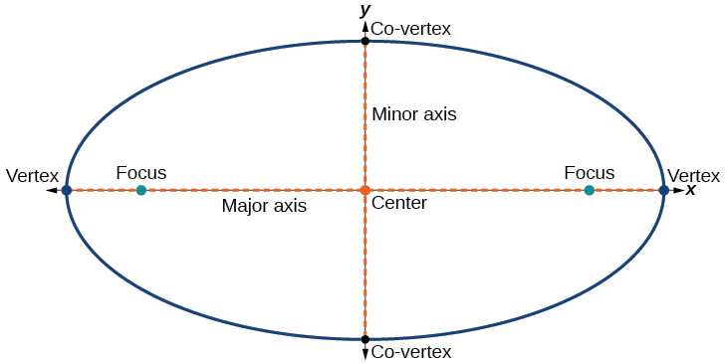

4.3 Plotting of the graph of an ellipse defined by: $\frac{x^{2}}{a^{2}}$ + $\frac{y^{2}}{b^{2}}$ = 1
To assist us in plotting the graph of an ellipse with centre (0 ;0), we will adopt the following procedure.
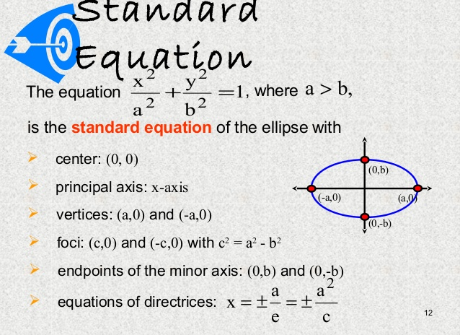
Step | Action
1 | Write the given equation in standard form
2. | If a > b then the major axis is the x-axis.
3. | Determine the x and y-intercepts.
4. | Determine the foci- (Foci is always on the major axis)
5. | Plot the key features.

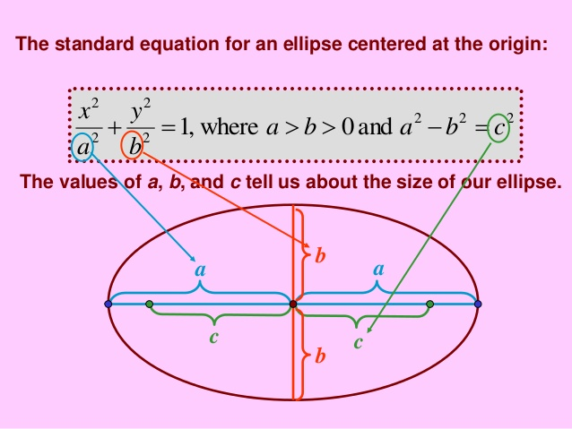
With foci at (– c ; 0) and (c ; 0)
Figure 1
The geometric interpretations of a and b can be found from the above equation. Letting y = 0 produces the x-intercepts, i.e : x = $± a$. The x-coordinates at the vertices are given by (a; 0) and (– a ;0). The chord joining the vertices is called the major axis, with length 2a units.
Letting x = 0 produces the y-intercepts, y = $± b$. The points (0 ; b) and (0 ; –b) are the endpoints of the minor axis, with length 2b units. The intersection of the major and minor axes is the centre of the ellipse, in our case the centre is at the origin (0; 0). Half of the axes are called the semi-axes whose lengths are a and b. Also, c is called the focal distance, since it represents the distance from the centre to foci.
From the above diagram (Figure 1), the following Pythagorean relationship between a, b and c can be established:
In the diagram alongside: c represents the distance from one of the focal points to the centre ; b represents the distance from the centre to the y-intercept ; and a represents the distance from the foci to the y-intercept; then:
a² = b² + c² …Pythagoras Theorem
$∴$c² = a² – b²

b
a

F
c

Figure 3
Figure 2

The standard form of the equation of an ellipse with foci at (0 ; c) and (0 ; –c) is:

$\frac{x^{2}}{b^{2}}$ + $\frac{y^{2}}{a^{2}}$ = 1, where a > b > 0 and c² = a² – b²

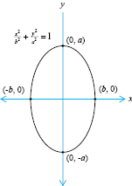
In the above diagram:
b² = a² – c²

The geometric interpretations of a and b can be found from the above equation. Letting y = 0 produces the x-intercepts, i.e : x = $± b$. The x-coordinates at the vertices are given by (b; 0) and (– b ;0). The chord joining the vertices is called the minor axis, with length 2b units.
Letting x = 0 produces the y-intercepts, y = $± a$. The points (a; 0) and (–a ; 0) are the endpoints of the major axis, with length 2a units. The intersection of the major and minor axes is the centre of the ellipse, in our case the centre is at the origin (0; 0). Half of the axes are called the semi-axes whose lengths are a and b. Also, c is called the focal distance, since it represents the distance from the centre to foci.

The centre is still at the origin, but the major axis is now along the y axis and
the minor axis is along the x axis.

To sketch graphs of equations of the either of the above forms is an easy
matter. We find the x and y intercepts and sketch in an appropriate ellipse. Since
replacing x with 2x or y with 2y produces an equivalent equation, we conclude
that the graphs are symmetric with respect to the x axis, y axis, and origin. If further
accuracy is required, additional points can be found with the aid of a calculator
and the use of symmetry properties.

Worked examples:
1 | Sketch the graph of each equation. Determine the co-ordinates of the foci, and the lengths of the major and minor axes.
a) | 9x² + 16y² = 144 |  | Step1: Write the given equation in standard form; i.e.: $\frac{x^{2}}{a^{2}}$ + $\frac{y^{2}}{b^{2}}$ = 1………(1)  To do that divide both sides of given equation by 144  i.e.: $\frac{{9x}^{2}}{144}$ + $\frac{{16y}^{2}}{144}$ = $\frac{144}{144}$  $\frac{x^{2}}{16}$ + $\frac{y^{2}}{9}$ = $1$ …………(2)  Compare (1) and (2):  a² = 16 $⟹$ a = 4 OR a = – 4  b² = 9 $⟹$ b = 3 OR b = – 3  Step 2:  To draw the graph:  X-intercepts:  (4 ; 0) and (–4 ; 0)  Y-intercepts:  (0 ; 3) and (0 ; –3)  Major axis: The x -axis. Major axis = 8 units  Minor axis: The y-axis. Minor axis = 6 units  Foci:  c² = a² – b²  = 16 – 9  c = $\sqrt{7}$  F₁ ($\sqrt{7}$ ; 0) ; F₂ ($–\sqrt{7}$ ; 0)
 | 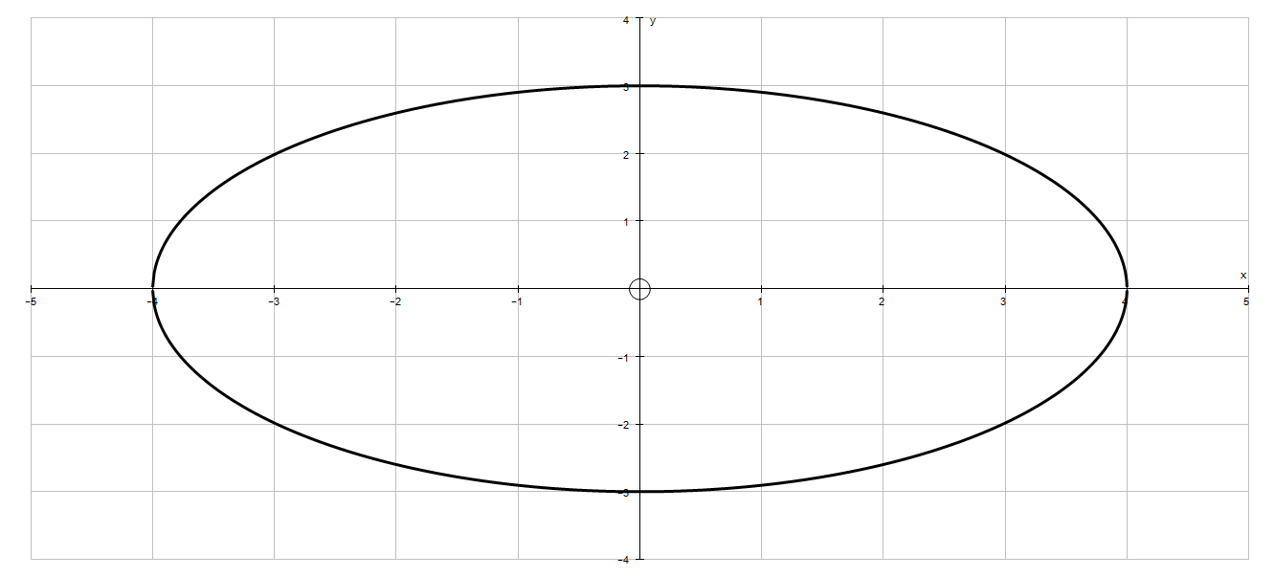
b) | 2x² + y² = 10 | Begin by dividing both sides of the equation by 10 to obtain the standard form:  i.e: $\frac{{2x}^{2}}{10}$ + $\frac{y^{2}}{10}$ = $\frac{10}{10}$  $\frac{x^{2}}{5}$ + $\frac{y^{2}}{10}$ = 1  Since 10 > 5, it implies that the y-axis is the major axis.  a² = 10 ; b² = 5  Intercepts:  X-axis: ( $\sqrt{5}$ ; 0) ; ($–\sqrt{5}$ ; 0)  Y-axis: (0 ; $\sqrt{10}$) ; (0 ; $–\sqrt{10}$)  Minor axis: 2 $\sqrt{5}$  Major axis: 2 $\sqrt{10}$  Foci: c²= a² – b²  = 10 – 5  = 5  c = $\sqrt{5}$  F₁ (0 ; $\sqrt{5}$ ) ; F₂ (0 ; $–\sqrt{5}$ )
 | 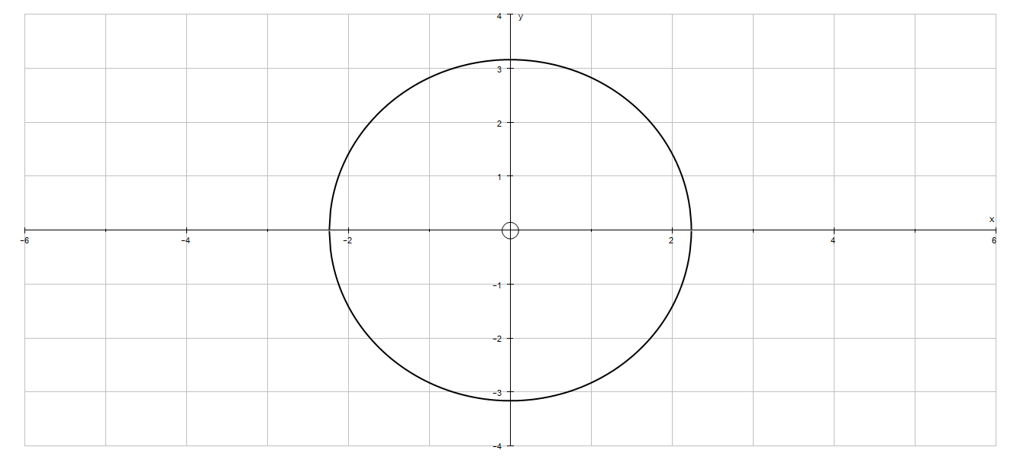
When the equation of an ellipse is in standard form, the major axis is horizontal if the x² – term has the largest denominator.
It will be vertical if the y² – term has the largest denominator.
Another way to determine this is to locate the endpoints of the two axes. The longer of the two is the major axis.



Activity 4
1. | In each of the following, determine:  - The intercepts with the axes;  - The coordinates of the foci;  - The length of the major axis  - The length of the minor axis.  Hence, use the above to sketch the graphs of the given equations.
a) | $\frac{x^{2}}{25}$ + $\frac{y^{2}}{4}$ = 1 | b) | $\frac{x^{2}}{4}$ + $\frac{y^{2}}{25}$ = 1
c) | $\frac{x^{2}}{9}$ + $\frac{y^{2}}{4}$ = 1 | d) | $\frac{x^{2}}{4}$ + $\frac{y^{2}}{9}$ = 1
e) | x² + 9y² = 1 | f) | 4x² + y² = 4
g) | 9x² + 16y² = 144 | h) | 4x² + y² = 16
i) | 25x² + 9y² = 225 | j) | 16x² + 25y² = 400
k) | 2x² + y² = 12 | l) | 4x² + 3y² = 24
m) | 4x² + 7y² = 28 | n) | 3x² + 2y² = 24
o) | 16x² + 9y² = 144 | p) | x² + 4y² = 16
q) | 4x² + 4y² = 36 | r) | 16x² + 9y² –144 = 0
**2. | A satellite follows an elliptical orbit around the earth such that the centre of the earth, E, is one of the foci. The furthest point that the satellite will be from the earth’s surface is 2500 miles and the closest will be 1000 miles. Take the y-axis to be the major axis, and use 4000 miles as the radius of the earth.
a) | Convert all distances to kilometres. (Hint: use 1 mile = 1,60934 kilometres)
b) | Determine the equation of the orbit of the satellite.
c) | Hence, plot the elliptical path followed by the satellite on the Cartesian Plane

EUCLIDEAN GEOMETRY

Outcomes for this section:
By the end of this section, the learner should be able to:
- Differentiate between a ratio and a proportion
- Recall the necessary and sufficient conditions for polygons to be similar
- Apply the following theorems:
  - That a line drawn parallel to one side of a triangle divides the other two sides proportionally;
  - That equiangular triangles are similar; and
  - That triangles with sides in proportion are similar.

Ratio
The reader encountered the term ratio in earlier grades. In this section, we will define the concept ratio and provide the reader with a few examples to illustrate the concept.
A ratio is the number of times a quantity contains another quantity of the same kind. It is an abstract number and is not associated with any particular unit. It is not a concrete quantity.
If a and b are two numbers or two quantities of the same kind and b $≠$ 0, then the ratio of a to b is the number $\frac{a}{b}$.
- A ratio is usually expressed in simplest form.
- If two numbers are in the ratio 2:3 (also written as $\frac{2}{3}$), this does not mean that the one number is 2 and the other is 3, but that the one number is 2k and the other is 3k where k $≠$ 0.

Worked examples
1. | AB is a line segment of arbitrary length. P is a point on AB such that AP: PB = 3:2.  A  B  Determine the following ratios: | 2 parts  3 parts  P
a) | $\frac{AP}{AB}$ | $\frac{AP}{AB}$ = $\frac{3 parts}{5 parts}$ = $\frac{3}{5 }$
b) | $\frac{AB}{BP}$ | $\frac{AB}{BP}$ = $\frac{5parts}{–2 parts}$ = $\frac{5 }{–2 }$ . Why? Discuss with your partner.
2. | M is a point on the line segment AB such that AM : MB = 2:5; and AM is 30 mm long. | 5k  2k  B  A  M
2. | - Calculate the length of MB | Method 1:  AM = 2k  30 = 2k  k = 15 mm  MB = 5 (15) = 75 mm.  Method 2:  $\frac{AM}{MB}$ = $\frac{30 mm}{MB}$ = $\frac{2}{5}$  i.e: $\frac{30 mm}{MB}$ = $\frac{2}{5}$  2(MB) = 5(30)  MB = 75 mm
2. | - If AM : AB = 2:9, calculate the length of MB if  AM = 36 mm | AM: AB = 2 : 9 ……. Given  Let AM = 2x ; then AB = 9x  i.e: 2x = 36 mm  x = 18 mm  AM + MB = AB  2x + MB = 9x  MB = 7x  = 7(18)  MB = 126 mm
2. | - If $\frac{AM}{MB }$ = $\frac{7}{3}$ , determine the numerical value of the ratio: $\frac{AM –MB}{AB}$ | Let : AM = 7x and MB = 3x  Then: AB = 10x  $\frac{AM –MB}{AB}$ = $\frac{7x –3x}{10x}$  = $\frac{4x}{10x}$  = $\frac{2}{5}$
3. | The points A, B and E are the vertices of $∆$ ABE. The points C and D are arbitrary points on BE, such that BC: CD: DE = 3 : 4: 5  Calculate the following ratios: | A  h  D  C  E  B
 | - $\frac{BC}{CE}$ | Let : BC = 3k ; CD = 4k and DE = 5k  Then; CE = CD + DE = 4k + 5k = 9k  $\frac{BC}{CE}$ = $\frac{3k}{9k}$ = $\frac{1}{3}$
 | - $\frac{Area ∆ ABC}{Area ∆ ACD}$ | Both triangles have the same height, hence the areas are in the ratio of their bases.  $\frac{Area ∆ ABC}{Area ∆ ACD}$ = $\frac{\frac{1}{2} ×base×height}{\frac{1}{2}×base×height}$ = $\frac{BC}{CD}$ = $\frac{3}{4}$
 | - $\frac{Area ∆ ACD}{Area ∆ ABC+Area ∆ ADE}$ | $\frac{Area ∆ ACD}{Area ∆ ABC+Area ∆ ADE}$ = $\frac{4k}{8k}$ = $\frac{1}{2}$
 | - $\frac{Area ∆ ACE}{Area ∆ ACE – Area ∆ ABC}$ | $\frac{Area ∆ ACE}{Area ∆ ACE – Area ∆ ABC}$ = $\frac{9k}{9k –3k}$ = $\frac{9k}{6k }$ = $\frac{3}{2}$

Activity 1
1. | In each of the following determine the value of the ratio $\frac{x}{y}$
a) | $\frac{x}{3}$ = $\frac{y}{2}$ | b) 5x – 2y = 3x + 5y | c) $\frac{x+y}{x –y}$ = $\frac{7}{4}$ | d) 9x – 5y = 0
e) | $\frac{2a}{b}$ = $\frac{c}{x}$ and  $\frac{a}{b}$ = $\frac{c}{y}$
2. | Complete the following statements
a) | If $\frac{x}{y}$ = $\frac{8}{5}$ , then $\frac{x+y}{y}$ = …………………… and $\frac{x– y}{y}$ = ……………..
b) | If $\frac{x}{2}$ = $\frac{y}{3}$ , then $\frac{y +3}{3}$ = …………………… and $\frac{y – 3}{3}$ = ……………..
c) | If $\frac{x+y}{y}$ = $\frac{8}{3}$ , then $\frac{x}{y}$ = …………………… and $\frac{x– y}{y}$ = ……………..
3. | If PQ = 50 mm and PR = 80 mm, determine the following ratios
a) | $\frac{PQ}{QR}$ and express PQ in terms of QR
b) | PR : PQ and express PQ in terms of PR
c) | QR: PR
4. | In the diagram alongside, K, M and N are the vertices of $∆$KMN. The points P and Q are points on MN.  If Area $∆ KMP$ : Area $∆$ KPQ = 3 : 4 and  PQ : QN = 2 : 3 |  | Q  P  N  M  K
a) | Determine the ratio MP: PQ : QN
b) | Determine the ratio $\frac{Area ∆KPQ}{Area ∆ KQN}$
c) | Show that the area $∆$ KQN = 2(Area $∆$ KMP)
d) | If PQ = 40 mm, calculate the length of MN

Proportion
If the ratio of two quantities a and b is equal to the ratio of two other quantities c and d, the four quantities form a proportion.
Therefore $\frac{a}{b}$ = $\frac{c}{d}$ ( where b $≠$ 0 and d $≠$ 0) is a proportion which also can be written as
a : b = c : d. The four quantities are called the terms of the proportion
- If a, b, c and d form a proportion, then $\frac{a}{b}$ = $\frac{c}{d}$ , where a is the first proportional to b , c and d. d is the fourth proportional to a, b and c.
- If a, b and c form a proportion, then $\frac{a}{b}$ = $\frac{b}{c}$ ; b is the mean proportional or geometric mean of a and c; hence b² = ac (by cross multiplication). [NB: for the mean proportional b is usually taken as being positive, i.e. b = $\sqrt{ac}$ ]
c is the third proportional to a and b.
- If a, b, c and d form a continuous proportion, then $\frac{a}{b}$ = $\frac{b}{c}$ = $\frac{c}{d}$
Fundamental properties of a proportion
If $\frac{a}{b}$ = $\frac{c}{d}$ , then | - ad = bc (cross multiplication)  - $\frac{b}{a}$ = $\frac{d}{c}$ (invertendo)  - $\frac{a}{c}$ = $\frac{b}{d}$ (alternando)  - $\frac{a+b}{b}$ = $\frac{c+d}{d}$ OR $\frac{a}{a+ b}$ = $\frac{c}{c+ d}$ (componendo)  - $\frac{a– b}{b}$ = $\frac{c–d}{d}$ OR $\frac{a}{a– b}$ = $\frac{c}{c– d}$ (dividendo)  - $\frac{a+b}{a – b}$ = $\frac{c+d}{c– d}$ (componendo et dividendo)  - ad = bc (The product of the mean terms = the product of the  extreme terms)

Worked examples
1. | Find the fourth proportional to 5 ; 8 ; $\frac{25}{2}$ | Let x be the fourth proportional  i.e.: $\frac{5}{8}$ = $\frac{\frac{25}{2}}{x}$  Then: 5x = 8($\frac{25}{2}$)  5x = 100  x = 20
2. | Find the third proportional to 5 and 8. | Let x be the third proportional  i.e: $\frac{5}{8}$ = $\frac{8}{x}$  5x = 8(8)  5x = 64  x = $\frac{64}{5}$ = 12$\frac{4}{5}$

Activity 2
- Calculate the fourth proportional to 3, 5 and 8. | - Calculate the mean proportional between 14 and 56
- Calculate the third proportional to 8 and 14. | - Calculate the mean proportional between 30 and 48.
- Solve for x if 28 : x = 7 : 3 | - Solve for x if 18 : x = x : 8

Theorem 1: A line drawn parallel to one side of a triangle divides the other two sides proportionally (line $∥$ one side of $∆$)
A

C
B

E
D

Given: Any $∆$ ABC with DE $∥$ BC
Conclusion: $\frac{AD }{DB}$ = $\frac{AE}{EC}$
Corollaries: 1) If $\frac{AD }{DB}$ = $\frac{AE}{EC}$
$\frac{AD }{DB}$ + 1 = $\frac{AE}{EC}$ + 1
Then: $\frac{AD}{AB}$ = $\frac{AE}{AC}$
2) If $\frac{AD }{DB}$ = $\frac{AE}{EC}$
Then: $\frac{AB }{DB}$ = $\frac{AC }{CE}$

Worked examples
1. | In the given diagram, EF $∥$ BC. AE = 20 units; EB = 12 units and AC = 48 units.  Determine the numerical value of AF.
 | C  F  20  12  A  E  B | In $∆$ ABC: EF $∥$ BC …….. Given  $\frac{AF}{AC}$ = $\frac{AE}{AB}$ ……(line $∥$ one side of $∆$)  $\frac{AF}{48}$ = $\frac{20}{32}$  AF = $\frac{20(48)}{32}$  AF = 30 units
2. | In the given diagram, BA $∥$ DE. AE = 25 mm ; EC = 65 mm ; BD = 30 mm and  DC = x mm.  Calculate the value of x  A
 | 25  E  65  30  C  x  D  B | In $∆$ ABC: BA $∥$ DE …….. Given  $\frac{CD}{DB}$ = $\frac{CE}{EA}$ ……(line $∥$ one side of $∆$)  $\frac{x}{30}$ = $\frac{65}{25}$  x = $\frac{(30)(65)}{25}$  x = 78 mm
3. | In the given diagram BD $∥$ FE and  HF $∥$ CB.  AF = 27 mm ; AH = 36 mm ;  HC = 16 mm ; FB = x mm ; AE = a mm and ED = b mm.  Calculate:  - The value of x  - The value of a : b
 | E  D  A  H  F  C  B | - In $∆$ ABC : HF $∥$ CB (Given)  $\frac{x}{27}$ = $\frac{16}{36}$ …(line $∥$ one side of $∆$)  x = $\frac{27(16)}{36}$ = 12 mm  - In $∆$ ABD : BD $∥$ FE (Given)  $\frac{a}{b}$ = $\frac{27}{12}$ …(line $∥$ one side of $∆$)  $\frac{a}{b}$ = $\frac{9}{4}$ mm

Activity 3
- Calculate
a) | The first proportional to 7 , 15 and 21
b) | The fourth proportional to 3 , 8 and 15
c) | The third proportional to 4 and 9
d) | The mean proportional to 4 and $12\frac{1}{4}$
2. | In the given diagram, A, B and C are the vertices of $∆$ ABC, with BA $∥$ DE.  AE = x units; EC = 55 units; DC = 65 units and BD = 26 units.  Determine the value of x.  A  x  E  55  26  65  C  D  B
3. | In the diagram below, KLMN is a parallelogram. ML is produced to R such that  RL = 20 mm. LM = x mm. $\frac{RQ}{RN}$ = $\frac{4}{13}$ . Determine the value of x.  N  K  Q  x mm  20 mm  M  R  L
3. | In the accompanying diagram, P, Q and R are the vertices of $∆$ PQR. QP $∥$ TS.  QT = x units ; TR = 7 units; RS = x + 4 units and SP = 3 units.  P  Determine the value of x.  S  R  Q  T
4. | In the accompanying diagram, K, M and N are the vertices of $∆$ KMN. P is appoint on KM ; Q is a point on MN and R is a point on KN. PMQR is a parallelogram, with PR = 33 mm and RQ = 14 mm. KP = y units and QN = x units. KR: RN = 3:2.  Determine the numerical values of:  - x ; and 2) y  K  y  33 mm  R  P  14 mm  x mm  N  M  Q
5. | In the accompanying diagram, A , B and C are the vertices of $∆$ ABC. D is a point on AB such that AD = 54 mm and DB = 36 mm. E is appoint on AC., and F is a point on BC. DE $∥$ BF and BD $∥$ FE. FC = x mm.  A  E  D  F  C  B
5.1. | What type of quadrilateral is DBFE? Provide a reason for your answer.
5.2 | Determine the numerical value of x.
6. | In the given diagram, P, Q and R are the vertices of $∆$ PQR. A is a point on PR so that PA: AR = 1: 2; B is a point on RQ such that RB: RQ = 1 : 3. It is also given that AB $∥$ PM, with M on RQ.  R  B  M  A  Q  P  Hint: Let RB = x units and PA = y units
6.1 | Write the numerical values for RA: RP and RB : BQ
6.2 | Show that MB: BR = 1 : 2
6.3 | Show that QM = MR

3.Similarity
Congruent polygons have the same shape and size. Similar polygons have the same shape but not necessarily the same size.

Activity 4
- State whether the two polygons are always, sometimes or never similar, by placing a tick in the appropriate column. Discuss your response with your partner.
 |  | Always | Sometimes | Never
a | Two equilateral triangles.
b | Two right angled triangles.
c | Two isosceles triangles.
d | Two scalene triangles.
e. | Two squares
f | Two rectangles
g. | Two rhombi (rhombuses)
h. | Two isosceles trapezoids
i. | A right-angled triangle and an acute angled triangle.
j.. | An isosceles triangle and a scalene triangle.
k. | A right-angled triangle and a scalene triangle.
l.. | An equilateral triangle and an equiangular triangle.
2. | Are the following pairs of polygons similar? Provide a reason(s) for your response.
a. | Two rectangles 60 mm X 35 mm; and 48 mm X 30 mm
b. | Two squares with sides 60 mm and 48 mm respectively.
c. | Two equilateral triangles with sides 60 mm and 36 mm respectively.
d. | Two isosceles triangles with the angles included by the equal sides 80º and 60º respectively
e. | Two rhombi (rhombuses) with sides 60 mm and 48 mm respectively
In this course, the focus is on the conditions under which two triangles are similar.

3.2 Similarity of triangles

Theorem 2: If the corresponding angles of two triangles are equal, then their corresponding sides are proportional. (equiangular $∆'s$)

Theorem 3: If the corresponding sides of two triangles are proportional, then their corresponding angles are equal. (sides of $∆$ prop.)

Corollaries
Theorems 2 and 3 shows that for triangles, if either of the conditions of similarity of polygons holds, the other holds automatically. We thus have that:
- Equiangular triangles are similar;
- If the corresponding sides of two triangles are proportional then the triangles are similar.
Furthermore, similar triangles are equiangular and have proportional sides. We may thus summarise this as follows:
Triangles are similar if and only if:
- They are equiangular ; OR
- Their corresponding sides are in proportion
Some important notes for you:
- The symbol for is similar to is lll
- Do not confuse lll with $≡$ which is the symbol for is congruent to.
- If $∆$ ABC is similar to $∆$ PQR, we write it as: $∆$ ABC lll $∆$ PQR
- In naming similar triangles it is advisable to follow the same convention as that used for naming congruent triangles, i.e. letters indicating corresponding angles should be written in the same order for all triangles.
If in $∆$ ABC and $∆$ PQR
$\hat{A}$ = $\hat{R}$ ;
$\hat{B}$ = $\hat{P}$
$\hat{C}$ = $\hat{Q}$
Then: $∆$ ABC lll $∆$ RPQ
It is now easy to write down the ratios which are equal:
$\frac{AB}{RP}$ = $\frac{BC}{PQ}$ = $\frac{AC}{RQ}$
Note that AB, BC and AC (the numerators) are the sides of $∆$ ABC; and that
RP, PQ and RQ (the denominators) are the sides of $∆$ RPQ

Worked examples
In each of the following name the similar triangles, and then calculate the values of marked sides.
a) | In the given diagram, AB $∥$ CD.  AB = 24 units;  AE = 18 units;  EB = 15 units;  ED = 30 units; EC = a units and CD = b units  C  A  a  18  E  b  24  15  30  B  D  - Show that $∆$ AEB lll $∆$ DEC  - Hence calculate a and b | - In $∆$AEB & $∆$DEC  $\hat{A}$ = $\hat{D}$ (alt. angles; AB//CD)  $\hat{B}$ = $\hat{C}$ (alt. angles; AB//CD)  $∆$ABE lll $∆$DCE ($∆^{'}sequiangular)$  - From i)  $∆$ABE lll $∆$DCE  $∴$ $\frac{AB}{DC}$ = $\frac{BE}{CE}$ = $\frac{AE}{DE}$  $\frac{24}{b}$ = $\frac{15}{a}$ = $\frac{18}{30}$  18a = 15(30)  a = 25 units  And ; 18b = 24(30)  b = 40 units
b) | In the accompanying diagram, ST $∥$ QR.  PS = 24 units; SQ = 16 units; ST = 36 units;  PT = 30 units; TR = y units and QR = x units.  P  30  24  2  S  1  36  T  y  16  1  1  x  R  Q  Determine the numerical values of:  - y;  - x | - In $∆$PQR , ST $∥$ QR  $\frac{PS}{SQ}$ = $\frac{PT}{TR}$ (line // to 1 side of $∆)$  $\frac{26}{16}$ = $\frac{30}{y}$  26(y) = 30(16)  y = 20 units  - $∆$ PST lll $∆$ PQR(why?)  $$\frac{PS}{PQ} = \frac{ST}{QR}= \frac{PT}{PR}$$  $$\frac{24}{40} = \frac{36}{x}$$  24(x) = 36(40)  x = 60 units

Activity 5
1. | In the given diagram, LK $∥$ PN. LP = 7,5 units; PM = 17, 5 units; LK = d units and  PN = c units.  K  N  1  c  d  17,5  2  7,5  P  M  L  - Prove that $∆$ MNP lll $∆$ MKL  - Determine the value of the ratio $\frac{c}{d}$
2. | In the given diagram, RT $∥$ PM. SM = m units ; MT = n units; RT = 32 units and  PM = 21 units.  R  32  P  21  n  m  1  T  S  M  - Prove that $∆$ SMP lll $∆$ STR  - Hence, determine the value of the ratio $\frac{m}{n}$
3. | In the given diagram, A, B and C are the vertices of $∆$ ABC, with DE $∥$ BC.  AD = x + 1 units; DB = 3 units; AE = 4 units and EC = x units.  A  4  x + 1  E  D  x  3  C  B  Determine the numerical value of x

4 | In the following diagrams, AB = 18 units; BC = 24 units and AC = 15 units;  PQ = 12 units ; QR = 16 units and PR = 10 units.  P  A  10  12  15  16  18  R  Q  24  C  B  Show that $∆$ABC /// $∆$PQR
5. | In the given diagram, D, g and H are the vertices of $∆$DGH. E is a point on DG such that DE = 4 units and EG = 8 units. Furthermore, F is a point on DH so that DF = 6 units and FH = 2 units. EF = 5 units and GH = 10 units. EF is not parallel to GH.  D  4  6  E  5  8  F  G  2  10  H  Show that $∆$DEF/// $∆$DHG
6. | In the accompanying diagram D is a point on AB and E is a point on BC such that ED$⊥$AB. AC = 12 units; AB = 20 units; $\hat{C}$ = 90º and AD = DB.  C  E  12  D  B  A  - Prove that $∆$BDE /// $∆$BCA  - Determine the numerical value of x , if x = $\frac{Area ∆ BDE}{Area ∆ BCA}$

7.1 | Complete: Rectilinear figures are similar if ……………….. and ………………….
7.2** | In the accompanying figure, AB is a diameter of a circle with centre O and  AB = 2r. OD is a radius perpendicular to AB. AC is a chord passing through M, the midpoint of OD. C and B are joined.  C  D  M  E  O  B  A  - Write down the size of $A\hat{C}$B.  - Calculate the length of AM in terms of r  - Prove that $∆AOM$lll $∆ACB$  - Calculate the length of MC in terms of r.  - Prove that OE = 0,6r if CE $⊥$ AB (Leave answer in simplified surd form)

TRIGONOMETRY

Outcomes for this section:
By the end of this section, you should be able to:
- Solve problems in two and three dimensions using:
  - basic trigonometry;
  - the sine rule, cosine rule and area rule.

Introduction
As a means of introduction, we will revise the trigonometry that you have studied up to now.

Basic definitions
In the diagram on the left hand side,
$\hat{B}$ = 90º; $\hat{A}$ = $θ$.
sin $θ$ = $\frac{opposite side}{hypotenuse}$ = $\frac{BC}{AC}$
cos $θ$ = $\frac{adjacent side}{hypotenuse}$ = $\frac{AB}{AC}$
tan $θ$ = $\frac{oppositet side}{adjacent side}$ = $\frac{BC}{AB}$
cosec $θ$ = $\frac{hypotenuse}{opposite side}$ = $\frac{AC}{BC}$
sec $θ$ = $\frac{hypotenuse}{adjacent side}$ = $\frac{AC}{AB}$
cot $θ$ = $\frac{adjacent side}{opposite side}$ = $\frac{AB}{BC}$

$\hat{B}$ = 90º

A
$$θ$$

C
B

Squares Identities
$\sin^{2}θ+ \cos^{2}θ$ = 1
$1+ \cot^{2}θ$ = ${cosec}^{2}θ$
$1+ \tan^{2}θ$ = $\sec^{2}θ$

Special Angles
 | 30º | 45º | 60º
Adj. side | $$\sqrt{3}$$ | 1 | 1
Opp.side | 1 | 1 | $$\sqrt{3}$$
Hypotenuse | 2 | $$\sqrt{2}$$ | 2

Quotient Identities
tan $θ$ = $\frac{\sin{θ}}{\cos{θ}}$
cot $θ$ = $\frac{\cos{θ}}{\sin{θ}}$

Right angled triangles
Apply trigonometric ratios directly:
When two sides are given:
$\frac{known side}{known side}$ = trig. Ratio (unknown angle)
$In ∆ABC : sinθ = \frac{BC}{AC}$
= $\frac{3}{6}$
$θ$ = 30º
A
$$θ$$
6
C
B

3

P
When a side and an angle are given:
$\frac{unknown side}{known side}$ = trig. Ratio (known angle)
$In ∆PQR : \sec{{30}^{o}}= \frac{PR}{PQ}$
$\frac{2}{\sqrt{3}}$ = $\frac{x}{3}$
$x$ = $\frac{6}{\sqrt{3}} × \frac{\sqrt{3}}{\sqrt{3}}$
x = 2$\sqrt{3}$
30º
x
3
R
Q

Non right-angled triangles
Sine rule: $\frac{a}{\sin{A}}= \frac{b}{\sin{B}}= \frac{c}{\sin{C}}$ OR
$\frac{\sin{A}}{a}= \frac{\sin{B}}{b} = \frac{\sin{C}}{c}$
Cosine rule: a² = b² + c² – 2bc cos A
b² = a² + c² – 2ac cos B
c² = a² + b² – 2ab cos C
$$\cos{A = \frac{b^{2}+c^{2}–a^{2}}{2bc}}$$
Area Rule: Area $∆ ABC= \frac{1}{2}$bc sin A

B

c
a
A
b
C

Summary of the formulae to be used in specific cases when solving triangles that are not right-angled triangles.

Information given | Rule to use | Form of the rule
2 angles and a side | Sine rule | $\frac{a}{\sin{A}}= \frac{b}{\sin{B}}$ ,  If a is the unknown
2 sides and a non-included angle | Sine rule (watch out for the ambiguous case) | $\frac{\sin{A}}{a}= \frac{\sin{B}}{b}$ ; if $\hat{A}$ is the unknown
2 sides and an included angle | Cosine rule | b² = a² + c² – 2ac cos B ; if b is the unknown
3 sides | Cosine rule | $\cos{A = \frac{b^{2}+c^{2}–a^{2}}{2bc}}$; if $\hat{A}$ is the unknown
3 sides and asked to calculate the area of a triangle | Area rule | Area = $\sqrt{s(s-a)(s-b)(s–c)}$;  where s = $\frac{perimeter of ∆}{2}$
2 sides and an included angle and asked to calculate the area | Area rule | Area $∆ ABC= \frac{1}{2}$bc sin A
Area, side and angle | Area rule | $b=\frac{2×area∆}{asinc}$ , if b is the unknown

Worked example of problems in a vertical plane
1. | In the accompanying diagram, A is a point in the same horizontal plane as B, the base of a tower BC. From A, the angle of elevation to the top of the tower is 23,4º. Dis a point in line with A and B, 45 m nearer to the tower than A. From D, the angle of elevation is 45,6º.  C  2  1  45,6º  23,4º  B  A  D  45 m
a) | Calculate the height of the tower BC | In $∆$ ABC: sin 23,4º = $\frac{BC}{AC}$  BC = AC. sin 23,4º………………(1)  In $∆$ ADC: ${\hat{C}}_{1}$ + 23,4º = 45,6º (ext < of $∆$)  ${\hat{C}}_{1}$ = 22,2º  In $∆$ ADC : $\frac{AC}{sin⁡({180}^{0 }-45,6°)}$ = $\frac{45}{sin22,2°}$  AC = $\frac{45 ×\sin{45,6°}}{\sin{22,2°}}$ ……………(2)  Substitute (2) in (1):  BC = $\frac{45 ×\sin{45,6°×sin 23,4°}}{\sin{22,2°}}$  BC = 33,794 m
b) | Calculate the distance DB | In $∆$ DBC: $\frac{DB}{BC}$ = cot 45,6º  DB = BC $×$ cot 45,6º  = 33,794 $×$ $\frac{1}{\tan{45,6°}}$  DB = 33,094 m

Activity 1
1. | In the accompanying diagram, BC is a diameter of the circle with BC = 40 units and $\hat{C}$ = 60º  - Write down the size of $\hat{A}$, with reason.  - Calculate the area of $∆$ ABC, leaving your answer in simplified surd form. | A  60º  C  40  B
2. | In the diagram alongside, PQRS is a parallelogram, with PQ = 5 units; PS = 3 units and QS = 7 units.  - Calculate the size of $Q\hat{P}$S, using the cosine rule.  - Hence, write down the size of $P\hat{Q}$R.  - Now, calculate the length of diagonal PR , leave your answer in simplified surd form. | P  S  R  Q
3. | In $∆$ ABC, $\hat{B}$ = $\hat{C}$ = 30º and AC = b units.  - What type of triangle is ABC?  - Determine the length of BC in terms of b  - Hence, determine the area of $∆$ ABC in terms of b.
4. | P, Q, R and S represent the four corners of a piece of land.  QR = 13 units; RS 16 units; $\hat{R}$ = 90º ; $P\hat{Q}$R = 122º and $P\hat{S}$R = 74º.  - Draw a diagram to represent the given information.  - Calculate, correct to two decimal places:  - The length QS  - The length PS  - The area of PQRS

5. | In the accompanying diagram, SRQ is a straight line with PR perpendicular to SRQ. $\hat{S}$ = $α$; $P\hat{R}$T = $\hat{Q}$ = $β$ and TS = RQ = x.  P  T  x  x  $$β$$  $$β$$  $$α$$  Q  R  S  - Express $T\hat{R}$S in terms of $β$.  - If $T\hat{R}$S = 90º – b, show that RT = $\frac{x.\sin{α}}{\cos{β}}$  - Show, that PR = x.tan $β$  - Use your results from b) and c) above to determine the area of $∆$ PRT.  - If the area of $∆$ PRT = 0,5x² sin $α$ tan² $β$, determine its value if x = 40,2 m;  $α$= 118,3º and $β$ = 49,8º
6. | From a point on the ground, a person measures the angle of elevation to the top of a mountain and finds it to be 28,6º. He walks 700 metres nearer the mountain at a gradient of 12,1º. There the angle of elevation is 36,7º.  C  1  36,7º  700 m  D  12,1º  B  A  Calculate the height of the mountain, i.e. BC
7. | ABCD is a trapezium with AB $∥$ DC, with BC = 1,91 m ; $B\hat{C}$D = 68º17’ and $D\hat{B}$C = 64º50’.  - Draw a diagram to represent the given information.  - Calculate the length of BD.  - Hence, calculate the length of AB if the area of $∆$ABD is 1,52m²

8. | From the roof of a house 28 m high, the angle of elevation of the top of a building is 38º42’ and the angle of depression of the foot of the building is 19º21’.  C  38º42’  D  B  19º21’  28 m  E  A  - Calculate the height of the building, i.e. CE
9. | In the accompanying figure AB represents a vertical cliff which is 112m high. From A the angles of depression of two boats C and D which are in the same horizontal plane as the foot of the cliff, are 74º and 66º respectively and AX is parallel to BCD.  X  A  66º  74º  112m  D  B  C  - Write down the size $A\hat{C}$B  - Calculate the length of AC  - Calculate the distance between the boats, i.e. the length CD
10 | In the accompanying figure, PABQ represents a straight road. At the points A and B side roads lead off PABQ to a circus site at C. A motorists travelling towards the circus site from P misses the first turn at A and has to travel an additiotional 5 kilometres before he takes the turn at B. The distance from A to C is 2 kilometres and $A\hat{C}$B = 120º.  C  120º  2 km  5 km  Q  B  A  P  Calculate:  - The size of $A\hat{B}$C  - The distance from B to C, correct to two decimal places.  - The distance the motorist would have saved if he had taken the turn at A.
11 | In the given diagram EABCD are beacons on a piece of land.EA is perpendicular to BA ; DB is perpendicular to CB. AB = BC = d. $E\hat{B}$A = $α$; $D\hat{C}$B = $θ$ and $E\hat{B}$D = $β$  (Note: ABC is not a straight line)  D  E  $$θ$$  C  $$β$$  d  $$α$$  d  A  B  - Determine an expression for EB in terms of d and a trigonometric ratio of $α$  - Determine an expression for DB in terms of d and a trigonometric ratio of $θ$  - Hence, show that the area of $∆$ EBD = $\frac{d^{2}.\sin{β.\tan{θ}}}{2\cos{α}}$  - Calculate the area of $∆$ EBD , if d = 84 m; $α$ = 36,6º ; $β$ = 43,4º and $θ$ = 61,6º

Heights and distances in two planes (three dimensional problems)
Whereas two-dimensional space occupies a single plane, three-dimensional space occupies three planes. The three planes are horizontal, vertical and inclined. The sine, cosine and area rules can also be used to solve problems in three-dimensional space. The diagram below illustrates the three different planes for an object in three dimensions.
C
D
B
φ

Vertical plane
Vertical plane
D
C
A
θ
Vertical plane
D
C
θ
φ
α
β
Horizontal plane
Vertical plane
B
A
C
B
A
α
Inclined plane
β
D
B
A
α
Horizontal plane

Worked example
A vertical flag pole TP stands in a corner of a horizontal field QRST. Using the information given in the diagram, calculate:
- The height of the flag pole
- The angle of elevation of P from S. (to the nearest degree)
34⁰

Q
R
P
T
15 m
30 m
S

20,2m

34⁰
20,2 m
Q
R
P
T
15 m
30 m
S

Solution:
1.1
1.2
(nearest degree)

1.3 (Calculate the value of DB first, then use the cosine rule)

Activity 2
- A vertical flag pole OP stands in the centre of a field QRST. Using the information given in the diagram, calculate the height of the flag pole.

Q
R
S
T
O
P
24 m
10 m
13 m
42⁰

2. A vertical flag pole RP stands in the corner of a horizontal field QRST. Using the information given in the diagram, calculate
Q
R
S
T

20 m
9 m
35⁰
P
2.1 The height of the flag pole
2.2 The angle of elevation of P from Q.

3. The diagram below shows a rectangular box with top ABCD and base EFGH. The distances
are as indicated on the diagram. From the diagram determine:
3.1 The distance DH
3.2 The angle FHB
A
B
F
C
D
E
G
H
5 cm
12 cm
13,3 cm
13 cm

4 The diagram below shows a wedge in which rectangle ABCD is perpendicular to rectangle
CDEF. The distances are as indicated on the diagram. From the diagram find:
A
B
C
D
E
F
3,1 m
9,2 m
5,4 m
10,67 m
11,1 m

4.1 The distance BE
4.2 The angle CEB
(Hint:Find EC first then find BE.)

- The diagram below shows a rectangular box with top ABCD and base EFGH. The distances are as indicated on the diagram. From the diagram find:
A
B
C
D
F
E
G
H
7 cm
24 cm
25 cm
5 cm
25,5 cm

5.1 The distance AG
5.2 The angle EGA

6. The diagram below shows a wedge in which rectangle ABCD is perpendicular to rectangle CDEF. The distances are as indicated on the diagram. Use the given information to determine:
6.1 The distance AF
A
B
C
D
E
F
8,7 m
6,3 m

10,74 m
4,8 m
6.2 The angle DFA

7. AB and DE are two towers in the same horizontal plane.
A
B
C
D
E
13 m
20 m
37°
43°
The angle of elevation from a man at point C to E,
the top of tower DE is 43°. From point C the angle of
elevation of A, the top of tower AB, is 37°.
AB is 13m high and DE = 20 m.
7.1 Calculate the length of AC

7.2 If CE = 29,33m, show that AE = 39,33m
A
71°
48°
55°
B
C
D
50 m
7.3 Calculate the area of ΔACE
8. In the figure Hector is standing at point A on
top of building AB that is 50 m high.
He observes two cars, C and D, that are
in the same horizontal plane as B.
The angle of elevation from C to A is 55°
and the angle of elevation from D
to A is 48°. .

8.1 Calculate the lengths AC and AD,
correct to 1 decimal place.
8.2 Calculate the distance between the two cars,
that is the length of CD
8.3 Calculate the area of ΔACD.

References
Budge, V.B. (1992). Geometry Workbook: Std 10. Lexicon Publishers: Johannesburg
Clarke, M; Evans, G., Horsley, D.; Mparutsa, S; & Sproule, S.(2007).Advanced Programme
Mathematics for the IEB Curriculum.Grade 11. Clever Books:Northlands
Gautler, B. & Gautler,M.(2001). Further Pure Mathematics. Oxford University Press: Cape
Town.
Gonin,A.A.; Du Plessis, N.M; Kuyler, H.A; De Jager, C.W.; Hendricks, W.E.; Hawkins,
F.C.W.; Slabber, G.P.L.; & Archer, I.J.M. (1987). Modern Graded Mathematics:
Standard 10 for Higher and Standard Grade New Syllabus 1987. Nasou: Cape Town
Gonin,A.A.; Du Plessis, N.M; Kuyler, H.A; De Jager, C.W.; Hendricks, W.E.; Hawkins,
F.C.W.; Slabber, G.P.L.; & Archer, I.J.M. (1997). Modern Graded Mathematics:
Standard 9 for Higher and Standard Grade New Syllabus 1986. Nasou: Cape Town
Haese, Harris, Haese, Webber & Danielsen. (n.d). Matriculation Mathematics: Part 1
Klain, R. & Corbitt, M.K.(1990). Prentice Hall Geometry.Prentice Hall: New Jersey.
Laridon, P.E.J.M.; Brink, M.E.; Burgess, A.G.; Jawurek, A.M.; Kitto, A.L.; Myburgh, M.J.;
Pike, M.R.; Rhodes-Houghton, R.H.; & van Rooyen, R.P. (1987). Classroom
Mathematics: Standard 10. Lexicon Publishers: Johannesburg.
Neill, H. & Quadling, D.(2002). Advanced level Mathematics: Pure Mathematics 2 & 3.
Cape Town: Cambridge University Press
Neill, H. & Quadling, D.(2002). Advanced level Mathematics: Pure Mathematics 1.
Cape Town: Cambridge University Press
Paulsen, R. (1988). Study Aid- Mathematics Std 10 (HG/SG). DeJager-Haum: PWV
(Pretoria)
Paulsen, R. (1989). Study Aid- Mathematics Std 9 (HG/SG). DeJager-Haum: PWV
(Pretoria)
Phillips, M.D.; Basson, J. & Botha, C. (2013). Mind Action Series Mathematics 12
Textbook. Allcopy Publishers: Sanlamhof
Rehill, G.S. & McAuliffe, R.(1989). Macmillan Senior Mathematics. Space and number:
Book one. Melbourne: The Macmillan Company Australia
Serra, M.(2003).Discovering Geometry: An InvestigativeApproach. Key Curriculum
Press: Emeryville, CA.
Smedley, R. & Wiseman, G.(2001). Introducing Pure Mathematics. Second Edition.
Oxford University Press: Cape Town
Stroud, K.A. (1995). Engineering Mathematics. Fourth Edition. London: Macmillan Press
Ltd.
Van Rensburg, M.J.J.(2014). Mathematics: N3- Student’s Book. Northcliff: Troupant
Publishers.
Van Rensburg, M.J.J.(1996). Mathematics: N4- Student’s Book. Northcliff: Troupant
Publishers.
Washington, A.J. (2015). Basic Technical Mathematics for Tshwane University of
Technology. Volume 2. Second Edition. Pearson: Cape Town.

